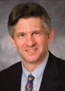 | Editor-in-Chief  Scot C Remick  FACP Professor of Medicine  Director, Mary Babb Randolph Cancer Center  Robert C. Byrd Health Sciences Center  West Virginia University  USA

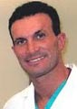 | Executive Editor  Domenico Calcaterra  Department of Cardiothoracic Surgery  Indiana University  USA  Tel. 317-923-1787/ 800-382-9911

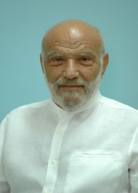 | Executive Editor  John Meletis  Professor  Department of Internal Medicine and Hematology  University of Athens  Greece  Tel. 302-107-456-902

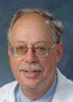 | Charles A Schiffer  Professor  Division of Hematology/Oncology  Wayne State University  USA  Tel. 131-357-687-37

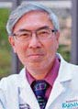 | Lawrence G Lum  Professor  Division of Hematology & Oncology  Wayne State University  USA  Tel. 313-576-8326  Fax 313-576-8923

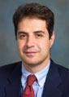 | Elias Jabbour  University of Texas  M. D. Anderson Cancer Center  Houston, TX, USA  Tel. 713-792-4764  Fax 713-792-0319

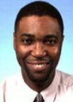 | Kenneth Isimemen Ataga  Associate Professor  Division of Hematology & Oncology  University of North Carolina at Chapel Hill  USA

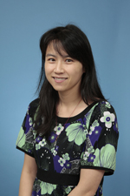 | Shan Yuan  Division of Transfusion Medicine  Department of Pathology and Laboratory Medicine  David Geffen School of Medicine at UCLA  USA

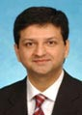 | Mehdi Hamadani  Division of Hematology and Oncology  West Virginia University  USA

David F Stroncek
Department of Transfusion Medicine
Warren G. Magnuson Clinical Center
USA

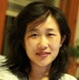 | Zejuan Li  Section of Hematology/Oncology  Department of Medicine  University of Chicago  Chicago, IL, 60637, USA  Tel. 1-773-702-1547

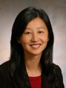 | Rong Stephanie Huang  Department of Medicine  Section of Hematology and Oncology  University of Chicago  USA  Tel. 773-702-9363  Fax 773-702-2770

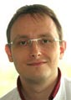 | Andreas Tiede  Hannover Medical School  Department.of Haematology & Haemostasis  Germany  Tel. 495-115-328-377/ 8488  Fax 495-115-328-351

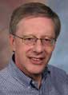 | Guido J.K. Tricot  Editor-in-Chief  Professor  Department of Medicine  University of Utah School of Medicine  USA

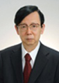 | Susumu Ikehara  Executive Editor  Professor  Department of Stem Cell Disorders  Kansai Medical University  Japan  Tel. 81-6-6993-9625

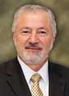 | Ramzi M. Mohammad  Professor  Department of Oncology  Wayne State University  USA  Tel. +313-576-8329  Fax +313-576-8389

Shinichiro Takahashi
Professor
Division of Hematology
Kitasato University School of Allied Health Sciences
Japan
Tel. 81-42-778-8216
Fax 81-42-778-8216

Lisa M. Hodge
Associate Professor
Department of Molecular Biology and Immunology
University of North Texas Health Science Center
USA

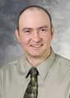 | Sinisa Dovat  Associate Professor  Division of Pediatric Hematology/Oncology  Pennsylvania State University  USA  Tel. +717-531-6012  Fax +717-531-4789

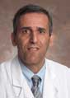 | Mojtaba Akhtari  Department of Oncology and Hematology  University of Nebraska Medical Center  USA  Tel. 402-559-3834  Fax 402-559-6520

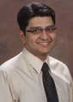 | Farrukh Tauseef Awan  Department of Internal Medicine  Section of Hematology/Oncology  Georgia Health Science University  USA  Tel. +706-721-2505  Fax +706-721-5566

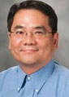 | Executive Editor  Mong-Hong Lee, PhD  Professor  Department of Molecular and Cellular Oncology  University of TexasUSA  Tel. 713-794-1323

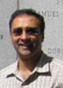 | Senior Editor  Sridhar Mani, MD, PhD  Professor  Medicine, Oncology and Genetics  Albert Einstein College of Medicine  USA  Tel. 718-430-2871

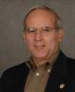 | Senior Editor  Vicente Notario, PhD  Professor  Radiation Medicine  Georgetown University  USA  Tel. 202-687-2102

Rajagopal Ramesh, PhD
Professor
Experimental Therapeutics & Translational Cancer Medicine
University of Oklahoma Health Sciences
USA
Tel. 405-271-6101; Ext: 52501

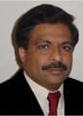 | Sanjay K Srivastava, PhD  Professor  Cancer Biology  Texas Tech University Health Sciences Center  USA  Tel. 806-356-4015; Extn: 319  Fax 806-356-4015

Sekhar Konjeti, PhD
Professor
Department of Radiation Oncology
Vanderbilt University
USA
Tel. 615-322-3603
Fax 615-343-3061

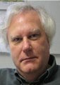 | Kurt S Zänker, PhD  Professor  Immunology and Oncology  Herdecke University  Germany

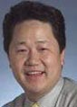 | Chulso Moon, MD, PhD  Director  Department of Medical Oncology  The South Western Medical Center  USA  Tel. 158-053-164-00  Fax 158-053-146-81

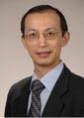 | Mitchell Ho, PhD  Head  Antibody Therapy Unit  National Cancer Institute  USA  Tel. 301-451-8727  Fax 301-480-4667

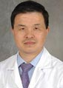 | Shenhong Wu, MD, PhD  Hematology and Oncology  Stony Brook University  USA  Tel. (631) 444-2066

Kamalesh Kumar Sankhala, MD
Division of Hematology & Oncology
University of Texas
USA
Tel. 210-450-5956/210-667-7029

Suzanne Miyamoto, PhD
Division of Hematology/Oncology
UC Davis Cancer Center
USA
Tel. (916)-734-3769
Fax (916)-734-5356

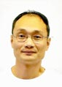 | Junqiang Tian, PhD, MD  Radiation and Oncology  Stanford University  USA  Tel. (650)-580-3390

