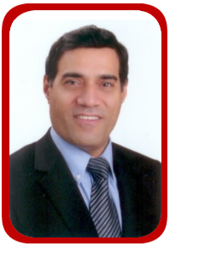 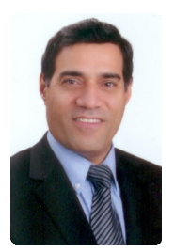 Sami Salem Ahmad Germany
Dr Sami Salem Ahmad is Consultant Surgeon, graduated in medicine from Hamburg University, Germany, and specialized in General and GI Surgery in Hamburg and London Hospitals, working in Bariatric Surgery since 1991.
Worked as Consultant Surgeon and Director of Gastriccenter in Stuttgart in Germany and Director of GI and Obesity Surgery in Abu Dhabi and now in Amman at Jordan Hospital.

- German Society for Surgery.
- Royal College of Surgeons, FRCS.
- Consultant Surgeon, registered in the Specialist Register U.K.
- IFSO, International Federation for the Surgery of Obesity.
- German Society for Morbid Obesity Surgery.

