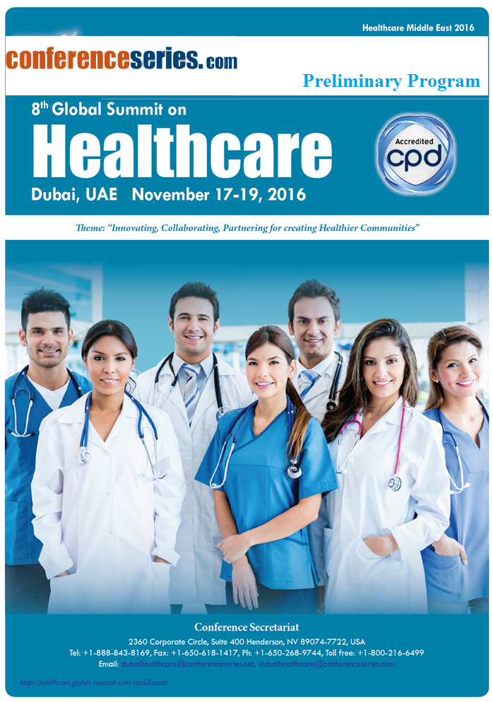

Introduction
Day 1 : Nov 17, 2016
Keynote Presentation
Polymer Science and Phytotherapy: Natural Remedy For Malaria and Cancer
based on Electrospun Nanofibers containing Artemisinin
 | Cosimo Carfagna, Institute for Polymers, Composites and Biomaterials (IPCB CNR), Pozzuoli (Italy)
 | Connected Care: Bring together a network of healthcare providers and partners to improve health outcomes
 | Dan Levitt, Executive Director, Tabor Village, Adjunct Professor, Gerontology Department, Simon Fraser University
Networking & Refreshment Break
2 more Keynote Speaker Opportunities Available
Session Introduction
Session Chair: Cosimo Carfagna, Institute for Polymers, Composites and Biomaterials (IPCB CNR), Pozzuoli (Italy)
Session Co-Chair: TBA
 | Chronic Disease Management: The Role of The Global Nurse
 | Sandra Skerratt, York University, Canada
 | The Power of One: A Revolutionary Theory to the Reduction and Elimination of Gender Based Violence
 | Lara Thomas, The MILLA Project, Inc. USA
 | Challenges in delivering health care, and remotely managing the health services in the Middle East region
 | Mohammad Al Safadi, Bath University School of Managmenet, Bath BA2 4QT, UK
 | DOMESTIC VIOLENCE AGAINST WOMEN IN KERSA, OROMIA REGION EASTERN ETHIOPIA
 | Wondimu S Yirga, CAN Genesis Healthcare Chelsea Center Massachusetts, USA
“Filipino Nurse’s in the Diaspora: Contextualizing Workforce Diversity & Cultural Adaptability:
A Middle Eastern Perspective
 | GLENN FORD D. VALDEZ, Salalah Nursing Institute –Ministry of Health, Sultanate of Oman
Lunch Break
 | The link between quality management systems and performance management systems: The case of university medical centers
 | Mira Thoumy, Notre Dame University – Louaize – ZOUK MOSBEH, LEBANON
 | Help-Seeking Behavior Among Adults In Riyadh, Saudi Arabia. A Cross Sectional Study
 | Waleed Khalid AL Shammari, College of Medicine, King Saud University, Riyadh, Saudi Arabia
 | Assessment Of Cultural Competency Of Filipino Immigrant Nurses
 | Anita Jasmine Valerio, Quezon City, Metro Manila, Philippines
 | Nutrition status and supplementation of undernourished patients with tuberculosis in Kapkatet Sub-County Referral hospital, Kericho County
 | cheruiyot sambu, Kapkatet county referral hospital, Kenya
 | Help-Seeking Behavior Among Adults In Riyadh, Saudi Arabia. A Cross Sectional Study
 | Wondimu S Yirga, CAN Genesis Healthcare Chelsea Center Massachusetts, USA
Networking & Refreshment Break
 | Exploring and Addressing Stress Reactivity Amongst Young Adults in the United Arab Emirates
 | Justin Thomas, Zayed University, UAE
Investigation the effect of health education based on health belief model on
nutritional self-efficacy in prevention of osteoporosis in female adolescence
 | Narjes Razavi, IRAN University of Medical Sciences, Tehran, Iran
5 more Speakers Opportunities Available
Panel Discussions
Day 2 : Nov 18, 2016
 | Introduction
 | Keynote Presentation
The Past And Present Of Human Movement Research: Towards The Design Of Human-Like
Robots
 | KINDA KHALAF, Khalifa University of Science, Technology and Research, UAE
3 more Keynote Speaker Opportunities Available
Session Chair: KINDA KHALAF, Khalifa University of Science, Technology and Research, UAE
Session Co-Chair: TBA
 | Safe Use of Medical Devices
Saleh S. Altayyar, Biomedical Technology Department, College of Applied Medical Sciences.
King Saud University, Riyadh, Saudi Arabia
Networking & Refreshment Break
 | Sustainable health care: The future of health care provision in the GCC
 | David Achanfuo Yeboah, Abu Dhabi University, UAE
 | Candidemia: a review over 5 years at a 300 beds military hospital (serving military personnel and their families) in the United Arab Emirates.
 | Ahmad Kanaan Uwaydah, Zayed Hospital, Abu Dhabi, UAE.
 | Antimicrobial susceptibility pattern of genital Mycoplasmasamong a group of pregnant women
 | Rania Hasan, Ain Shams University, Cairo, Egypt
Lunch Break
 | Workshop – “Bridging Global Health and Health Disparities for Minorities and the Underserved”
 | Lara Thomas, Executive Director, The MILLA Project, USA
 | ICU Robotic facilitates rapid ICU physician response to unstable patients and decreased cost in oncology ICU.
 | Alisher Agzamov, Department of Anaesthesiology & ICU, KCCC, Kuwait City, Kuwait.
7 more Speakers Opportunities Available
 | Nursing Care in Bangladesh: Problems and Prospects
Anisur Rahman Forazy, Begum Rabeya Khatun Chowdhury Nursing College
Pathantula, Bangladesh
 | Health Status of Children in India
 | Gulnawaz Usmani, AMU India
Networking & Refreshment Break
 | Poster Presentations
Session Judges | Poster Judges will be announced prior to 15 days of the event
 | Maternal Health Status and it’s affect on Child Health
 | Gulnawaz Usmani, AMU India
Panel Discussions
Day 3 : Nov 19, 2016
 | Introduction
2 more Keynote Speaker Opportunities Available
Session Introduction
Session Chair:
Session Co-Chair: TBA
 | Implicit out-group preference predicts eating disorders symptoms amongst Emirati Females
 | Justin Thomas, Zayed University, UAE
 | Booming Industry of Medical Tourism in India; How the World Will Benefit From It
 | Anurav Rane, PlanMyMedicalTrip.com, India
 | A Comparative Study Of Non Communicable Disease Risk Factors Among Gulf Migrant Workers And Non Migrant Workers Of Malappuram District, Kerala
 | Shamim Begam, Dubai, UAE
Networking & Refreshment Break 11:20-11:35
 | Assessment of staffing needs and workload pressures of human resource personnel working in the emergency department of district headquarter hospital, attock
 | Khuram Shahzad Sheikh, Pakistan
 | Prevalence and associated factors of stress, anxiety and depression among medical Fayoum University students
 | Wafaa Abdel Wahed, Egypt
8 more Speakers Opportunities Available
Lunch Break
 | Grain Amaranth and Traditional Healthcare Systems: Towards Curative Therapies for Chronic Diseases
 | Linus K. Ndonga, Strategic Poverty Alleviation Systems-SPAS, Nairobi, Kenya
Assessment of Hospitalized Patients’ Differential Awareness of their Rights in
Saudi Arabia
 | Faisal Asiri, College of Medicine, King Saud University, Riyadh, Saudi Arabia
Networking & Refreshment Break
Award Ceremony
Note: Tentative Program has been designed with the projected speakers, names, titles and timings in this program are subject to change Avail Speaker Opportunity @ Healthcare Middle East -2016
Send us your abstract and biography by July 25, 2016
Send your proposals & details to confirm your participation Email: dubaihealthcare@conferenceseries.net / dubaihealthcare@healthcaremeeting.com



