Katie Moriarty, PhD, CNM, CAFCI, RN
Director, Detroit Nurse-Family Partnership
Detroit Wayne County Health Authority
American College of Nurse-Midwife, Board of Directors, Region IV Representative

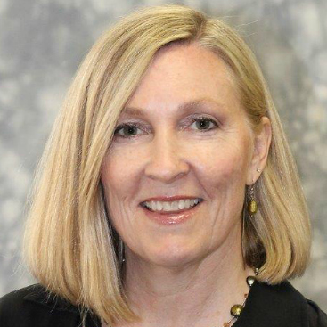

Katie Moriarty (CNM, PhD, CAFCI, RN) is the Director of Nurse-Family Partnership at Detroit Wayne County Health Authority. She has been a nurse-midwife since 1992 and was the first midwife certified by Acupuncture Canada. She launched the first Integrative Healthcare and Complementary Therapies Clinic in Pregnancy and Reproductive Women’s Health at the University of Michigan, Nurse Managed Center. She is the Region IV Representative for the Board of Directors of the American College of Nurse Midwives (ACNM). Dr. Moriarty earned her BScN at the University of Windsor, Ontario CANADA; MS and PhD from the University of Illinois at Chicago.

