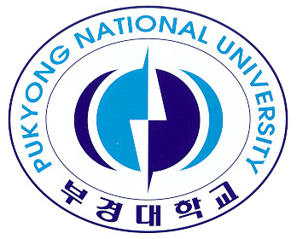
Title: Exploration of Fathers' Perception of Obesity in Preschool Children by Applying Q Methodology

Name: Euna Park

Pukyong National University Department of Nursing, Busan 608737, South Korea

Traditionally, fathers have been a bread earner and responsible for external matters as the head of household. However, the interest of today's fathers in their children has changed from that of the traditional fathers due to the increased employment of female, decreased birth rate and the trend of shared role in parenting. The purpose of this study was to identify the perception type of fathers of preschool children regarding obesity and the characteristics of the type by applying Q-methodology, and to create the basic data for the development of education programs for fathers or policy-making to prevent child obesity. Data were collected by applying 38 Q statements to 24 fathers of preschool children. Collected data were analyzed with the PC QUANL program.
Results indicate that fathers' perception of obesity was divided into three types: 'management of physical activity and diet,' 'generous acknowledgment of reality' and 'compromised emphasis on homemade meal.' The 'compromised emphasis on homemade meal' type is those who consider homemade food important, although they sometimes suggest conditions to make their children cooperative for food.
It was found that the subject of the study uniformly recognized that processed foods, fast foods or chocolates are harmful to health. The type of fathers' perception of obesity in preschool children was discussed, focusing on the perception type identified in this study.

Biography

Euna Park has completed her PhD at the age of 33 years from Keimyung University college of Nursing. She is the assistant professor of Pukyong National University department of nursing. She has She has an interest in youth problem and gender role identity.

