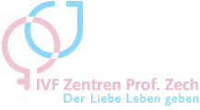 | 

Biography Johannes Wogatzky M.D.

J. Wogatzky M.D.

Born in 1968 in Hamburg, Germany, married, 3 children
Studied medicine in Hamburg- Germany, Heidelberg- Germany and Basel- Switzerland
License to practice medicine 1997 in Heidelberg
Doctoral thesis 1999 in cardiology and psychosomatic medicine
Consultant in sportsmedicine 1998
Consultant in emergency medicine 2002
Consultant in family medicine 2005
Consultant in O&G 2006
Specialist degree in reproductive medicine and endocrinology 2011
Worked in Germany, Switzerland, Austria, England, New Zealand and Australia
Since 2008 leading O&G consultant in the IVF Centers Prof. Zech, Austria
Special fields of interest: Andrology, Endocrinology

