Thrombosis-2015

(Theme: Advances in clinical diagnosis and therapeutic interventions)

About the Conference:
Thrombosis-2015 welcomes attendees, presenters, and exhibitors from all over the world to Beijing, China. We are delighted to invite you all to attend and register for the “International Conference on Thrombosis and Hemostasis (Thrombosis-2015)” which is going to be held during July 13-15, 2015 in Beijing, China.
The organizing committee is gearing up for an exciting and informative conference program including plenary lectures, symposia, workshops on a variety of topics, poster presentations and various programs for participants from all over the world. We invite you to join us at the Thrombosis-2015, where you will be sure to have a meaningful experience with scholars from around the world. All members of the Thrombosis-2015 organizing committee look forward to meeting you in Beijing, China.
For more details please visit- http://thrombosis-hemostasis.conferenceseries.com/

Importance & Scope:

The Important of Thrombosis-2015 is to update, clinically relevant audience regarding the evidence supporting current Advances in diagnosis of Thrombosis and Hemostasis. Researchers and scientists whole over the world can exchange ideas and views. Students from different universities gather together and improve their knowledge. Pharmaceutical companies can exhibit their new products and research and development methods.
Thrombosis-2015 is an international platform for presenting research about, exchanging ideas about it and thus, contributes to the dissemination of knowledge in research techniques in diagnosis and prevention of blood disorders for the benefit of both the young researchers, scientists, Pharmaceutical companies and Academia. Thrombosis-2015 is where the future of exhibit new Diagnostics methods and Instruments used for treatment and diagnosis and novel drugs. This event brings together senior brand marketers and agency executives to explore marketing and advertising opportunities on Pharmaceutical companies.

Why Beijing?
Beijing formerly Romanized as Peking is the capital of the People’s Republic of China and one of the most popular cities in the world, with a population of 19,612,368 as of 2010. The metropolis, located in northern China is governed as a direct-controlled municipality under the national government, with 14 urban and suburban districts and two rural counties. Beijing Municipality is surrounded by Hebei Province with the exception of neighboring Tianjin Municipality to the southeast.
Beijing is China’s second largest city by urban population after Shanghai and is the country’s political, cultural, and educational center and home to the headquarters for most of China’s largest state-owned companies. Beijing is a major transportation hub in the national highway, expressway, railway and high-speed rail network. Beijing’s Capital International Airport is the second busiest in the world by passenger traffic. In China more than 250 Universities/ colleges, 165 pharmaceutical companies, and more than 50 Associations and societies are working on Thrombosis and hemostasis and other blood related disorders. Funding grants by the government of china for research nearly 9 million USD$ to universities and 5 million USD$ to the pharmaceutical and research institutes.

Conference Highlights:
- Thrombosis
- Thrombosis and Hemostasis beyond Cardiovascular Disease
- Diabetes and Metabolic Disorders and Thrombosis
- Therapeutic Approaches
- New Issues and Developments in Thrombosis and Hemostasis
- Hemorrhagic Diathesis and Coagulation Factors
- Infection, Inflammation and Thrombosis
- Platelets
- Therapeutic Approaches

Why to attend???
Share your Knowledge Conferences share a lot of knowledge to Universities, companies. It benefits to medical students and researchers as well as professors and lab technicians. Conferences also benefits and share knowledge between scientist, doctors and delegates. One company networks with the other company and they share knowledge to each other about their product at the conference. The companies come to attend conferences and show their exhibit in front of eminent members and delegates present at the Conference.
A Unique Opportunity for Researchers and Exhibitors at this International event:
http://thrombosis-hemostasis.conferenceseries.com/abstract-submission.php

Major Thrombosis and Related Associations around the Globe
International Society on Thrombosis and Hemostasis
Hemostasis and thrombosis research society
American Society of Hematology (ASH)
American Heart Association (AHA)
European Hematology Association

Major Marketing Associations in China
China Association for Medical and Health Industry
Chinese Medical Communication Association
Chinese Society of Hematology

Funding Grants in China
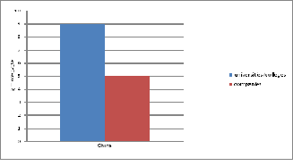

Figure 1: Funding grants in china for research

Source Reference1

Target Audience:
Scientists, Researchers, Young Scientists, Professors, Deans, Physicians, Students, Academia, Directors/Managers, Departmental Managers, Vice Presidents/ Directors & Brand Manufacturers/ Marketers of Consumer Products. Retailers, Marketing, Advertising and Promotion Agency Executives.

Target Audience:
Industry 30%
Academia 60%
Others 10%

Members in city/state:

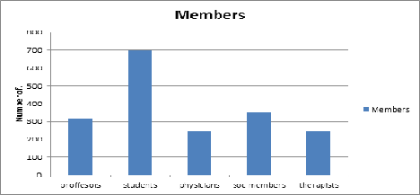

Figure 2: Related members in city/ state

Top Universities in China/Collages:
Peking University
Fudan University
Nanjing University
Zhejiang University
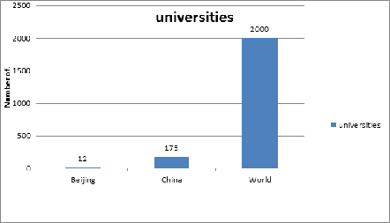

Figure 3: Top Universities/ Colleges in China

Source Reference1
Source Reference2

TOP pharmaceutical companies Market Share:

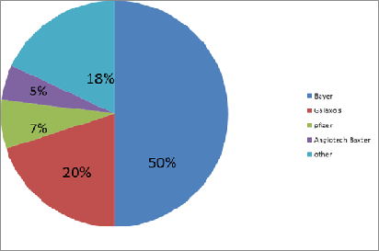

Figure 4: Top Pharmaceutical Market Share

References:
- https://grants.nih.gov/grants/guide/rfa-files/RFA-HL-08-002.html
- http://en.wikipedia.org/wiki/Pharmaceutical_industry_in_China
- http://www.traditionalvalues.org/content/home/31684/nih_grants_china_90_million_in_taxpayer_dollars_for_research
- http://en.wikipedia.org/wiki/List_of_medical_schools_in_China
- http//en.wikipedia.org/wiki/list_of_universities_and_colleges_in_Beijing

