Market Research:
Food Packaging Market by Material (Paper & Board, Plastic, Glass, Metal), Type (Rigid, Semi-Rigid, Flexible), Application (Dairy, Bakery, Confectionery, Convenience Foods, Fruits, Vegetables, Meat, Sauces, Dressings) - Global Trends & Forecast to 2019
The increase in consumption of convenience foods is driving the food packaging market. Convenience features such as easy opening, portability, and single-use packaging drive food packaging innovation for processed foods. Visual appeal and convenience are the two aspects that drive the growth of the food packaging market.
The food packaging market is segmented on the basis of material, types, application, and geography. The materials involved in food packaging are paper & board, rigid & flexible plastic, glass, and metal. The segmentation of the market, on the basis of application includes bakery, confectionery, dairy products, convenience foods , sauces, dressings & condiments, fruits & vegetables, meat, fish & poultry, and other products. The geographical segmentation of the market includes four regions: North America, Europe, Asia-Pacific, and Rest of the World (RoW). The key countries of these regions have also been studied.
Food Packaging Market Size, by Geography, 2014 – 2019 ($Million)

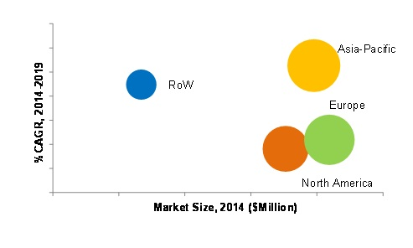
p - Projected
Source: MarketsandMarkets Analysis
The food packaging market is projected to reach a value of $305,955.1 Million by 2019 and Asia-Pacific market is projected to grow at the highest CAGR during forecasted period.

Food Packaging Market Size, by Material, 2014 Vs. 2019 ($Million)
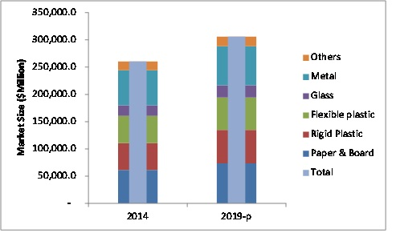
In 2014, the rigid and flexible plastics segments, together, held the largest market share, in terms of material, and were subsequently followed by the metal, and paper & board segments. The paper & board segments are estimated to grow at the highest CAGR from 2014 to 2019.
This report includes market size, in terms of value ($million). It provides both, qualitative and quantitative analyses of the food packaging market, the competitive landscape, and the preferred development strategies of key players.
The key players invest heavily in the expansion of their business and development of new food packaging material to maintain a competitive edge in the market. The key players were observed to prefer new joint ventures, agreements, collaborations, and expansions as strategies to enhance their production facilities and acquire a larger share in the market. The report provides a complete analysis of the key companies and a chronology of developments with respect to new products and their applications. It also analyzes the market dynamics, winning imperatives, and issues faced by the leading players.
Scope of the Report
The research study categorizes the food packaging market on the basis of material, type, application, and geography.
On the basis of materials for food packaging, the market was sub-segmented as follows:
- Paper & board
- Metal
- Rigid plastic
- Flexible plastic
- Glass
- Others (Wood and textile)
On the basis of types of food packaging, the market was sub-segmented as follows:
- Rigid
- Semi-rigid
- Flexible
On the basis of applications of food packaging, the market was sub-segmented as follows:
- Bakery
- Confectionery
- Convenience foods
- Dairy products
- Fruits & vegetables
- Sauces, dressings and condiments
- Others (whole grain food, pulses, and oil)
On the basis of geography for food packaging, the market was sub-segmented as follows:
- North America
- Europe
- Asia-Pacific
- ROW
Science Funding Agencies
- National Institutes of Health (NIH)
- US Department of Defense (including Congressionally Directed Medical Research Programs and the Minerva Initiative)
- National Science Foundation (NSF)
- US Office of Naval Research
- US Department of Agriculture
- US Department of Energy – Office of Science
- National Aeronautics Space Agency (NASA)
- FDA
- UDSA
- FAO
- WTO
- World Food Centre
- IFT
- World packaging Organisation
- IPA
- PAC

Major Food industry sector supporting associations
- National Food Processors Association
- PMMI: The Association for Packaging and Processing Technologies
- World Packaging Organisation
- National Frozen Food Association
- American Institute of Food Distributors
- Flexible Packaging Association
- Food Institute
- Food Marketing Institute
- Foodservice & Packaging Institute
- Institute of Food Technologists
- International Association of Food Industry Suppliers
- International Dairy Foods Association
- National Beverage Packaging Association
- National Confectioners Association of the U.S.A.
- The Aluminum Association
- Women in Packaging
- Georgia Food Bank Association
- Georgia Food Industry Association

Food Science associated universities
- Brigham Young University--Department of Food Science & Nutrition
- Cornell University - Food Science
- Iowa State University - Food Science and Human Nutrition Department
- Louisiana State University - Department of Food Science
- Michigan State University - Department of Food Science and Human Nutrition
- Mississippi State University - Department of Food Science and Technology
- North Carolina State University - Department of Food Science
- North Dakota State University
- Ohio State University Food Science and Technology
- Oregon State University - Department of Food Science and Technology
- Pennsylvania State University - Department of Food Science
- Purdue University - Department of Food Science
- Rutgers University - Department of Food Science
- Texas A&M University - Institute of Food Science and Engineering
- University of Arkansas - Food Science Department
- University of California Davis - Food Science & Technology
- University of Florida - Food Science and Human Nutrition
- University of Georgia - Center for Food Safety
- University of Illinois - Department of Food Science and Human Nutrition
- University of Kentucky - Food Science Section
- University of Leeds - Biofreeze Food Freezing Research and Consultancy
- University of Leeds - Proctor Department of Food Science
- University of Maryland - Department of Nutrition and Food Science
- University of Massachusetts - Department of Food Science
- University of Maine - Department of Food Science & Human Nutrition
- University of Minnesota - Department of Food Science and Nutrition
- University of Missouri (Columbia) - Food Science Program
- University of Nebraska - Department of Food Science and Technology
- University of Tennessee - Department of Food Science and Technology
- University of Wisconsin (Madison) - Department of Food Science
- University of Wisconsin (River Falls) - Food Science and Technology
- Virginia Polytechnic Institute and State University - Food Science & Technology
- Wageningen Agricultural University - Food Chemistry and Microbiology
- Washington State University - Food Science and Human Nutrition
- Wayne State University - Nutrition and Food Science
- Food Science Department at the University of Guelph, Ontario Canada
- University of Alberta - Department of Agricultural, Food and Nutritional Science, Alberta, Canada
- University of British Columbia - Department of Food Science
- Technische Universitat Berlin - Department of Food Biotechnology and Food Process Engineering
US Industries Associated
- Atkins Nutritionals  - Annie's Homegrown  - Appalachian Brewing Company  - Auntie Anne's  - Blackjack Pizza  - Boston Market  - ConAgra Foods  - Campbell Soup Company  - The Coca-Cola Company  - Columbus Salame  - Dave's Killer Bread  - Dean Foods  - Deep Foods  - Dr Pepper Snapple Group  - Frontier Natural Products Co-op  - Tabatchnick  - The Hershey Company  - The J.M. Smucker Co. | - General Mills  - H.J. Heinz  - Hormel  - Kellogg Company  - Kraft Foods  - Land O Lakes  - McCormick & Company  - Mars  - MOM Brands  - Mondelez  - Ocean Spray  - Odwalla  - Pure Indian Foods  - PepsiCo  - Pinnacle Foods  - Ralcorp  - Richelieu Foods  - Sara Lee Corporation  - United States Bakery  - U.S. Mills  - Utz Quality Foods, Inc.  - Vanee Foods  - McDonald's | - Richelieu Foods  - Sara Lee Corporation  - Schwan Food Company  - Smucker's  - Stonyfield Farm  - Tabatchnick  - The Hershey Company  - The J.M. Smucker Co.  - Tröegs Brewing Company  - United States Bakery  - U.S. Mills  - Utz Quality Foods, Inc.  - Vanee Foods  - McDonald's  - Tröegs Brewing Company  - Schwan Food Company  - Smucker's  - Stonyfield Farm

Worldwide Food Industries
- Nestle
- Cargill
- Archer Daniels Midland
- PepsiCo Inc.
- Kraft Foods Inc.
- The Coca-Cola Company
- Anheuser-Busch InBev
- Tyson Foods Inc.
- Unilever Plc/Unilever NV
- Mars Inc.
- SABMiller Plc
- Kirin Brewery Company Ltd
- Heineken N.V.
- Lactalis
- Asahi Breweries Ltd.
- Associated British Food
- Diageo Plc
- Fonterra
- General Mills Inc.
- Kellogg Company
- FrieslandCampina NV
- Vion
- ConAgra Foods Inc.

Food Preservative Market worth $2.7 Billion by 2018
The report “Food Preservative Market by Type (Natural, Chemical), Function (Antimicrobial, Antioxidant), Application (Oil & Fat, Bakery, Dairy, Snack, Meat, Poultry & Seafood, Confectionery, Beverage), & Geography – Global Trend & Forecast to 2018” defines and segments the food preservative market with an perusal of the global market size in terms of value ($million). It also identifies the driving and restraining factors for this market with an analysis of trends, opportunities, burning issues, winning imperatives, and challenges. The market segment includes food preservative by type, by function, by application, and by geography.
Food preservative is a growing market in the food additives sector. There is an increasing trend towards consumption of processed food products in the developing countries, which further signifies the increasing use of food preservatives. A number of chemical and physical changes take place in a food product during storage, which deteriorates the freshness and product quality. Hence, the use of preservatives has increased in the market.
The food preservative market value forecast by type includes natural and chemical preservatives, projected based on significant regions such as North America, Europe, Asia-Pacific (APAC), and Rest of the World (ROW).
Food Preservative Market Value Share, by Geography, 2014
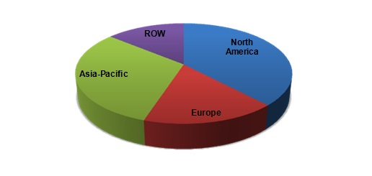
ROW: Rest of the World
Source: Expert Interviews, Government Authorities, Related Associations/Institutes, Related Research Publication, Government Publication, Company Press Release, Company Annual Report, Company Website, Company Publication, and MarketsandMarkets Analysis
In 2014, North America dominated the food preservative market, followed by Asia-Pacific. Increasing demand for natural foods and safety concerns with respect to processed products drives the market. The food preservative market is estimated to reach $2.7 billion by 2018.
The increase in population has a tremendous impact on the global food supply. The question of food safety and quality has received widespread attention. Different governments and private industries have come a long way in achieving high standards for pure and unadulterated food containing preservatives. The consumer demands placed on technology have resulted in the development of different preservatives that afford us abundant, appetizing, and economical foods.
Retail ready packaging (RRP) demand amounted to 27 million tonnes of material in 2011, worth over $54 billion, and is expected to reach $63.4 billion and 32.1 million tonnes by 2017.
RRP is a high growth sector of the overall packaging market, having been adopted in the UK and Europe around 2005 and now spreading across the globe. The most popular type of RRP is corrugated board, which accounts for three-quarters of the total volume of materials used in 2014. Within this, die-cut display containers are the predominant choice, making up more than half the market, with decline-wrapped trays constituting 17% of demand and modified cases the remaining 5%.
The Future of Retail Ready Packaging to 2017 presents an analysis of the global demand for RRP and assesses the major influences driving demand for this type of packaging. The market is quantified and segmented according to type of material, end use application and geographic location, across 18 individual countries and 22 end use markets for the period from 2011 to 2017. This report provides raw material suppliers, converters, users, processors and others along the supply chain with an up-to-date view of the current state of the market.
The major driver of growth in demand for RRP will be the burgeoning development of supermarkets, especially in under-developed economic regions. The on-going formalisation of the retail supply chain in countries such as China, India and Brazil, as well as parts of Africa and South America, will provide the stimulus to maintain growth in demand for RRP, whilst preventing any marked decline in demand from other regions. Russia is also showing high growth.
.FIGURE 1.1 Global demand for RRP by region, 2012 and 2017 ($ million) 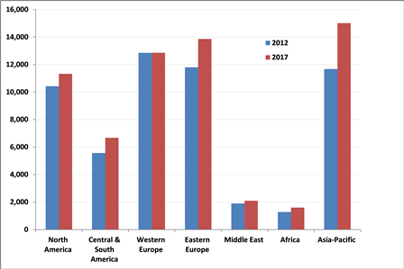
The early adoption of RRP by European retailers is evident from the 38% share of demand enjoyed by Europe in 2011. The Americas accounted for a third of the total with Asia accounting for an additional 22% and the balance spread over the other regions. Asia is expected to show the highest growth rate with demand predicted to improve at a rate of 6.2% annually on average between 2012 and 2017. This region will also see the highest incremental tonnage demand over the period, with more than 2.2 million tonnes of extra material required to meet 2017 demand compared to projected 2012 tonnage. The Americas will contribute incremental demand for almost 1.2 million tonnes over this period, and a further 1.1 million tonnes of additional demand will emanate from Europe, in spite of declining markets in most of Western Europe.
Three-quarters of RRP demand originates in the food sector, while the beverage industry accounts for a further 16%, with the balance in non-food products. Over the medium term, demand for RRP from the non-food category is forecast to increase by 3.1% on average per annum from 2012 to 2017, compared to 2.7% and 2.8% for food and beverages respectively. The food sector will contribute an additional 3.3 million tonnes of incremental demand for RRP materials in 2017, with a further 700,000 tonnes coming from the beverage market and 400,000 tonnes from non-foods.
High quality graphics go hand-in-hand with RRP and this is creating an opportunity for producers in increase the value-added element of their product portfolios. More and better paperboards are being developed and launched into the market by the paper mills, providing the material necessary for the demands of the retailers and marketers to create visually attractive packs to capture consumers' attention.

References

http://en.wikipedia.org/wiki/List_of_food_companies

http://www.smitherspira.com/news/2013/december/global-packaging-industry-market-growth-to-2018

http://www.marketsandmarkets.com/PressReleases/food-preservatives.asp

http://www.foodinfonet.com/university.htm

