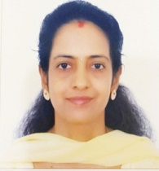

Usha Adiga

Title: Association of Leptin Gene Polymorphism with Metabolic Parameters in Gestational Diabetes Mellitus: A Cross sectional study

Biography

Dr. Usha Adiga MD PhD
Qualification:
MBBS - 2001,JN Medical College ,Belgaum,Karnataka
MD Biochemistry- 2006, Kasturba Medical College,Mangalore
PhD in Public health 2017 ,University of Swahili Foundation,Panama
Present designation/Institute: Professor in Dept of Biochemistry, KS Hegde Medical Academy, Nitte University, Mangalore
Total Number of teaching & research experience: 14 years
Number of presentations at conferences: 15
Number of CMEs & workshops attended:25
Number of research publications in indexed journals: 72
Chapters contributed in books- 6
Research grants obtained from agencies : 7
Intellectual property right - 1

Research Interest
Gynecology and Obstetrics

No Content found...
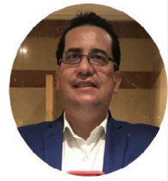

Barrientos-Vargas German

Title: Abdominal Pregnancy and In Vitro Fertilization with Embryonic Transfer

Biography
Obstetrician-Gynecologist and Colposcopist. Certified by the Mexican Council of Gynecology and Obstetrics. Fellow of the American College of Obstetricians & Gynecologists. Titular Member of College of the Mexican College of Specialists in Gynecology and Obstetrics. Federated Member of the Mexican Federation of Colleges of Obstetrics and Gynecology. Treasurer of the Mexican College of Gynecologists dedicated to Colposcopy. Busan, Korea Coordinator and Professor of the subject of Medical Embryology in the Faculty of Medicine of the University of Ixtlahuaca CUI- UNAM. Professor of the subject of Surgical Techniques in the Faculty of Medicine of the University of Ixtlahuaca CUI- UNAM.
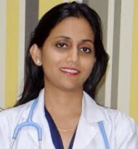

Ekta Jaiswal

Title: Placenta previa: Clinical Profile And Pregnancy Outcome Of Patients In A Tertiary Care Referral Institute in Northern India

Biography
Dr. Ekta Jaiswal Consultant Obstetrician and Gynaecologist and Laparoscopic Surgeon
Dr. Ekta Jaiswal is a dedicated Obstetrician and Gynaecologist .She has done her MBBS from KUSMS Kathmandu following which she went to India to pursue her post graduation training in Obs/Gynae from prestigious institute PGI Chandigarh where she also won several awards for outstanding performance. Thereafter she completed her 1 year Fellowship In Gynae Laparoscopy from Sonipat, India. She is a member of the Nepal Obs/Gynae Society and Indian Fertility Society. Dr.Ekta has more than 2.5 years of clinical experience as a obstetrician/gynaecologist, with special focus on laparoscopy and hysteroscopy. She has a strong research background with multiple contributions to national and international peer reviewed journals. She has given numerous presentations at regional, national and international conferences. She has taught medical students, supervised students and nurses in their quality improvement audits and researches.
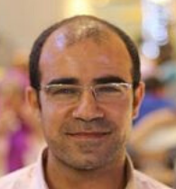

Yasser Younis

Title: Oocyte retrieval-ET simulator, A step towards competence and proficiency in ICSI procedures.

Biography
Fellow of Auvergne University, Clermond- Ferrand, France. Member of American Society of reproductive medicine (ASRM) Member of European society of human reproduction and embryology (ESHRE)

