






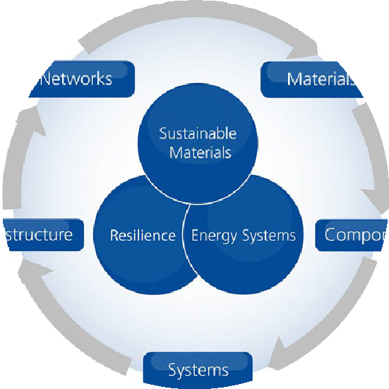


Sustainable Material-2021

Webinar on
Sustainable Materials

November 28, 2020
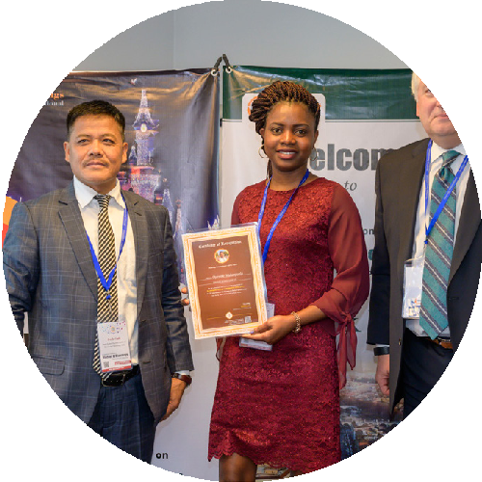
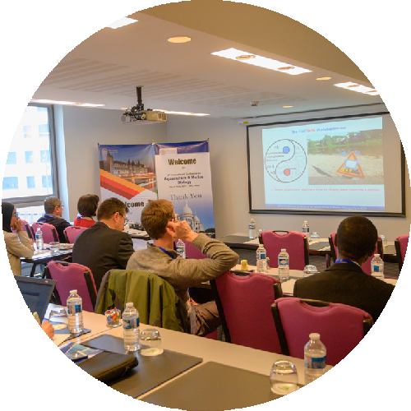

Invitation
Dear Attendees
Meetings International proudly announces the Webinar on Sustainable Material scheduled during November 28, 2020 in Berlin, Germany.
The Sustainable Material-2020 gathering gives a mind-blowing opportunity to discuss the latest progressions inside the field. This conference brings together the innovations in Sustainable Material and brings the key opinion leaders and thought leaders in the field from around the world for two intensive days of scientific presentations, networking as well as engagement with companies developing innovations in tools and technologies in this space. The purpose of Sustainable Material-2020 is to provide an international technical forum to showcase recent advances in Materials , Nanotechnology, Science and Technology conference operation committee is providing a platform for all the budding young researchers, young investigators to showcase their research and innovation.
Sincerely, Operating Committee Sustainable Material 2020

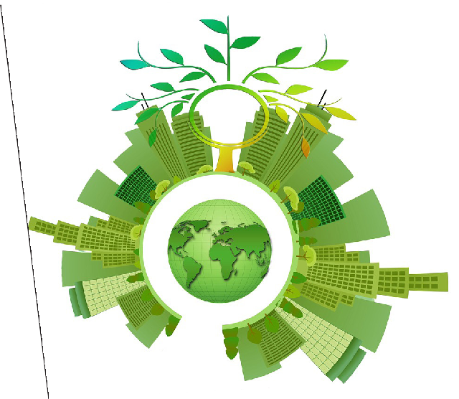

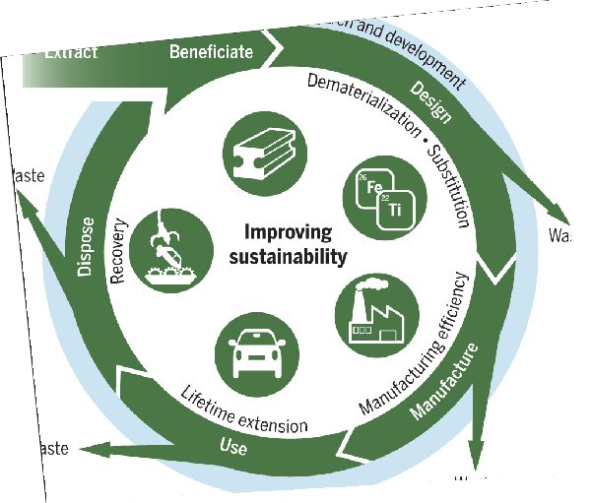
Webinar
Highlights

- New Technologies and Product
- Sustainable Manufacturing and Translational
- Smart bio-materials
- Nano Materials for Sustainability
- Advance Device Material
- Sustainability of Materials Process
- Smart materials for sewage treatment
- Green Nano Materials
- Eco-friendly and sustainable materials
- Dynamic behavior of material
- Ceramic and composite materials
- Polymer-based smart materials



- To identify the future directions of research
- Peer review and high quality publication
- Quality research

SPEAKERS FOR WEBINAR

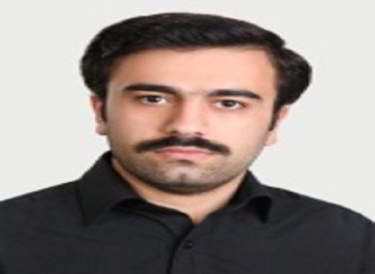
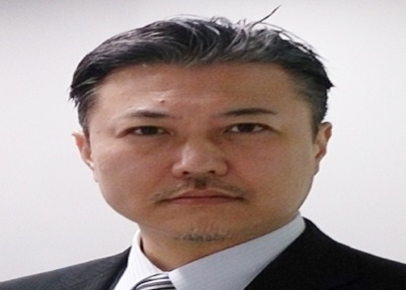
Dr Mohsen
Prof. Soshu Kirihara, Japan



Dr You Qiang

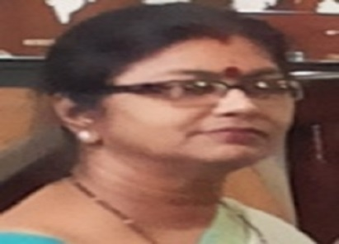
Ms Lavinia warnars
Dr Sharda Sundaram Sanjay


Sustainable Material-2020
Venue
Berlin, Germany

Useful Links
Home Page
https://www.meetingsint.com/webinars/sustainable-materials
Registration
https://www.meetingsint.com/webinars/sustainable-materials/registration
Abstract Submission
https://www.meetingsint.com/webinars/sustainable-materials/abstract-submission

Meetings International
28 Maxwell Road, #03-05 Red Dot Traffic, Singapore (069120),
Phone: +65 3158 1626, WhatsApp: +441250400009
www.meetingsint.com e: contact@meetingsint.com

https://www.meetingsint.com/webinars/sustainable-materials

