
Global summit on
Surgery-2022
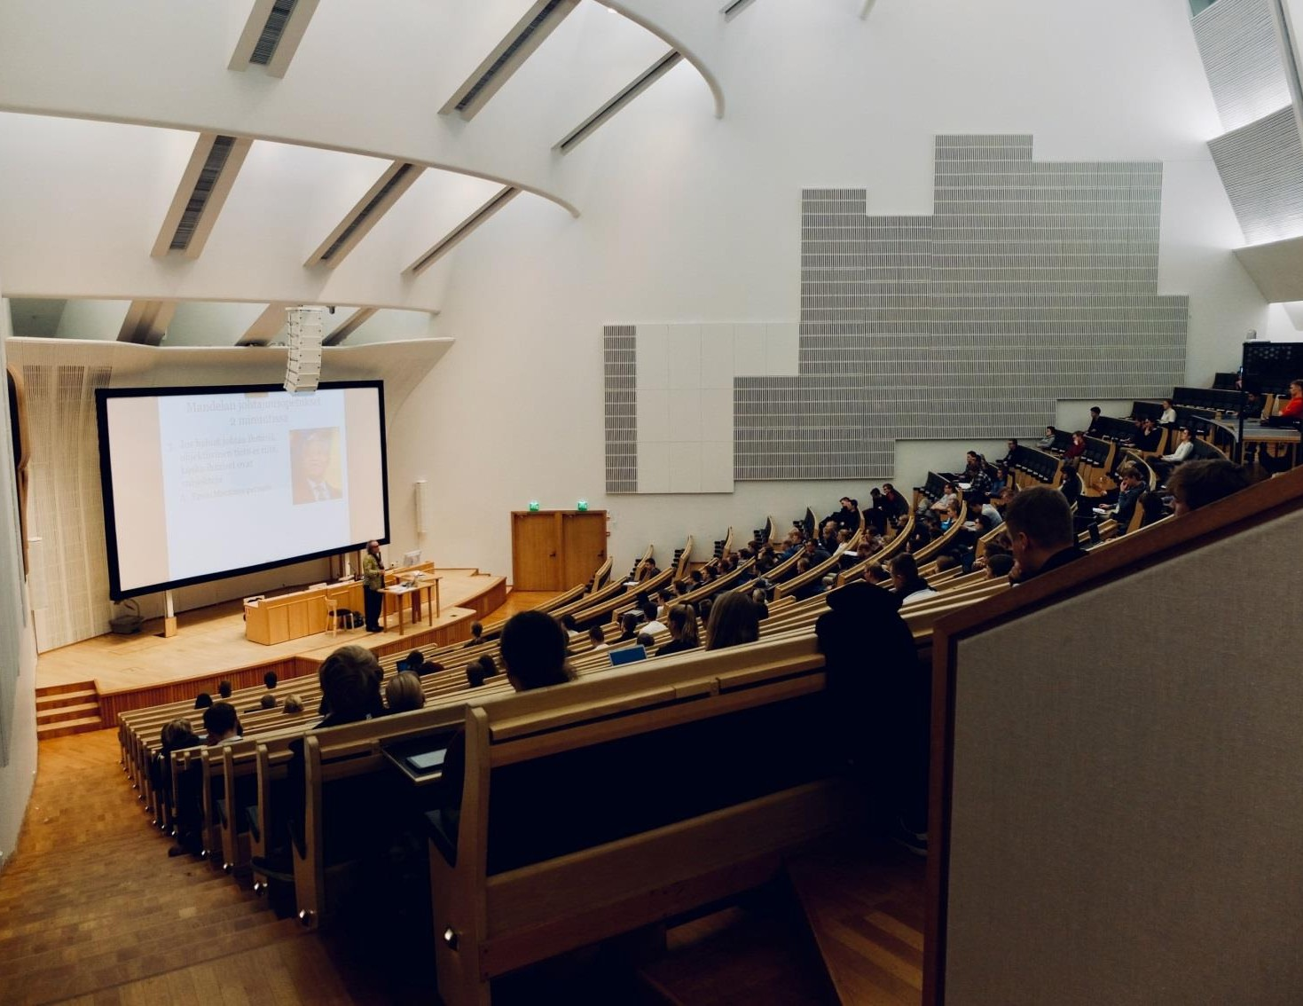
June 24-25, 2022 | NEW YORK, USA
https://www.meetingsint.com/conferences/surgeon
Theme: “Accelerating Advance Research and Innovation in Surgery”

Surgery-2022

Dear All,
International Conference on Surgery, Surgeon and Anesthesia is going to be held in New York, USA on June 24-25, 2022. We invite you to join the global event that impacts the advancements and technology trends in Surgery and Anesthesia The theme of the conference is "Accelerating Advance Research and Innovation in Surgery". Surgery Conference will discuss the latest research outcomes and technological advancements in the field bringing together leading surgeons, physicians, research scholars to exchange their views on critical aspects of surgery research. This conference is designed in a way to provide an exclusive platform for new researchers and scholars to present and discuss the most recent innovations, trends and practical challenges encountered, and the solutions adopted in the field of Surgery. Surgery Conference is focused to address the constant effort being made by scientists to improve the existing and inventing novel technologies for the future.
Sincerely,

Organizing Committee
Surgery-2022.

About The Company
Meetings International (Meetings Int.) is a global leader in producing high quality conferences, meetings, workshops and symposia in all major fields of science, technology and medicine. Since its inception, Meetings Int. has been associated with national and international associations, corporations and high level individuals, dedicated to host world class conferences and events.
https://www.meetingsint.com/conferences/surgeon

Surgery-2022

SCIENTIFIC SESSIONS..

- Ophthalmology Surgeon
- Bariatric Surgeon
- Trauma Care Surgeon
- Otorhinolaryngology Surgeon
- Plastic Surgeon
- Orthopaedic Surgeon
- Abdominal Surgeon
- Paediatric Surgeon
- Cardiac Surgeon
- Oculoplastic Surgeon
- Colorectal Surgeon

Target Audiences…

- All the Stake Holders (both Academia & Industry) of the Sector
- Researchers & Innovators
- Engineers
- Experts Looking for Collaborative Work
- Product Developers
- Solution Providers
- Sales & Marketing Professionals
- Associations, Societies, & Professional Bodies
- Funding Agencies & Fund Raisers
- Management Bodies
- Decision Makers


About NewYork
Surgery 2022


The City of New York is the most populous city in the United States. New York City is also the most densely populated major city in the United States. Located at the southern tip of the state of New York, the city is the center of the New York metropolitan area, the largest metropolitan area in the world by urban landmass and one of the world's most populous megacities. A global power city, New York City has been described uniquely as the cultural, financial, and media capital of the world, and exerts a significant impact upon commerce, entertainment, research, technology, education, politics, tourism, art, fashion, and sports. The city's fast pace has inspired the term New York minute. Home to the headquarters of the United Nations, New York is an important center for international diplomacy. Two noteworthy stream valleys – the north-south Hudson River Valley and the east-west Mohawk River Valley – separate these more hilly locales. Western New York is viewed as a component of the Great Lakes Region and fringes Lake Ontario, Lake Erie, and Niagara Falls. The focal piece of the state is overwhelmed by the Finger Lakes, a well-known vacation and tourist destination.


e Research 2021
Surgery-2022


Important Updates

Abstract Submission Deadline: March 25, 2022 Early Bird Registration Deadline: April 28, 2022
Pre-Webinar Registration Deadline: June 23, 2022

Important Links:

Abstract Submission Link: https://www.meetingsint.com/conferences/surgeon/abstract-submission
Registration Link: https: https://www.meetingsint.com/conferences/surgeon/registration
(Registration fees are available in the registration page. If you have any queries, please contact us via email or phone.)

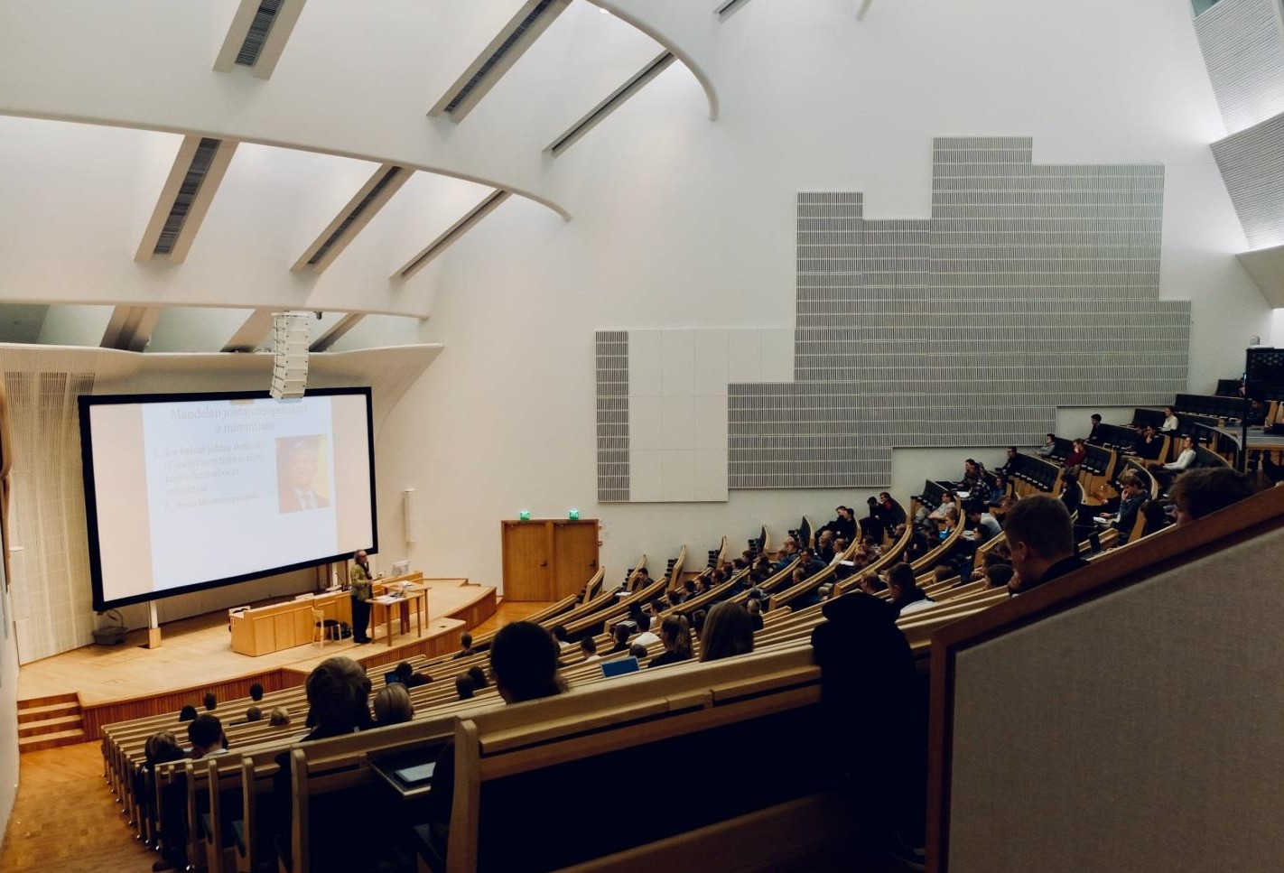
Contact Us

Phone/ WhatsApp: +44 1333540004

For more details, please visit our website
https://www.meetingsint.com/conferences/surgeon
Website: https://www.meetingsint.com/conferences/surgeon

