



International Conference on
Marketing Management and Strategic Planning

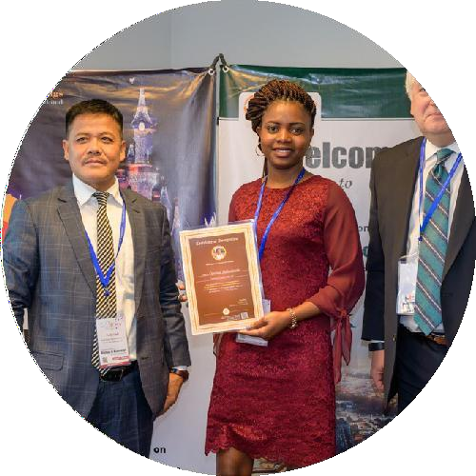
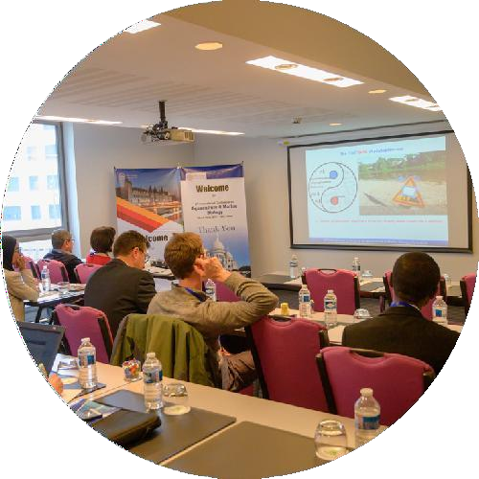
Invitation
Dear Attendees,

Meetings International proudly announces the International Conference on Marketing Management and Strategic Planning scheduled during May 25,26- 2022 in Berlin, Germany
The conference emphasizes the theme
“EFFECTIVELY DEVELOP AND IMPLEMENT CORPORATE STRATEGIES”
Strategic Planning 2022 is the premier event that brings together a unique and international mix of experts, researchers, and decision-makers both from academia and industry across the globe to exchange their knowledge, expertise and business innovations to build a world-class This Strategic Planning Conference will be having sessions on business and marketing Management, Strategic management is that the current designing, monitoring, analysis and assessment of all wants a corporation has to meet its goals and objectives. Changes in business environments would force organizations to perpetually assess their methods for achievement.to establish a connection for exchanging ideas.
Sincerely,
Operating Committee
Strategic Planning -2022

Conference Highlights





- Risk Management
- Business Strategy
- Operational Strategy
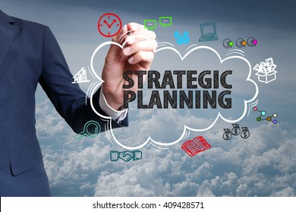
- Profit Management
- Social & Economic Management
- Production & Material Management
- Demand Analysis and Forecasting



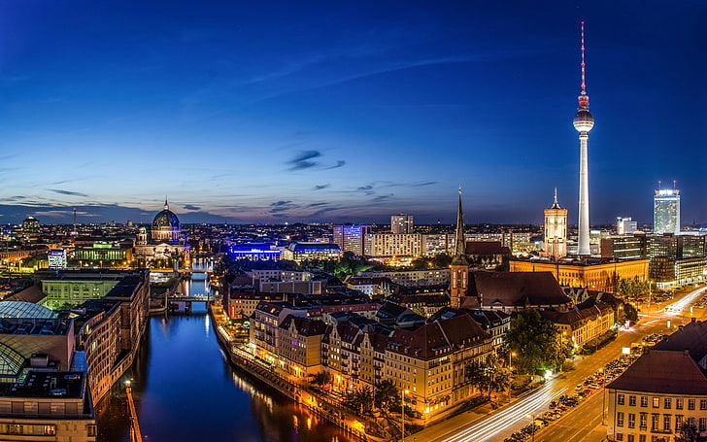
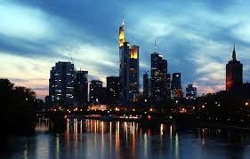
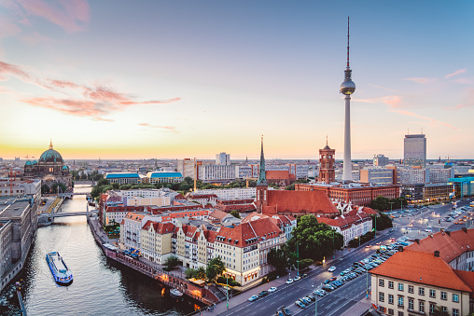

Germany Attractions
Stem Cell Research-2021

https://www.meetingsint.com/conferences/stemcellresearch

Explore Germany

Germany is a Western European country with a landscape of forests, rivers, mountain ranges and North Sea beaches. It has over 2 millennia of history. Berlin, its capital, is home to art and nightlife scenes, the Brandenburg Gate and many sites relating to WWII. Munich is known for its Oktoberfest and beer halls, including the 16th-century. Frankfurt, with its skyscrapers, houses the European Central Bank. Germany is famous for being the Land of Poets and Thinkers. From vital inventions to Christmas traditions, sausages and beer, Germany is home to plenty of culture, history and quirky laws! Germany is also known for its major cities, the Black Forest, the Alps and Oktoberfest

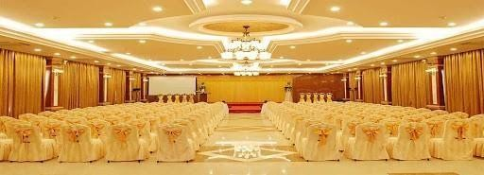
Strategic Planning -2022

VeNUe,
Berlin,Germany

Important Dates
Early Bird: November 30-2021
Abstract Submission Deadline: May 24-2022

Useful Links
Home Page
https://www.meetingsint.com/conferences/strategic-planning
Registration
https://www.meetingsint.com/conferences/strategic-planning/registration
Abstract Submission

https://www.meetingsint.com/conferences/strategic-planning/abstract
submission

Meetings International
28 Maxwell Road, #03-05 Red Dot Traffic, Singapore (069120), Phone: +44 135 230 0003, WhatsApp: +44 135 230 0003
w: www.meetingsint.com e: contact@meetingsint.com

