
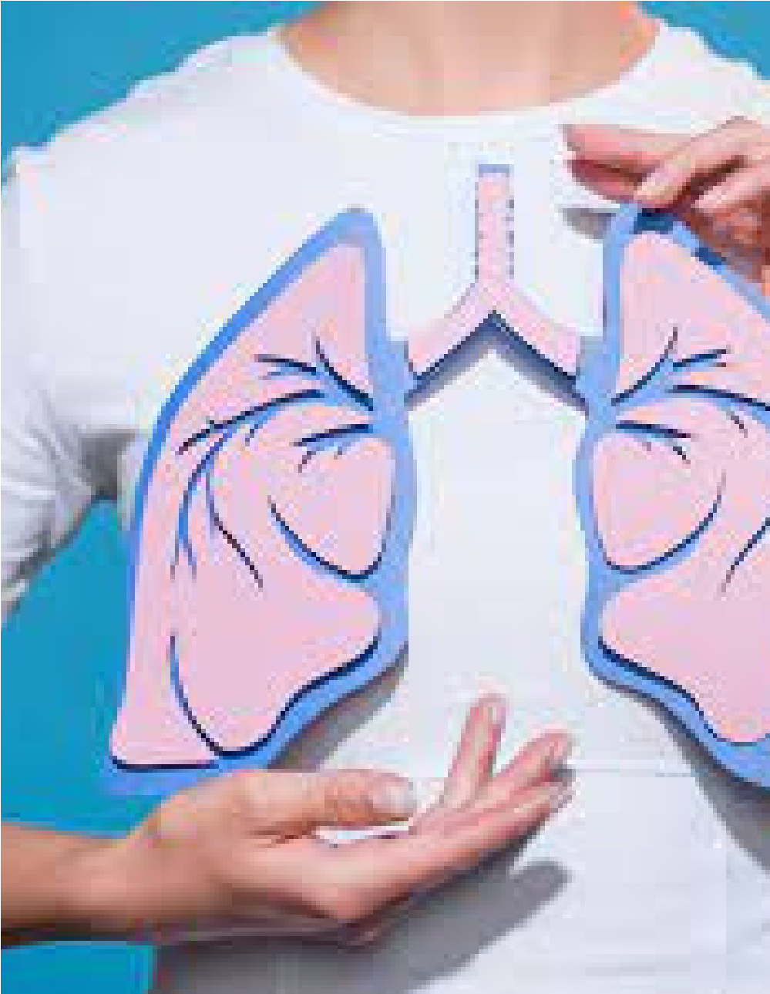


·COVID-19 and Asthma
·Chronic Obstructive
Pulmonary Disease
·Pneumonia
·Idiopathic Pulmonary Fibrosis
·Interstitial Lung Disease
·Lung Transplantation
·Pulmonary Hypertension
·Pulmonary Rehabilitation

WEBINAR
RESPIRATORY
DISORDER
June 24, 2021
EARLY BIRD
May 30, 2021
https://www.meetingsint.com/webinars/respiratory
MAJOR SESSIONS
healthscience@theexpertsmeet.com

