5th International Conference onNursing Research and Evidence based Practice

Dubai | UAe

December 06-07 | 2021

MEETINGS INTERNATIONAL
Company Registration No: 201524282R
28 Maxwell Road, #03-05 Red Dot Traffic
Singapore (069120)
Phone /WhatsApp: +65 3158 1626

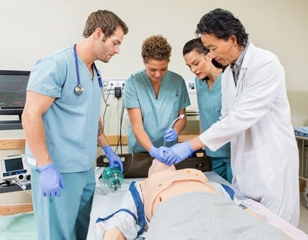

Day 1
Program
Keynote | Title: Simulation and 3D printing manufacturing of microfluidics for continuous particle separation with applications in monitoring air pollution
Keynote | Hamid Sadabadi, Wireless Fluidics, Canada
Keynote | Title: Micro-flow analysis with monolithic columns
Keynote | Petr Solich, Charles University, Czech Republic
Oral Session 1
Oral | Title: A microfluidic-based sensor with a built-in probe for conformal mechanical measurements of different anatomical sites at the exterior surface of human Pectus Carinatum (PC) costal cartilage
Oral | Jiayue Shen, SUNY Polytechnic Institute, USA
Oral | Title: Review of microfluidics device for drug delivery and formulation screening
Oral | DELAMARE Romain, Medincell SA, France
Oral | Title: Will update soon
Oral | Reza Abdolvand, University of Central Florida , USA
Oral | Title: Microfluidics for cancer research
Oral | Valerie Taly, CNRS, France
Speakers Slot available
Oral Session 2
Oral | Title: Inkjet microfluidic technology for printing and life science applications
Oral | Alexander Govyadinov, HP Inc. Advanced Technology and Platform Solutions Organization, USA
Oral | Title: Will update soon
Oral | Kari Ullakko, LUT University , Finland
Oral | Title: Will update soon
Oral | Bruce McCord, Florida International University, USA
YRF | Title: Microplastic detection using impedance measurements in a microfluidic channel
YRF | Vienna Mott, Draper, USA
Speakers Slot available
Day 2
Keynote | Title: Artificial intelligent point-of-care tools for rapid diagnostics of trauma
Keynote | Deniz Vurmaz, NYU Tandon School of Engineering, USA
Keynote | Title: Direct fabrication of fluctuated walls in ceramic tubes by lithographic additive manufacturing
Keynote | Soshu Kirihara, Osaka University, Japan
Oral Session 1
Oral | Title: A flexible and highly conducting bioelectrode utilizing nanostructured ceria for detection of Vitamin-D in serum sample
Oral | Deepika Chauhan, Jawaharlal Nehru University. India
Oral | Title: Modelling an Artificial Synaptic Communications with Microfluidics
Oral | Harwey Tawfik, Saarland University, Germany
Oral | Title: Design of DLD mechanism based microfluidic channel for separating the circulating tumor cells
Oral | Srigitha S Nath, Saveetha Engineering College, India
Oral | Title: Methods for the Reﬁnement of Protein Structure 3D Models
Oral | Recep Adiyaman, University of Reading, UK
Oral | Title: Retinal vascular network based Biomimetic Microchannel for LOC applications
Oral | Sudha R Karbari, RV College of Engineering, Bangalore, India
Poster presentation
**Conference Adjournment**

CITY ATTRACTION

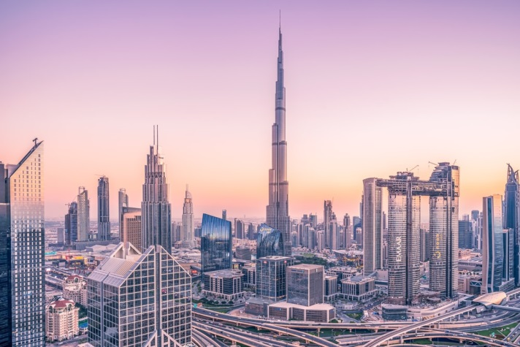
1. Dubai Burj Khalifa

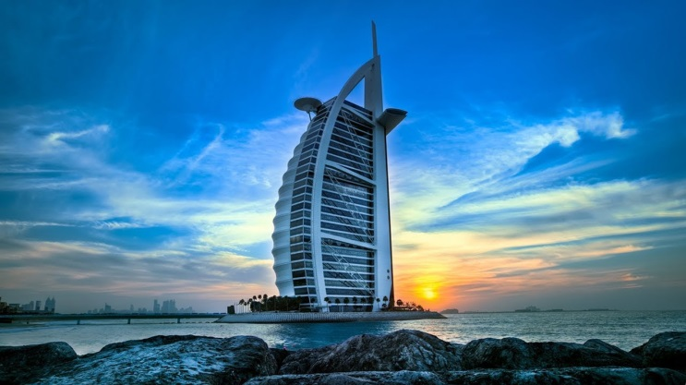
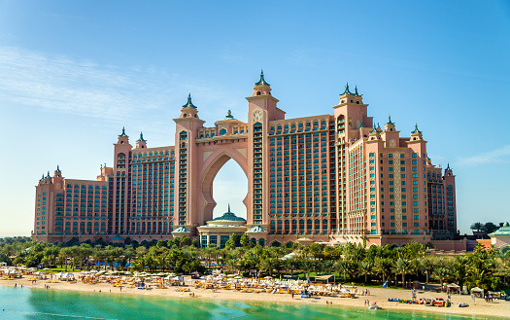
2.Atlantis Palm
3. Burj Al-rab

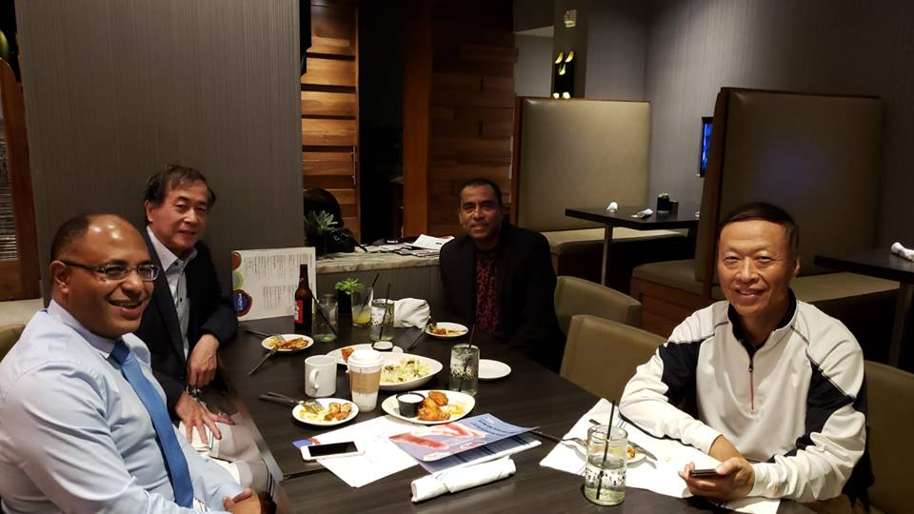
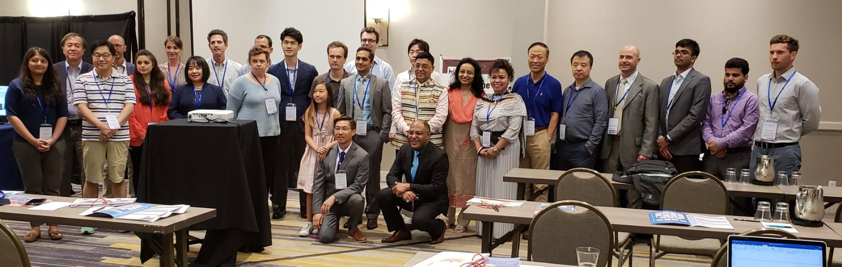
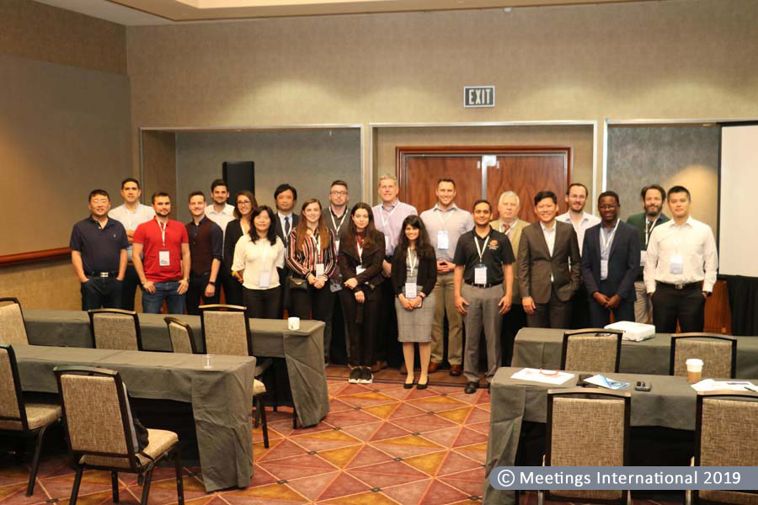
Glimpses OF Nursing 2018 & 2019
