Dubai, UAE

december 06-07 | 2021

International conference on Geriatrics

MEETINGS INTERNATIONAL
Company Registration No: 201524282R
28 Maxwell Road, #03-05 Red Dot Traffic
Singapore (069120)
Phone /WhatsApp: +44 135 230 0003



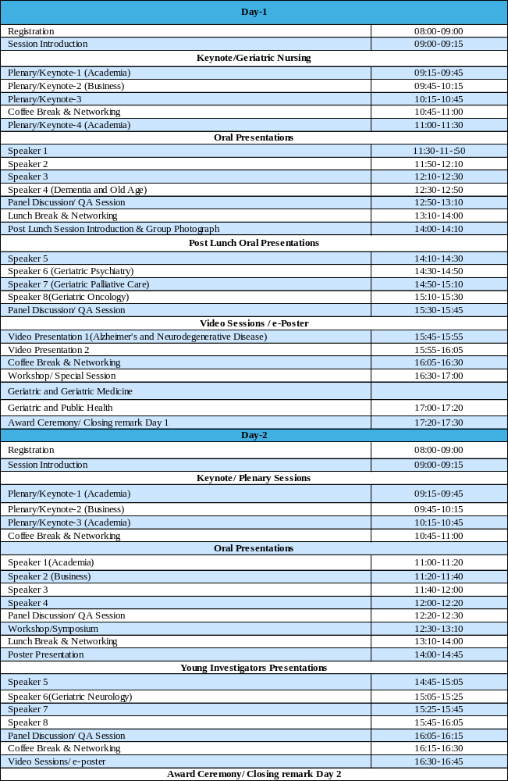

CITY ATTRACTION

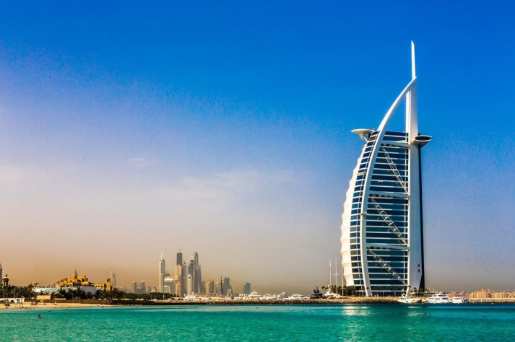
1. Burj Al Arab, Dubai

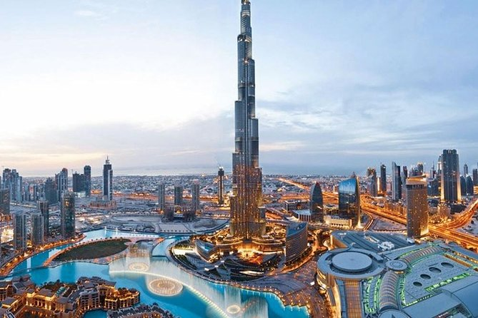
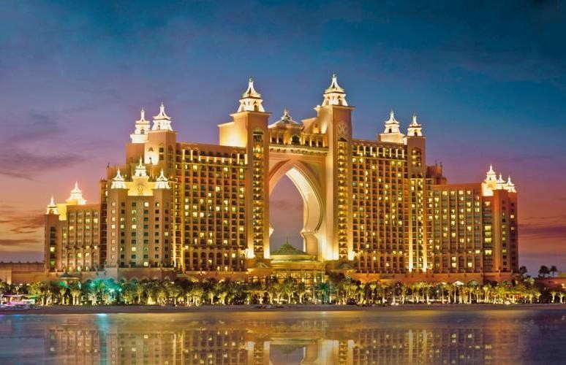
2. Atlantis Hotel, Dubai
3. Burj khalifa, Dubai

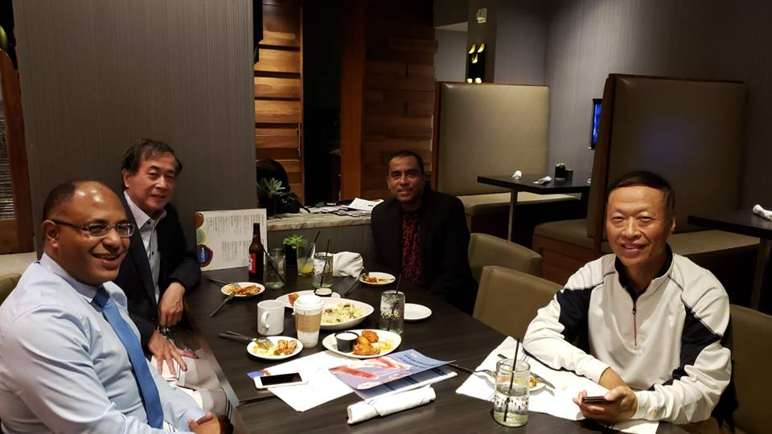
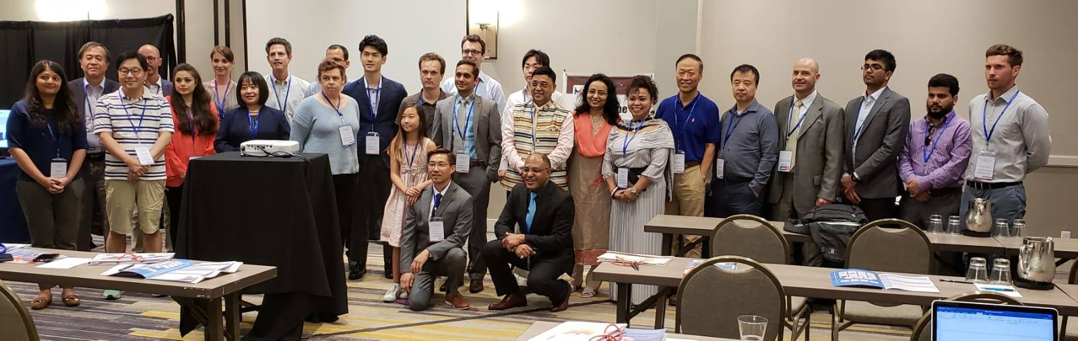
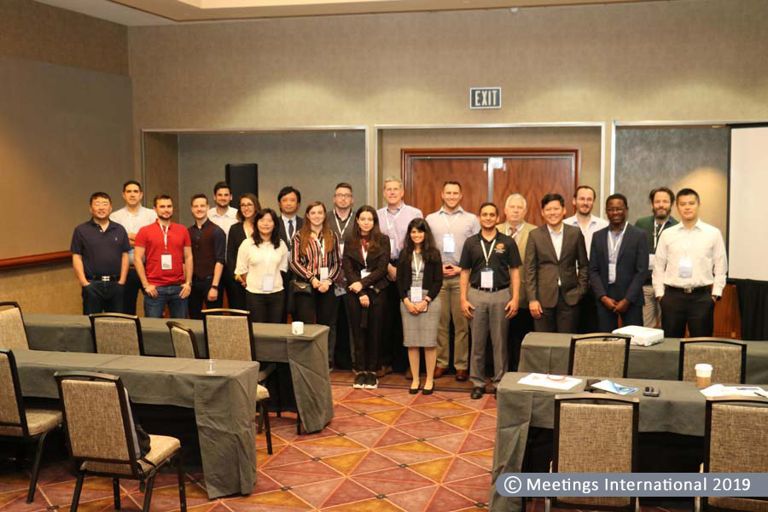
Glimpses OF Geriatrics 2019 & 2020 @ USA
