
Gastroenterology 2020

4th International Conference on Gastroenterology and Hepatology
February 19-20, 2020 Dubai, UAE
“Contemporary Researches on Gastroenterology and Hepatology”
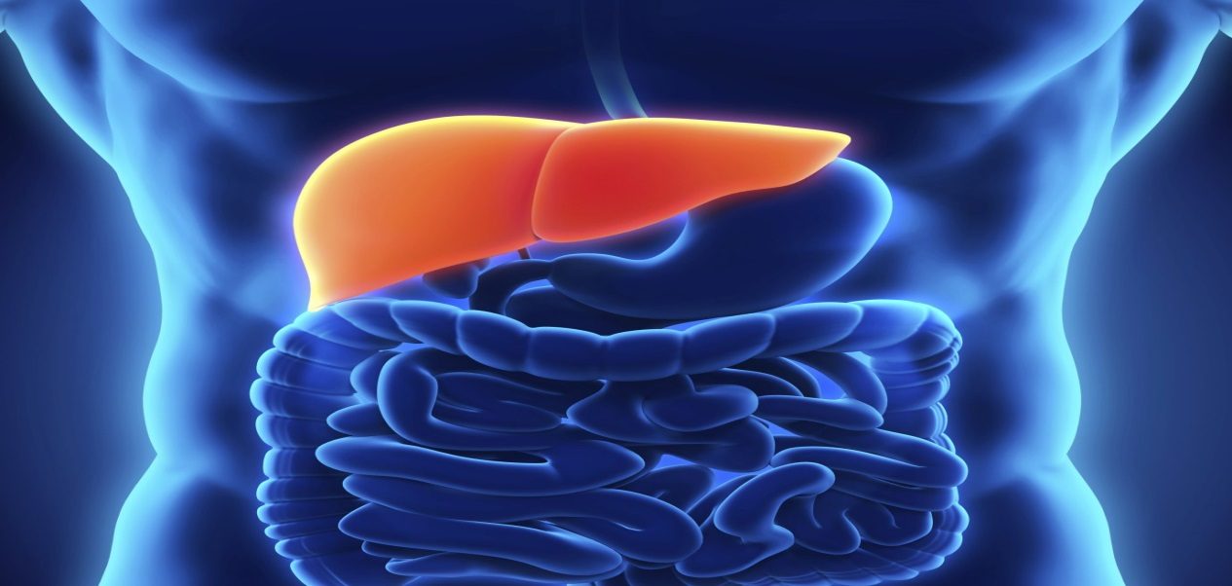

Conference Secretariat:
28 Maxwell Road, #03-05 Red Dot Traffic Singapore (069120)
Ph: +65 3158 1626, Fax: +1-650-618-1414, Toll free: +1-800-216-6499
Email: gastroenterology@insightsummits.com
Website: https://www.meetingsint.com/conferences/gastro

4th International Conference on Gastroenterology and Hepatology
February 19-20, 2020
Program at a Glance
Day 1
Morning Sessions | Reception/Registration | 08.00-09.00 |  |  |  |  | 19 Speakers for Day 1
Morning Sessions |  | Time |  | General Session |  |  | 19 Speakers for Day 1
Morning Sessions |  | 09.00-09.15 |  | Inaugural Address |  |  | 19 Speakers for Day 1
Morning Sessions | Least of 3 Keynote/Plenary Talks | 09.15-09.45 |  | Keynote/Plenary Talk 1 (Slot Available) |  |  | 19 Speakers for Day 1
Morning Sessions | Least of 3 Keynote/Plenary Talks | 09.45-10.15 |  | Keynote/Plenary Talk 2 (Slot Available) |  |  | 19 Speakers for Day 1
Morning Sessions | Least of 3 Keynote/Plenary Talks | 10.15-10.45 |  | Keynote/Plenary Talk 3 (Slot Available) |  |  | 19 Speakers for Day 1
Morning Sessions | Panel Discussions/Group Photo |  |  |  |  |  | 19 Speakers for Day 1
Morning Sessions | Coffee/Tea Break 10.45-11.00 (Networking) |  |  |  |  |  | 19 Speakers for Day 1
Morning Sessions | 11.00-12.40 |  |  | 5 Speakers (20 Mins Each) (Slot Available) |  |  | 19 Speakers for Day 1
 | Lunch Break 12.40-13.30 |  |  |  |  |  | 19 Speakers for Day 1
 | 13.30-15.30 |  |  | 6 Speakers (20 Mins Each) (Slot Available) |  |  | 19 Speakers for Day 1
 | Coffee/Tea Break 15.30-15.45 (Networking) |  |  |  |  |  | 19 Speakers for Day 1
 | 15.45-17.25 |  |  | 5 Speakers (20 Mins Each) (Slot Available) |  |  | 19 Speakers for Day 1
Day 2
Morning Sessions |  | Time | Session 1 |  | Session 2 |  | 40 Speakers on Day 2
Morning Sessions | 09.00-10.40 |  | Keynote Speakers (Slot Available) |  | Keynote Speakers (Slot Available) |  | 40 Speakers on Day 2
Morning Sessions | Coffee/Tea Break 10.40-10.55 (Networking) |  |  |  |  |  | 40 Speakers on Day 2
Morning Sessions | 10.55-12.35 |  | 5 Speakers (Slot Available) |  |  | 5 Speakers (Slot Available) | 40 Speakers on Day 2
Evening Sessions | Lunch Break 12.35-13.25 |  |  |  |  |  | 40 Speakers on Day 2
Evening Sessions | 13.25-15.05 |  | 5 Speakers (Slot Available)) |  |  | 5 Speakers (Slot Available) | 40 Speakers on Day 2
Evening Sessions | Poster Sessions |  |  |  |  |  | 40 Speakers on Day 2
Evening Sessions | Coffee/Tea Break 15.05-15.20 (Networking) |  |  |  |  |  | 40 Speakers on Day 2
Evening Sessions | 15.20-17.00 |  | 5 Speakers (Slot Available) |  |  | 5 Speakers (Slot Available) | 40 Speakers on Day 2
Evening Sessions | Awards & Closing Ceremony
NOTE: Program Schedule is subject to change with final allotment of the speaker slots
For more Details PS: https://www.meetingsint.com/conferences/gastro
gastroenterology@insightsummits.com

Final Program will be update before 45 days of the event

Tourist Attractions @ Dubai
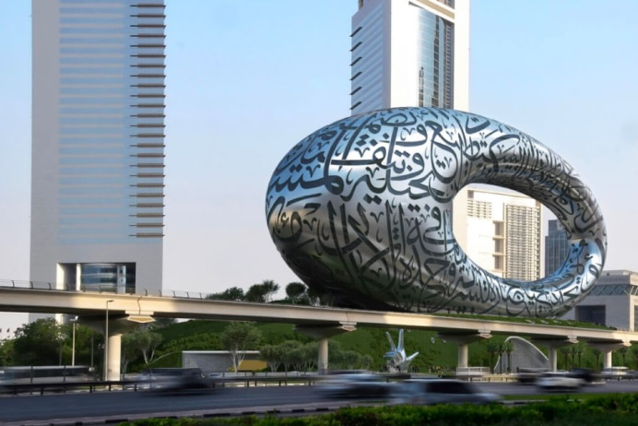

Dubai Museum
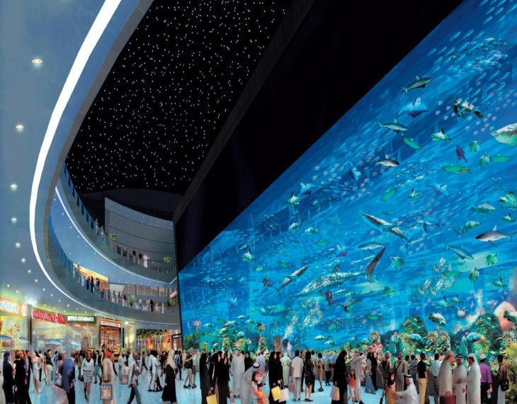
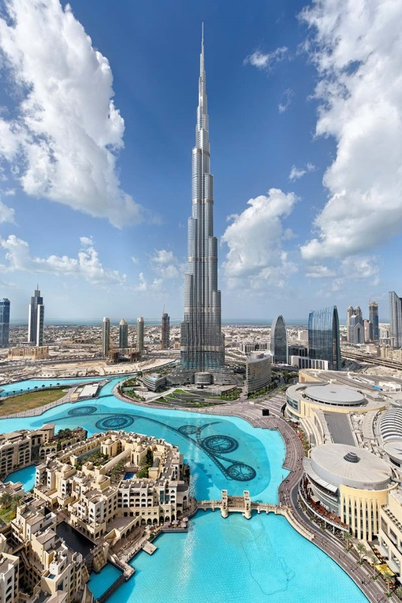

Dubai Mall
Burj Khalifa
Dubai Mall

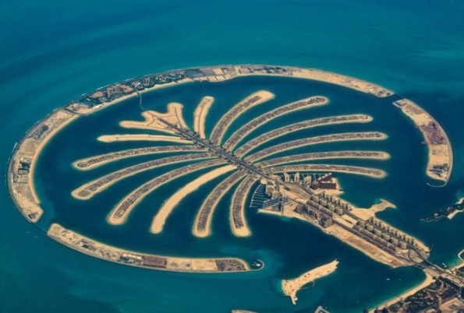
Palm Jumeriah

