MEETINGS INTERNATIONAL
Company Registration No: 201524282R
28 Maxwell Road, #03-05 Red Dot Traffic
Singapore (069120)
Phone /WhatsApp: +44-1352-300003

Paris, france

February 23-24 | 2022

International Conference on Clinical Research



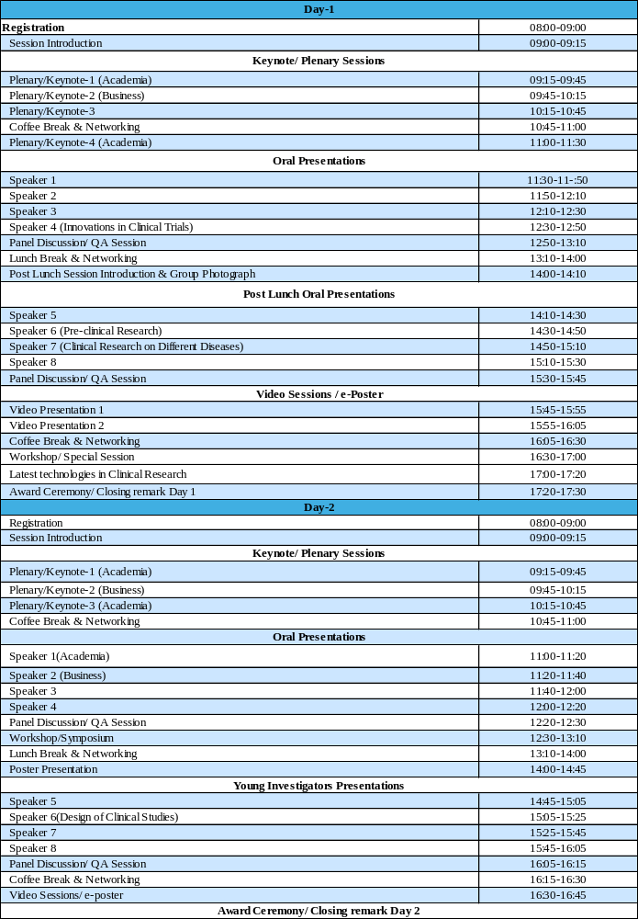

CITY ATTRACTION

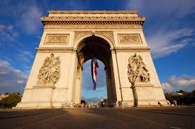
1. Archide de triomphe



2. Eiffel tower
3. Louvre museum

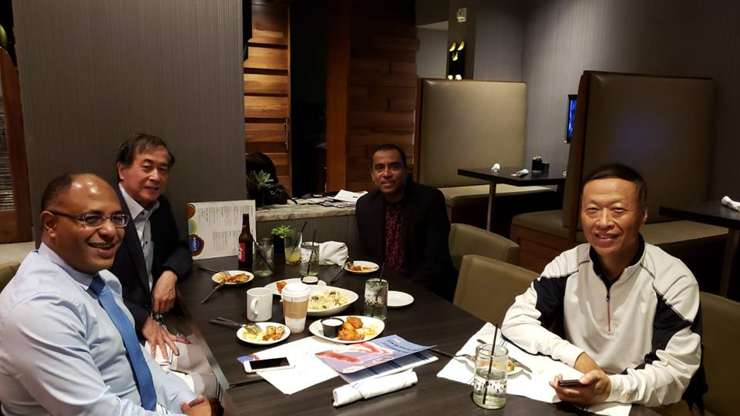
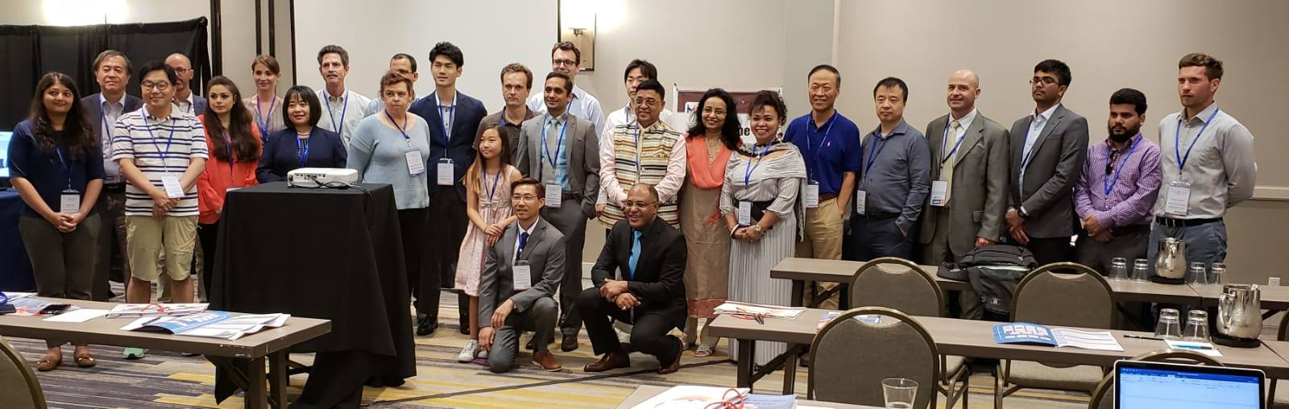
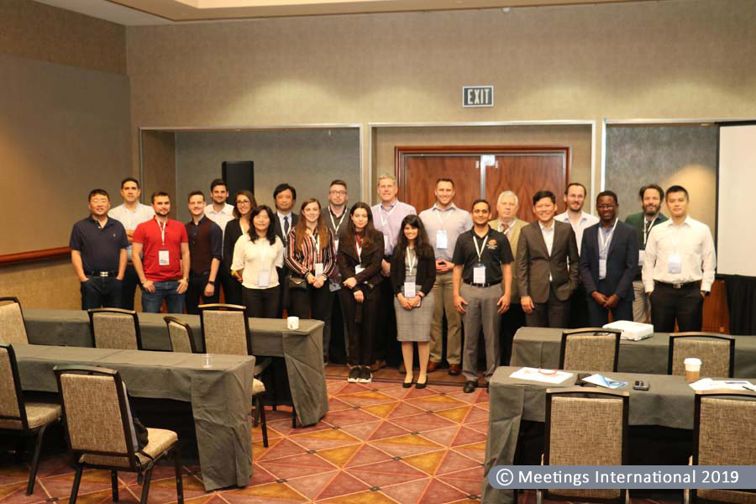
Glimpses OF Clinical Research@ Paris
