Abstract Template

Title: Identification of new alleles in salinity tolerant rice local cultivars through phenotypic and genotypic screening

Authors and Co-authors- XXXX L1, XXXXX ES1, XXXX ALD1, 2,

1Department of Crop Improvement, International Rice Research Institute, Manila, Philippines
2Department of Genetics and plant Breeding, National Rice Research institute, Osaka, Japan

- Abstract Body (up to 250 words)
The present study investigated eight rice lines (Rupsal, Nagalmutha, Polai, Ravana, Marishal, Talmugra, Kamini and Raspanjar) collected from coastal region of eastern India for salinity tolerance through phenotypic and genotypic screening. Among these, three rice lines as highly tolerant (Talmugra, Marishal and Kamini), three tolerant (Rupsal, Polai and Raspanjar) and two moderately tolerant (Ravana and Nagalmutha) to salt stress were identified in phenotypic screening. Pokkali was categorized as tolerant under salinity condition (12 EC dS m-1). In PCR screening using microsatellite (SSR) markers located within Saltol locus, we documented new allelic pattern in selected highly tolerant and tolerant genotypes with RM8094 marker as compared to Pokkali. Besides, another marker RM10694 was found to associate with selection of salinity tolerant genotypes similar to Pokkali. In gene expression studies, no significant difference linked with abscisic acid (ABA), calciumdependent proteins kinase (CDPK), ionic and osmotic signaling pathways in salinity tolerant genotypes was found as compared to sensitive line (IR29). Induction of AP37 gene expression differentiated Kamini and Marishal genotypes from other tolerant and sensitive lines.

Image:
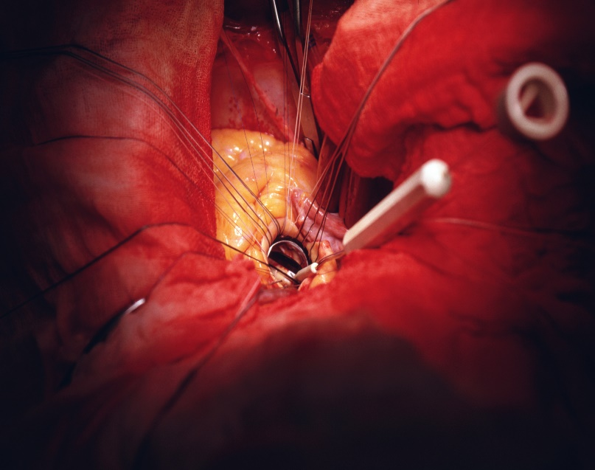

- Reference:

1. Tester, M. and R. Davenport, 2003. Na+ tolerance and Na+ transport in higher plants. Ann. Bot., 91; 503–527

- Thomson, M.J., M. de Ocampo, J. Egdane, M.A. Rahman, A.G. Sajise, D.L. Adorada, R.K. Singh, G.B. Gregorio and A.M. Ismail, 2010. Characterizing the saltol quantitative trait locus for salinity tolerance in rice. Rice, 3: 148–160

- Senguttuvel, P., M. Raveendran, C. Vijayalakshmi, K. Thiyagarajan, J.R.K. Bapu and B.C. Viraktamath, 2010. Molecular mechanism of salt tolerance for genetic diversity analysed in association with Na+/K+ ratio through SSR markers in rice (Oryza sativa L.). Int. J. Agric. Res., 5: 708–719

Biography:
XXXX has completed his PhD at the age of 25 years from XXXX University and Postdoctoral Studies from School of Medicine, XXXX University, Singapore. He is the Director of XXXX, a premier Bio-Soft service organization. He has published more than 25 papers in reputed journals and has been serving as an editorial board member of repute. (Up to 100 words)

Presenting author details

Full Name:
Contact number:
Twitter account:
LinkedIn account:
Session name/ number:
Category: (Oral presentation/ Poster presentation)

Copyright © 2016-2018
Meetings Int PTE Ltd, All Rights Reserved.
Meetings International Pte Ltd

Company Registration No: 201524282R,28 MAXWELL ROAD, #03-05 RED DOT TRAFFIC, SINGAPORE (069120)
Tel: +6531080483 | Toll Free no. +800-852-6126
Web: https://www.meetingsint.com/conferences/cardiologist | E-mail: cardiologist@annualmeetings.net

