5th International Conference on
Nursing Healthcare Minl
[Course title]
[Date]

Cancer Therapy
5th International Conference on
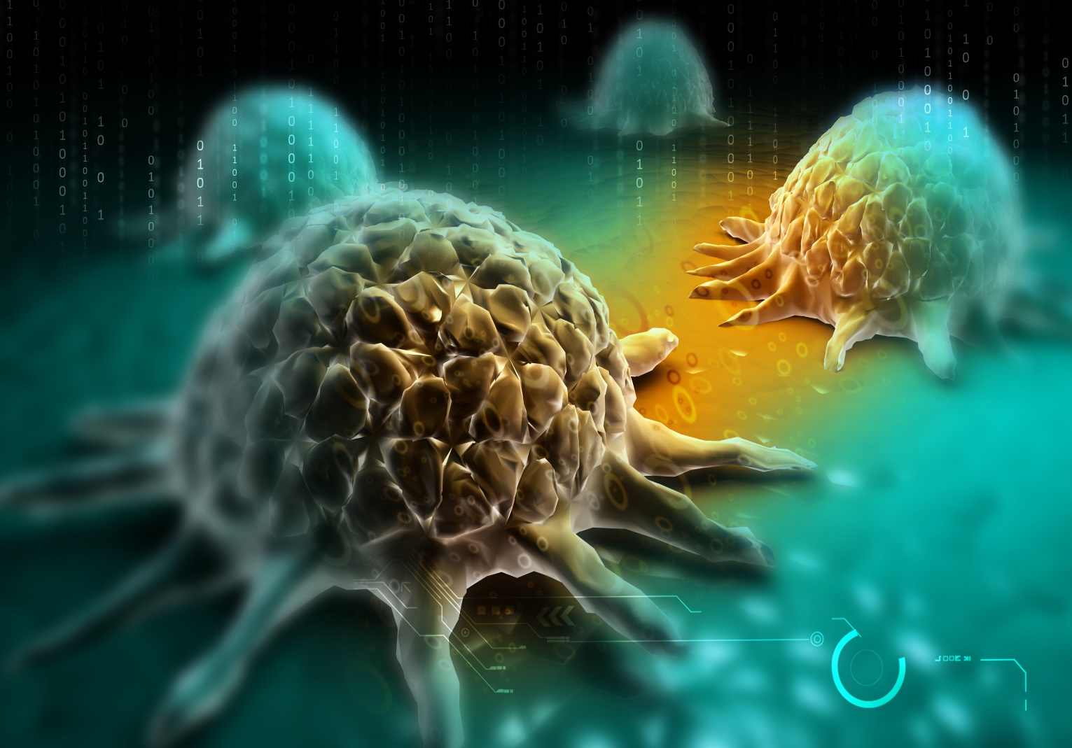
Toronto, Canada |August 25-26, 2019
MEETINGS INTERNATIONAL
28 Maxwell road, #03-05 red dot traffic
Singapore (069120)
Email: cancer@insightsummits.com
www.meetingsint.com/conferences/cancertherapy
Contact us: +65 3158 1626
WhatsApp: +65 9372 8964

Tentative Scientific Program

Day 1 August 25, 2019
Conference Hall
09:00 - 9:30 | Registration
9:30-10:00 | Opening ceremony
Keynote Session
10:00-10:35 | Title: The decline of the prevalence of cancers during organism senescence
10:00-10:35 | Alvaro Macieira-Coelho, French national institute of health, France
10:00-10:35 | Alvaro Macieira-Coelho is a Research Director at the French National Institute of Health. He received an MD from the University of Lisbon, Portugal, and a phd from the University of Uppsala Sweden. He made an internship at the University Hospital in Lisbon and was a research associate at the Wistar Institute in Philadelphia (USA) and at the Department of Cell Biology of the University of Uppsala (Sweden).
10:35-11:10 | Title: Gene fusion resulting from chromosome recombination causes human cancers
10:35-11:10 | Jianhua Luo, University of Pittsburgh, United States
10:35-11:10 | Jianhua Luo has been studying molecular mechanisms of human malignancies in the last 32 years. Currently, he is a Professor of Pathology and Director of High Throughput Genome Center at University of Pittsburgh. In the last 20 years, Dr. Luo has been largely focusing on the genetic and molecular mechanism of human prostate and hepatocellular carcinomas
Group Photo 11:10-11:20
Networking & Refreshment Break 11:20-11:40
Workshop
11:40:12-40 | Title: Effects of far-infrared & terahertz Onnetsu therapy on various cancers, rheumatoid arthritis and other diseases
11:40:12-40 | Kazuko Tatsumura, Gaia Holistic Health, USA
11:40:12-40 | Kazuko Tatsumura studied Oriental Traditional Medicine of Japan, Korea, Taiwan and China. In 2000 she received her PHD and OMD from the International Academy of Education in Tokyo. She established the Oki-Do Holistic Health Center in 1994 in NY and in 2001 the GAIA Holistic Center (501C3 non-profit organization) at the wake of 9/11 tragedy, for body mind and spirit, aiming for the noninvasive natural healing methods based on the wisdom of the East.
Lunch Break 12:40:13:40
Oral Session
13:40-14:00 | Title: Miracles of comprehensive non-pharmacological approaches: An optimized cancer treatment for children
13:40-14:00 | Samira Ali Kreidie, Clinical Pharmacist, UAE
13:40-14:00 | Samira has completed her MPHARM (Clinical Pharmacy) at the age of 27 years from Dubai Medical University and she is a consultant in Psychology and sociology from Global Academy of Human mind development, UK, London.
14:00-14:20 | Title: Effect of alpha 1 antitrypsin combined polyunsaturated fatty acid on interleukin 1β and peroxisome proliferator –activated receptor γ in breast cancer cells
14:00-14:20 | Preethika A, K S Hegde Medical College, India
14:00-14:20 | Preethika A completed Medical MSc in biochemistry from Kasturba Medical College, Manipal University and currently working as a research scholar at K S Hegde Medical Academy NITTE Deemed to be University. Published five papers in reputed journal.
14:20-14:40 | Title: New bioactives for cure non-small cell lung carcinoma
14:20-14:40 | Ali Aameri Siahooei, Hormozgan University of Medical Sciences, Iran
14:20-14:40 | Ali Aameri Siahooei, Pharmacy student , Researcher about drug design for cancer cells by system biology softwares and methods, Faculty of Pharmacy and Pharmaceutical Sciences, Hormozgan University of Medical Sciences
14:40-15:00 | Title: In vitro photothermal destruction of cancer cells using gold nanoparticles
14:40-15:00 | Mehrnaz Mostafavi, Shahid Beheshti University of Medical Sciences, Iran
Networking & Refreshment Break 15:00-15:20
15:00-15:20 | Speaker 5
15:20-15:40 | Speaker 6
15:40-16:00 | Speaker 7
Day 2 August 26, 2019
9:30-9:40 | Introduction
Keynote Session
9:40:10:15 | Keynote 1
10:15-10:50 | Keynote 2
10:50-11:25 | Keynote 3
Networking & Refreshment Break 11:25-11:40
Kazuko Tatsumura, | Kazuko Tatsumura,
Lunch Break 12:40-13:40
13:40-14:05 | Speaker 1
14:05-14:30 | Speaker 2
14:30-14:55 | Speaker 3
14:55-15:20 | Speaker 4
Oral Session II
**Speakers slots are available
Video Session and poster presentation
Networking & Refreshment Break 17:30-18:00
Conference Adjournment
City Attractions (Toronto, Canada)

