







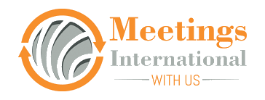

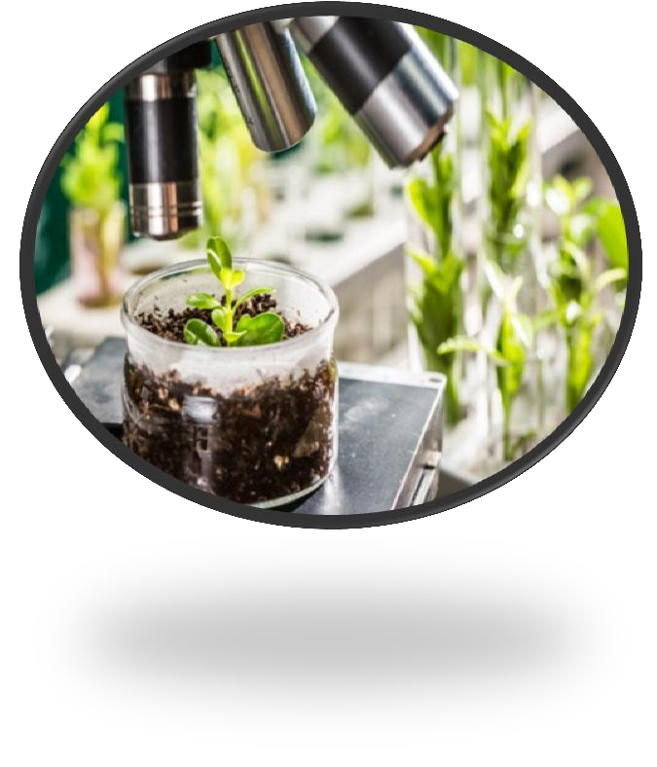
Stem Cell Research-2021

International Conference on
Business Management
September 19,20-2022| Brussels, Belgium





https://www.meetingsint.com/conferences/businessmanagement

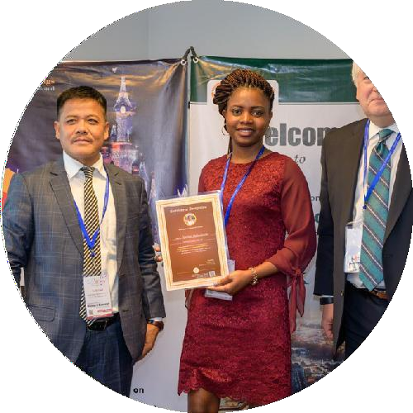
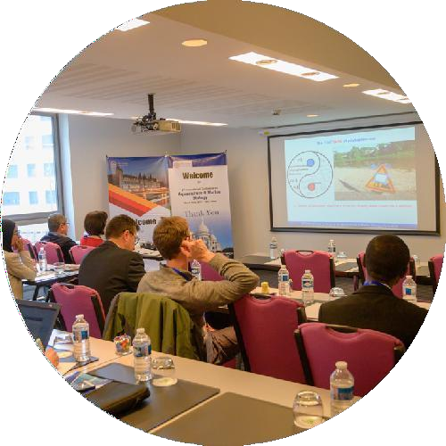
Invitation
Dear Attendees,

Meetings International proudly announces the International Conference on Business Management scheduled during September 19, 20- 2022 in Brussels, Belgium.

The conference emphasizes the theme
“RECENT INNOVATION ON BUSINESS MANAGEMENT”
Business Management Conference appearance forwards to hospitable all the participants across the planet to attend the “International Conference on Business Management” during September 19-20 in Brussels, Belgium which includes the theme “Recent Innovations in Business and Management”. Whether you are looking to put a spotlight on your research and present it to an international community of peers or would like to catch up on the latest trends in the field, we encourage you to start planning your trip. This is a unique opportunity to have your paper published in prestigious indexed journals as well as to get inspiration for your next research project. Our attendees come from countries such as the United States, Mexico, Argentina, France, Czech Republic, Malaysia, Indonesia, Australia, Iran, Nigeria, and dozens of others.
Sincerely,
Operating Committee
Business Mangement-2022



Conference Highlights

- Business Management
- Business Law
- Corporation Communication
- Business Leadership
- Business Model
- Advertising Management
- Arts Administration
- Critical Management
- Food Management
- Environment Management
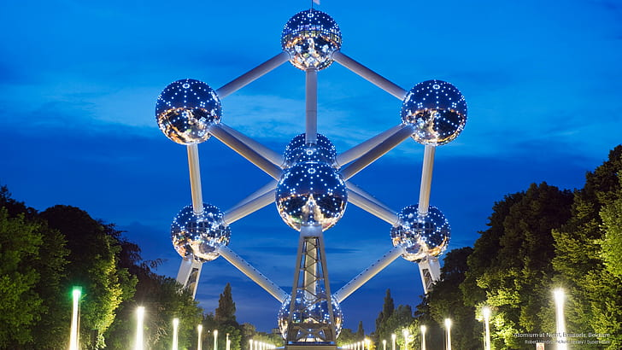

Brussels Attractions
Business Management-2022

https://www.meetingsint.com/conferences/businessmanagement
Explore Brussels

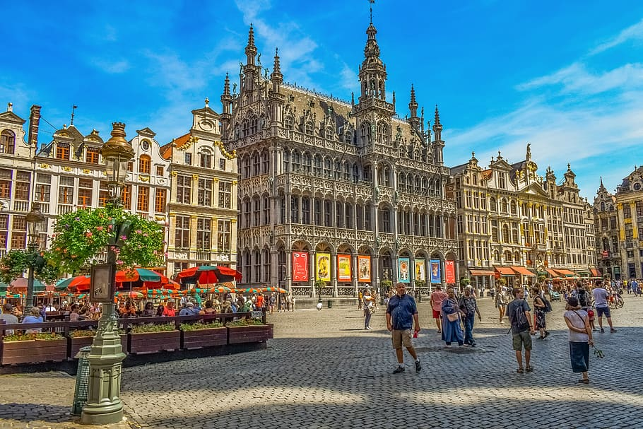

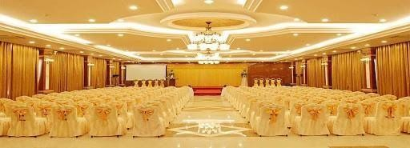
Business Magement -2022

Venue,
Brussels, Belgium

Important Dates
Early Bird: June 22, 2022
Abstract Submission Deadline: June 22, 2022

Useful Links
Home Page
https://www.meetingsint.com/conferences/businessmanagement

Registration
https://www.meetingsint.com/conferences/businessmanagement/registration

Abstract Submission

https://www.meetingsint.com/conferences/businessmanagement/abstract-submission

Meetings International
28 Maxwell Road, #03-05 Red Dot Traffic, Singapore (069120), Phone: +441686948004, What Sapp: +441686948004
www.meetingsint.com e: contact@meetingsint.com

https://www.meetingsint.com/conferences/businessmanagement

