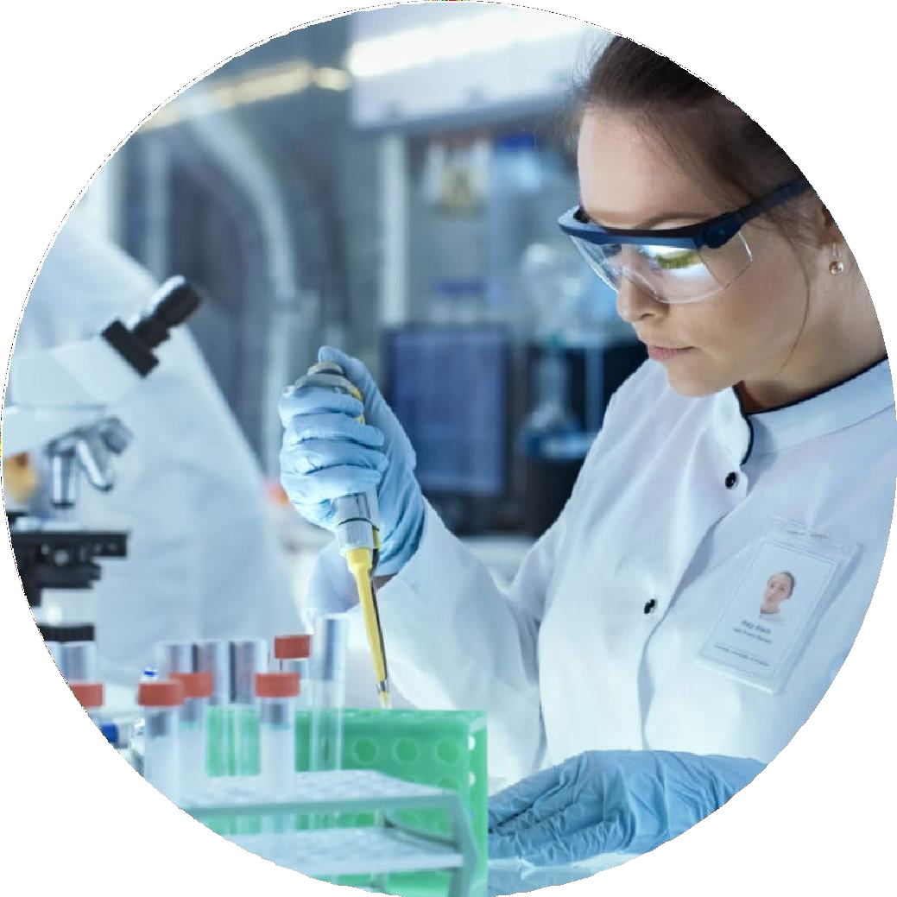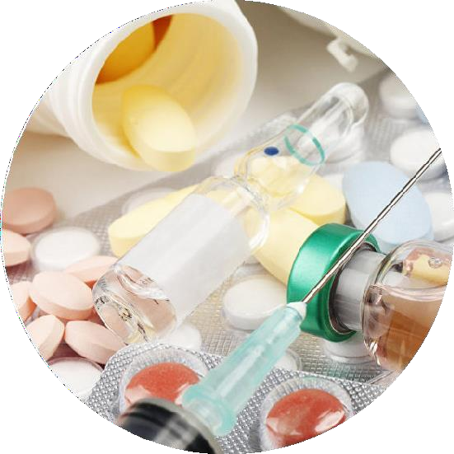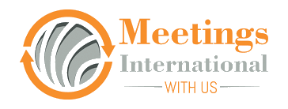
BABE-2021

Be a part of
Annual Summit On Bioavailability and Bioequivalence
July 20-21, 2022 | Tokyo, Japan

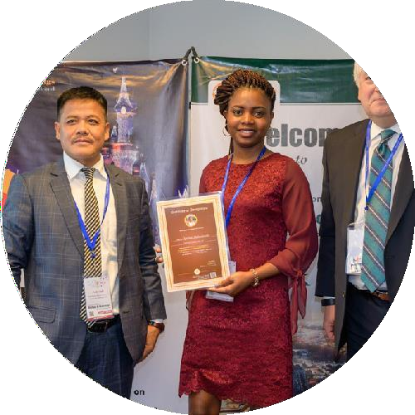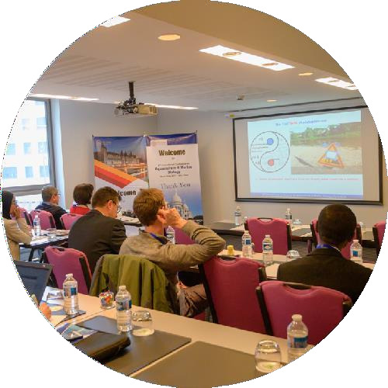Invitation
Dear Attendees,
Meetings International proudly announces the Annual Summit on Bioavailability and Bioequivalence scheduled during July 20-21, 2022 in Tokyo, Japan.
The conference emphasizes the theme “BABE: Outspreading latest Innovation in Public and Medical Health”.
The BA-BE 2022 gathering gives a mind- blowing opportunity to discuss the latest progressions inside the field. This conference brings together the innovations in microfluidics and brings the key opinion leaders and thought leaders in the field from around the world for two intensive days of scientific presentations, networking as well as engagement with companies developing innovations in tools and technologies in this space. The purpose of BABE-2022 is to provide an international technical forum to showcase recent advances in Drug design & Development. BA-BE 2022 conference operation committee is providing a platform for all the budding young researchers, young investigators to showcase their research and innovation.
Sincerely, Operating Committee
BA-BE 2022

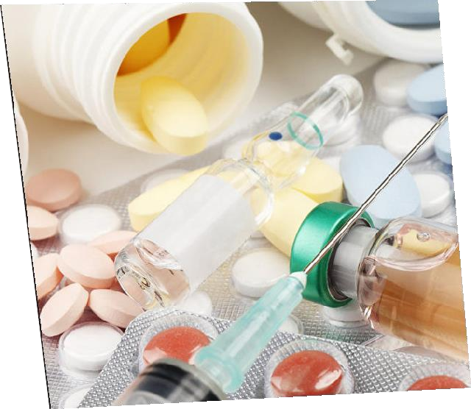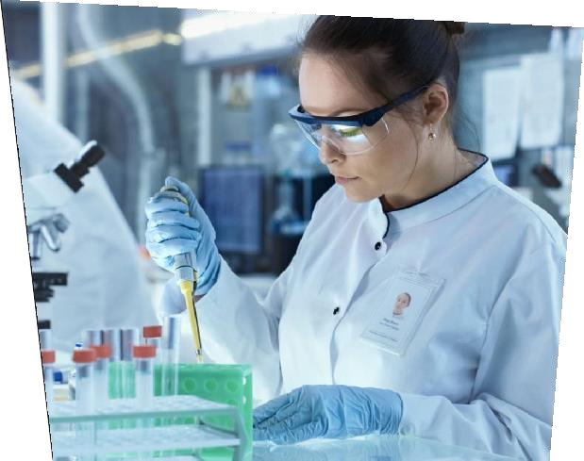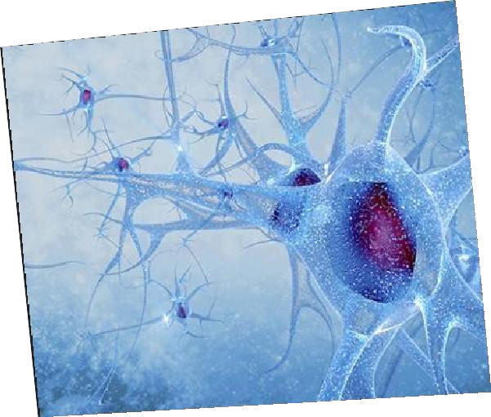Conference Highlights
- Drug metabolism
- Absolute & Relative bio- availability
- First pass metabolism
- Pharmaceutical equiva- lents
- Drug Design and evolution
- Factors affecting Bio- availabity of drug
- Pharmacokinetic & phar- macodynamics
- In vitro and In vivo studies
- Applied Bio pharmaceutics

- FDA in bioequivalence


  - To identify the future directions of research
  - Peer review and high quality publi- cation
  - Quality research

Japan Attractions
BABE-2021


Explore Tokyo City

Tokyo, Japan’s busy capital mixes the ultramodern

and the traditional, from neon-lit skyscrapers to historic temples. The opulent Meiji Shinto Shrine is known for its towering gate and surrounding woods. The Imperial Palace sits amid large public gardens. The city's many museums offer exhibits ranging from classical art (in the Tokyo National Museum) to a reconstructed kabuki theatre.


BA-BE 2022

VeNUe
Tokyo, Japan

Important Dates
Early Bird: December 30, 2021
Abstract Submission Deadline: March 22, 2022

Useful Links
Home Page
https://www.meetingsint.com/conferences/bioavailability-bioequivalence
Registration
https://www.meetingsint.com/conferences/bioavailability-bioequivalence/registration
Abstract Submission
https://www.meetingsint.com/conferences/bioavailability-bioequivalence/abstract-submission

Meetings International
28 Maxwell Road, #03-05 Red Dot Traffic, Singapore (069120),
Phone: +447480725689, Whatsapp: + 447480725689
www.meetingsint.com e: contact@meetingsint.com

