Abstract Template

Title: Neuroscience, Therapeutics and Neuropsychological Assessment

Dr. BAJRANGI YADAV¹
¹ Assistant Professor of PSYCHOLOGY, Department of PSYCHOLOGY, Kamla Nehru Institute (KNI), Sultanpur, U.P.-INDIA.

Keywords: Neuroscience, Therapeutics and Neuropsychology, Psychotherapy.

- Abstract Body (up to 250 words)
The present study investigated the therapeutic relationship evolves out of what both client and therapist bring to the therapeutic situation. The outcome of psychotherapy normally depends on whether the client and therapist on successful in achieving a productive working alliance. The client’s major contribution is his or here motivation. Client who are pessimistic about there chances of recovering or who are ambivalent about dealing with their problems and symptoms respond less well to treatment.
Measuring Success in Psychotherapy- Evaluating treatment success is not always as easy as it might seem. Attempts at estimating clients’ gain a therapy generally depend on one or more of the following sources of information’s:-
- A therapist’s impression of changes that occurred.
- A client’s reports of change.
- Reports from the client’s family or friends.
- Comparison of pre-treatment and post-treatment scores on personality.
- Measure of change in selected over behaviours.
- Unfortunate, each of these sources has own limitations.
The Neuropsychological Assessment:- Neuropsychological assessment is the process of gathering information about the client’s brain functioning on the basis of performance on psychological tests. Clinicians use neuropsychological assessment measures to attempt to determine the functional correlates of brain damage by comparing a client’s performance on a particular test with normative data from individual who are known to have certain types of injuries or disorders. there is no one set procedure for conducting a neuropsychological assessment.
The techniques described so far have shown success in identifying brain abnormalities that are very often accompanied by gross impairments in behaviour and varied psychological deficits. However, behavioural and psychological impairments due to organic brain abnormalities may be come manifest before any organic brain lesion is detectable by scanning or other means. In these instances, reliable techniques are needed to measure any alteration in behavioural or psychological functioning that has occurred because of the organic brain pathology. this need is met by a growing cadre of psychological specializing in neuropsychological assessment, which involves the use of various testing devices to measure a person’s cognitive, perceptual and motor performance as clues to the extent and location of brain damage.

- Image:

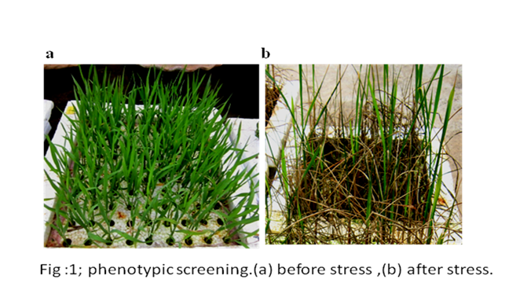

- Reference:
- Sunderland, T; Hill, J.L.; Mellow, A.M.; Lawlor, B.A.; Gundersheimer, J. (1989). Journal of the American Geriatrics SoCiety, 37 (8), 725-729.
- Rabin, L.A.; Barr, W.B. & Burton, L.A. (2005). Assessment practice of cilinical neuropsychologists in the Unitd Sate and Canada. 20 (1), 33-65.
- Nugahama, y.; Okina, T.; Suzuki, N.; Nabatame, H.; & Matsuda, M. (2005). Journal of Neurology, Neurisergery, 76 (20, 169-175.
- Biography:

Dr. BAJRANGI YADAV has completed his PhD at the age of 31 years from Dr. Ram Mnohar Lohiya Avadh University, Ayodhya (U.P.)-India. He has published more than 28 papers in reputed journals and 18 National and International attended conference has been serving as an editorial board member of repute. (Up to 100 words)

- Presenting author details


Full Name: Dr. BAJRANGI YADAV
Contact number: 9559037318
Twitter account: Bajrangi Yadav
Linked In account:
Session name/ number: Neuroscience
Category: Oral presentation
Passport Number: N6410188

