Tentative Program
Meetings

International

https://www.meetingsint.com/conferences/3dprinting
Theme: 3D printing: The manufacturing technology that will change the world

3rd International Conference on
3D Printing and Additive Manufacturing

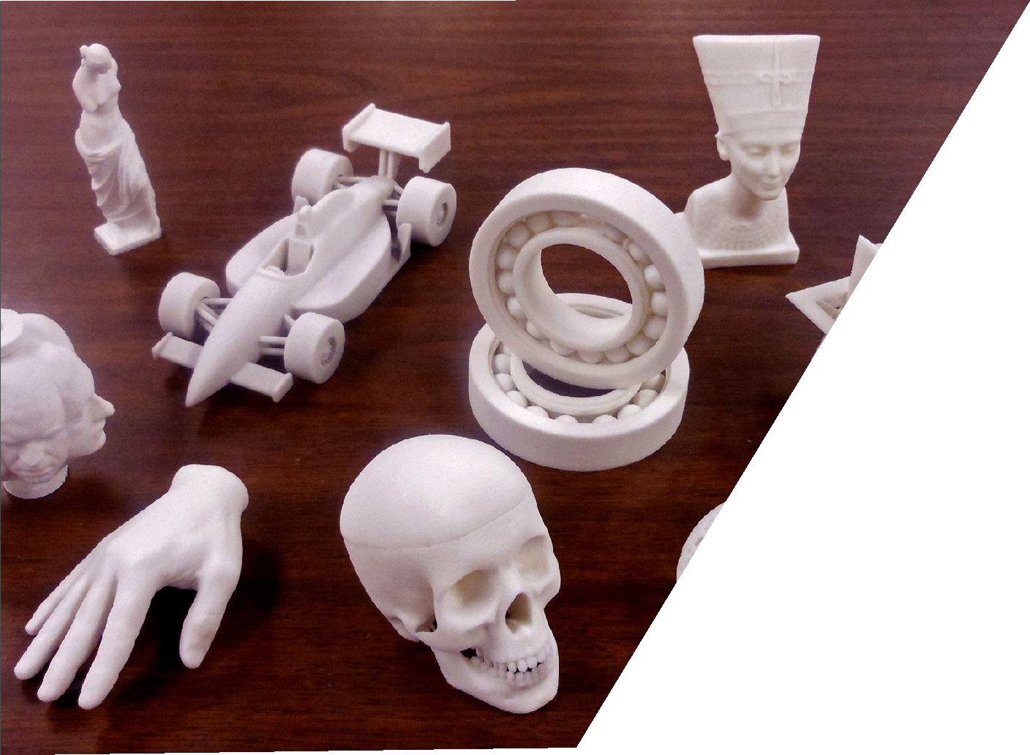
May 22-23, 2020
Paris, France

Dear Colleagues
Meetings International extends its welcome to “3rd International Conference on 3D Printing and Additive Manufacturing” scheduled on May 22-23, 2020 in Paris, France, with the theme of “3D printing: The manufacturing technology that will change the world”.
3D Printing and Additive Manufacturing 2020 will serve an excellent experience and opportunities to enhance one’s career. Join us in Paris. It is comprised of 12 tracks designed to offer comprehensive sessions that address current trends in 3D Printing, and many more. 3D Printing and Additive Manufacturing 2020 composed of symposiums by world class researchers and experts.

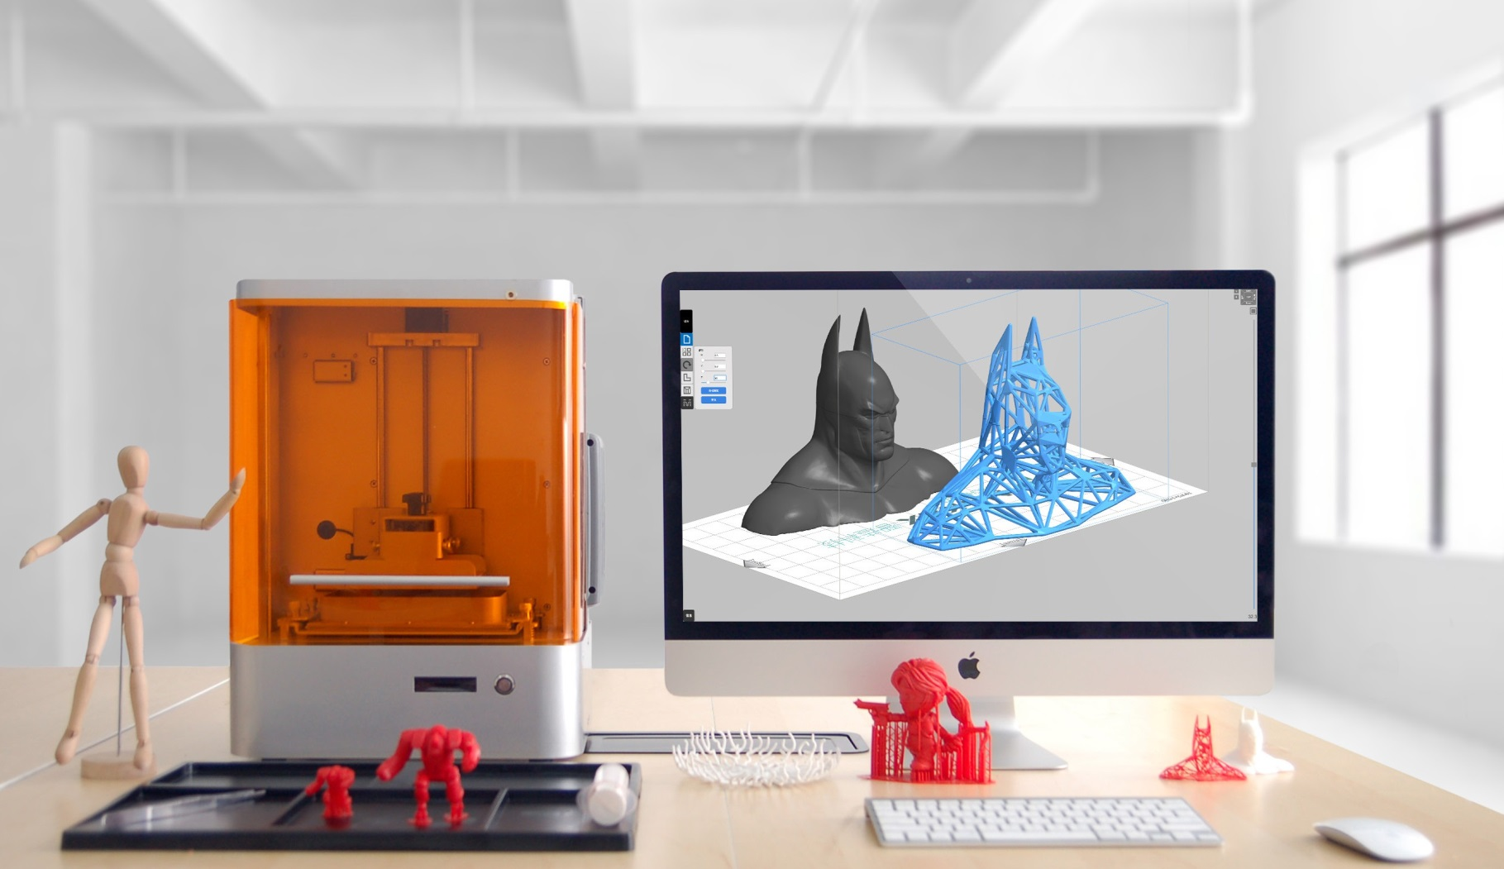
Conference Highlights:
https://www.meetingsint.com/conferences/3dprinting
- Advances in 3D Printing & Additive Manufacturing Technology
- Innovations in 3D Printing

- 3D Printing Materials

- 3D Printing Technology Impact on Manufacturing Industry
- Applications of 3D Printing in Health Care & Medicine

- 3D printing in Biomaterials

- Polymers in 3D Printing

- Space and Aerospace 3D Printing

- 3D Printing in Automotive Industry

- Additive Manufacturing and 3D Robotics

- Digital Light Processing (DLP) 3D printing

- Layered Manufacturing and Additive Fabrication

Submit Your Abstract and Register Soon to book your slot. As only few slots are available.
Day 1: May 22, 2020
Conference Hall
08:30 -09:00 | Registration
09:00-09:15 | Opening ceremony
Keynote Session
9:15-10:00 | Title: 5D printing of Nano-laden fibre aerogel
9:15-10:00 | Ruben Foresti, University of Parma, Italy
10:00-10:45 | Title: Design for AM – the key to the industrialization of additive manufacturing
10:00-10:45 | Olaf Diegel, University of Auckland, Newzealand
Group Photo 10:45-10:50
Networking & Refreshment Break 10:50-11:05
Oral Sessions I | Innovations in 3D printing | 3D printing materials | 3D printing in biomaterials | Polymers in 3d printing | 3D printing in space and aerospace | 3D printing in automotive industry
11:05-11:30 | Title: Damage modelling, detection and identification in composite structures
11:05-11:30 | Dimitrios Chronopoulos, Associate Professor, University of Nottingham, UK
11:30-11:55 | Title: Sustinable 3D Printing In Manufacturing and Construction
11:30-11:55 | Tan Ming Jen, Nanyang Technological University, Singapore
Speaker Slots Available (11:55-13:00)
Lunch Break 13:00-14:00
14:00-14:25 | Title: XXL 3D Printing
14:00-14:25 | Benoit Furet, University of Nantes, France
Workshop
14:25-14:55 | Title: Additive Manufacturing, Processes and ASTM/ISO Standards
14:25-14:55 | Fabio Sant'Ana, Dynamach Máquinas e Equipamentos, Brazil
Networking & Refreshment Break 14:55-15:25
Oral Sessions II | Innovations in 3D printing | 3D printing materials | 3D printing in biomaterials | Polymers in 3d printing | 3D printing in space and aerospace | 3D printing in automotive industry
15:25-15:55 | Title: 3D printed Spare Parts: from good idea to reality in the field
15:25-15:55 | Paul Guillaumot, CEO, Spare Parts 3D, France
15:55-16:25 | Title: Biomimetic 3D bioprinting of cellular laden nanocomposite scaffold through co-axial and core-co-cultured structure
 | Fahimeh Shahabipour, National Cell Bank of Iran,Pasteur Institute of Iran, Tehran, Iran
Speaker Slots Available (16:25-17:10)
Poster Presenation (17:10-18:10)
 | A FEW SLOTS ARE AVAILABLE FOR PRESENTATION AND WORKSHOP
Poster I | Title:Additive manufacturing applied in parallel architecture machine
Poster I | David Sebastian Matamoros, National university of Colombia, Colombia

Day 2: May 23, 2020
Conference Hall
09:00-09:15 | Opening ceremony
Keynote Session
9:15-10:00 | Title: Cellular Structures Design and Optimization for Additive Manufacturing: A Review
9:15-10:00 | Aamer Nazir, National Taiwan University, Taiwan
Group Photo 10:45-10:50
Networking & Refreshment Break 10:50-11:05
Oral Sessions I | Innovations in 3D printing | 3D printing materials | 3D printing in biomaterials | Polymers in 3d printing | 3D printing in space and aerospace | 3D printing in automotive industry
11:05-11:30 | Title: Process control, optimization and parameter characterization of mild steel single and multi-layer deposits using Wire + Arc Additive Manufacturing
11:05-11:30 | Harley Stinson, Ulster University Magee Campus, Northern Ireland
11:30-11:55 | Title: Experimental Experimental study of powder layer coatings using Structured Light Sensing in Selective Laser Melting Printer Additive Manufacturing
11:30-11:55 | Niall O'Dowd, University of California San Diego, USA
Speaker Slots Available (11:55-13:00)
Lunch Break 13:00-14:00
14:00-14:25 | Title: An investigation into the effect of a recycling regime upon ELI Ti6Al4V (Grade 23) powder used within the selective laser melting (SLM) process
14:00-14:25 | Ryan Harkin, Ulster University, UK
Workshop
14:25-14:55 | Title: Wire Arc Additive Manufacturing - Current developments and industrial applications
14:25-14:55 | Tobias Rohrich, GEFERTEC GmbH, Germany
Networking & Refreshment Break 14:55-15:25
Oral Sessions II | Innovations in 3D printing | 3D printing materials | 3D printing in biomaterials | Polymers in 3d printing | 3D printing in space and aerospace | 3D printing in automotive industry
15:25-15:55 | Title: Changing Realities through 3D Printing
15:25-15:55 | Trenton Hall, LeTourneau University, USA
15:55-16:25 | Title: Poly-p-dioxanone as a new scaffold material for 3D printing in tissue engineering
 | Sebastian Loewner, Leibniz University Hannover, Germany
Speaker Slots Available
16:25 - 16:55 | Title: Free Software and Hardware Design: Tools for laboratory automation and science communication
16:25 - 16:55 | Laureana Stelmastchuk Benassi Fontolan, Physics Institute of Sao Carlos, Brazil
 | Poster Presenation (17:10-18:10)
 | A FEW SLOTS ARE AVAILABLE FOR PRESENTATION AND WORKSHOP
Poster II | Title: Selective laser sintering of three-dimensional geometries and structures of quartz glass - possibilities and limits
Poster II | Andrea Barz, Ernst-Abbe-University, Germany
Poster III | Title: Development of a process chain for the manufacturing of complex ceramic components by means of Fused Deposition Modelling
Poster III | Jens Bliedtner , Ernst Abbe University, Germany
Conference Adjournment

About Paris
The French historic, political and economic capital, with a population of only 2.5 million is located in the northern part of France. Paris is one of the most popular cities among travellers. Known as the “City of Light” or the “City of Love” the streets of Paris overflow with culture, art, beauty, and history. Whether searching out Monet’s Water Lilies at Musee de l’Orangerie, climbing the many steps of Sacre-coeur, standing before the Eiffel Tower in awe, or searching out the best crepes along the Seine, Paris is a city that captures the hearts of millions ever year. One of the most beautiful cities in the world. Home to historical monuments such as Notre Dame, the Eiffel tower (320m), Bastille, Louvre and many more. The night life is rich with the famous cabarets such as the Moulin Rouge, Lido and the Crazy Horse. Gastronomic restaurants offering cuisine of the finest are numerous and at all prices.

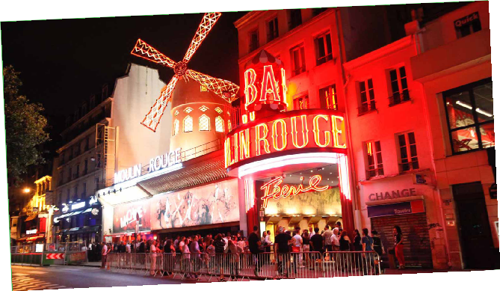
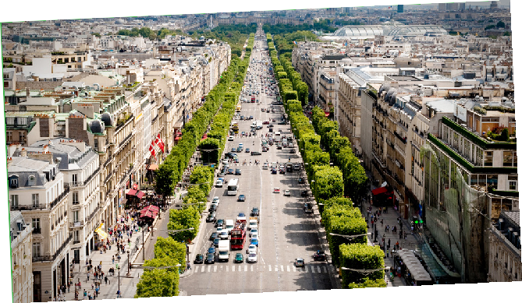
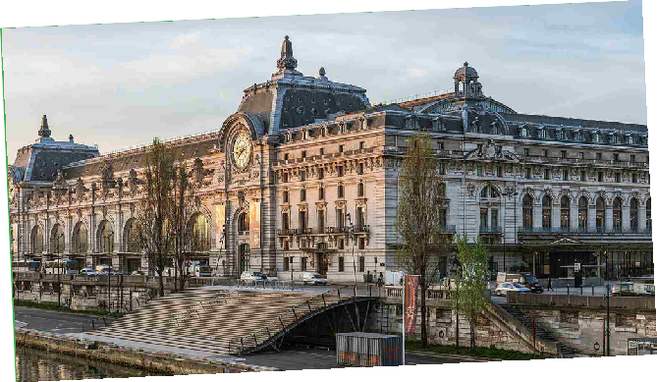
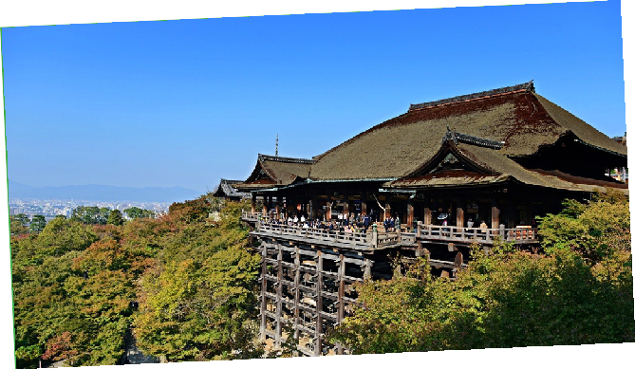
Mail us to know more!
For Abstract Submission Guidelines | For Reserving your slot | Proposals | Registration | Posters | Accommodations No doubt you have lots of queries... Why not get in touch..!
Drop us your query with details and we will call you right away

Meetings International Pte Ltd
28 Maxwell Road, #03-05 Red Dot Traffic, Singapore
Phone: +65 3158 1626

