A clinical study demonstrating a beneficial effect of radial shock waves delivered to pressure ulcers.
Robert Dymarek, MSc, PhD, Wroclaw Medical University, Poland
Izabela Kuberka, RN, PhD, Wroclaw Medical University, Poland
Mirosław Sopel, MSc, PhD, Wroclaw Medical University, Poland
Magdalena Milan, MD, PhD, Wroclaw Medical University, Poland
Joanna Rosińczuk, RN, PhD, Wroclaw Medical University, Poland
Jakub Taradaj, MSc, PhD, Katowice Academy of Physical Education, Poland

Abstract
Statement of the Problem: Recently, the initial reports indicates a promising effects of shock wave (ESW) therapy, which might be an alternative method supporting the healing process in chronic wounds. A preliminary reports indicates a potential beneficial clinical effectiveness and safety of shock wave therapy (ESWT) in venous and diabetic ulcers. The purpose of this case series study was to demonstrate the effect of ESWT administered to the pressure ulcers (PU).
Methodology & Theoretical Orientation: A three elderly female patients with PU located in the sacral region received a series of three radial ESWT sessions performed once a week (300 standard pulses + 100 pulses counted for 1 cm2 at pressure of 2.5 bars, energy flux density of 0.15 mJ/mm2 and frequency 5 Hz. Outcomes evaluation was performed using the innovative planimetric smartphone application (Swift Medical, Canada). All assessments were taken at baseline (M0), one week after the last third ESWT (M1–M3). Also, follow-up's measures were collected after 1, 2 and 4 weeks following ESWT (M4–M6).
Findings: After the study, we showed an improvement in all tested panties in the total wound surface area for all measurement time points from M0 to M6 [cm2]. Other parameters of the PU, such as length, width, depth, undermining and tunneling have been also significantly improved.
Conclusion & Significance: ESWT could be a valuable, non-invasive supporting physical method stimulating healing of PUs. This preliminary reports should be reliably verified in the course of well-designed and multicenter clinical studies with the highest methodological quality considering immunohistochemical and histopathological analyses.

Image

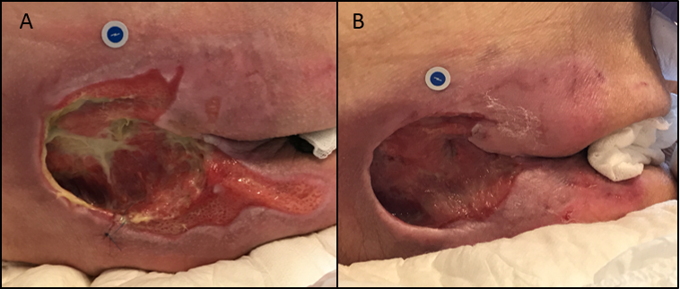
Figure: A case study of female patient with a large PU in the sacral region with III-IV grade according to the EPUAP criteria with duration of 5 months: planimetry measurement: A) M0 before ESWT (42.9 cm²) and B) M6 after three sessions of ESWT (22.1 cm²) – reduction of wound area of 48%.

Recent Publications
[1] Dymarek R. et al. Extracorporeal shock wave therapy as an adjunct wound treatment: a systematic review of the literature. Ostomy Wound Manage. 2014;60(7):26-39.
[2] Omar MT. et al. Extracorporeal shockwave therapy for the treatment of chronic wound of lower extremity: current perspective and systematic review. Int Wound J. 2017;14(6):898-908.
[3] Zhang L. et al. Extracorporeal shock wave therapy for chronic wounds: A systematic review and meta-analysis of randomized controlled trials. Wound Repair Regen. 2017;25(4):697-706.
[4] Dolibog P. et al. Shockwave therapy in selected soft tissue diseases: a literature review. J Wound Care. 2018;27(9):573-583.
[5] Cooper B, Bachoo P. Extracorporeal shock wave therapy for the healing and management of venous leg ulcers. Cochrane Database Syst Rev. 2018;6:CD011842.

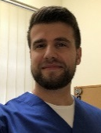 Biography
Dr. Robert Dymarek is an Assistant Professor at Dept. of Nervous System Diseases, Wroclaw Medical University in Poland. He is a physiotherapist and specialist in shock wave treatment (ESWT). His research interests include the application and evaluation of the effectiveness of physical methods in wound healing. Dr. Dymarek was a principal investigator of the project founded by The National Science Centre (NNC, Poland): "Shock wave therapy on upper limb spasticity after stroke". Currently, he is a coordinator and principle investigator of the research project "The SHOWN project (SHOck Waves in wouNds)" aimed at clinical, pathomorphological, immunocytochemical and molecular characterization of the effects of ESWT in patients with chronic wounds: a prospective, single-blinded, placebo-controlled, randomized clinical study with an in vivo and in vitro comparison.
Email: r.dymarek@gmail.com

Notes/Comments:

