Concomitant procedure for coronary artery disease and aorto iliac vessel block
Durgaprasad Reddy, MBBS, MS, MCH, VIMS & RC, Bangalore, India

Abstract
Statement of the Problem: The prevalence of coronary artery disease (CAD) in patients with peripheral vascular disease (PVD) varies widely from 19%–42% in published reports. Treatment of the same has always been controversial and challenging.
The purpose of this study is to describe a technique of surgery for coronary artery disease and peripheral vascular disease using an artificial conduit from the ascending aorta to peripheral vessels in a single sitting.
Method:
Records of 47 patients above the age of 65 years who underwent cardiac and peripheral revascularisation between January 2009 and January 2017 were retrospectively analysed. All patients had a diseased abdominal aorta with claudication pain and a coronary angiogram showing either a triple vessel disease (30) or a double vessel disease (17). All patients underwent coronary artery bypass grafting and aorto-bifemoral grafting in a single sitting.
Results:
Post-operative Doppler study showed good peripheral blood flow in all the patients. Patients were relieved from rest pain and angina. All ulcers had ultimately healed and limb salvage was possible in all cases. Four patients had pericardial effusion due to weeping of the graft, which was drained with the help of pig tail catheter. Seven patients had serous collection at the inguinal sites, which required drainage. One patient during follow up had developed graft infection and expired subsequently.
Conclusion & Significance:
Single sitting for CAD and PVD revascularization is easy to perform, reduces the morbidity, and avoids abdominal complications. It also reduces hospital stay and thus is cost effective.

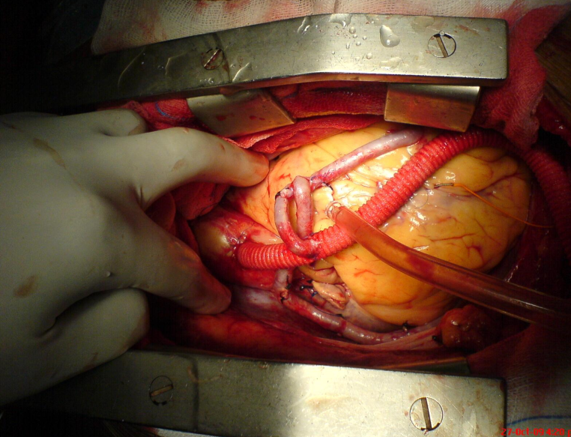
Recent Publications
- Perrone-Filardi P, Chiareiello M.Harper C. Coronary artery disease and intermittent claudication: how to manage the patient. European Heart Journal Supplements (2002) 4 (Supplement B), B58–B62
- Beşir, Yüksel et al. “An alternative method of transperitoneal graft introduction in aortobifemoral bypass surgery.” Cardiovascular journal of Africa vol. 26,1 (2015): 45-8. doi:10.5830/CVJA-2015-011
- Clair DG, Beach JM. Strategies for managing aortoiliac occlusions: access, treatment and outcomes. Expert Rev Cardiovasc Ther. 2015;13(5):551–563. doi:10.1586/14779072.2015.1036741
- Spronk S, Bosch JL, Ryjewski C, et al. Cost-effectiveness of new cardiac and vascular rehabilitation strategies for patients with coronary artery disease. PLoS One. ;3(12):e3883. doi:10.1371/journal.pone.0003883
- Dhaliwal G, Mukherjee D. Peripheral arterial disease: Epidemiology, natural history, diagnosis and treatment. Int J Angiol. 2007;16(2):36–44.

 Biography
Professor Durgaprasad Reddy is cardiothoracic and vascular surgeon in the prestigious Vydehi Institute of Medical Sciences and Research in Bangalore. He is the head of the department and his expertise includes complex congenital heart diseases, adult cardiac surgery, MICS, thoracic surgery, and vascular surgeries. He has completed over 13,000 cases over his span at Vydehi Institute of Medical Sciences and is geared up to do much more. He is also running a successful postgraduation program in which he personally trains his students as well as his staff. Professor Durgaprasad Reddy has built the department over his 15 year tenure at Vydehi hospital.

Email: durga2723@gmail.com

Notes/Comments:

