Title: Experience in the integrated treatment of chronic wounds
Nor N.N.1, Slesarenko S.V2., Badyul P.A.1,2
1. State Establishment "Dnipropetrovsk Medical Academy of Health Ministry of Ukraine"
2. Department of General Surgery, Burn and plastic surgery center, Dnipro, Ukraine.

Keywords: chronic wounds, negative pressure effect, skin grafting surgery
I. Abstract Body
Treated 36 women aged from 35 to 83 years with chronic wounds of the lower extremity in the period from 2014 to 2018 years. Etiology of wounds: 19 mechanical injury, 8 - animal bites; 2 - abscess; 3- chronic venous insufficiency; 2 - bedsore; 1- skin cancer. Duration of wound existind from 1 month to 50 years. Combined treatment included antibacterial therapy, NPWT, gialuronic acid injection and application, skin grafting. We studied: clinical indicators of skin grafts healing and wound healing time, bacteriological examination of the wounds and the perfusion control with laser Doppler flowmetry. In 27 patients there was 100% healing of skin grafts, in 6 - 75% engraftment, these patients after 10-12 days after the operation applied dressings with Ialuset - cream for 2-3 weeks, in 1 patient wound healed within 14 days after the course of VAC therapy without surgery, and 1 experienced severe pain during the negative pressure action that led to abandon the VAC therapy. Prior NPWT in most cases in wounds were found: Staphylococcus aureus (45%); Klebsiella (27%); Pseudomonas aeruginosa (18%); Proteus mirabilis (10%). During monitoring of tissue perfusion in 66% patients were increase of perfusion rate from 2 to 6 hours after vacuum therapy, in 34% - rates unchanged and even had a tendency to decrease. Observation for 12 months after discharge showed no recurrence. By using the combined method of treatment of chronic wounds achieved complete healing of the wound defect in all patients during the period from 2 to 6 weeks.
II. Image:
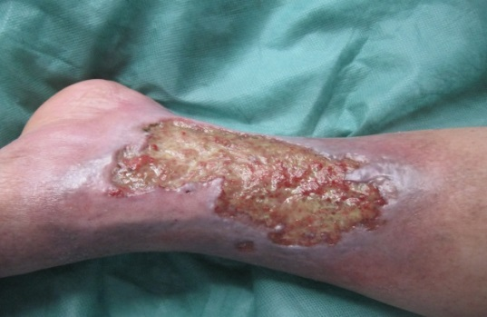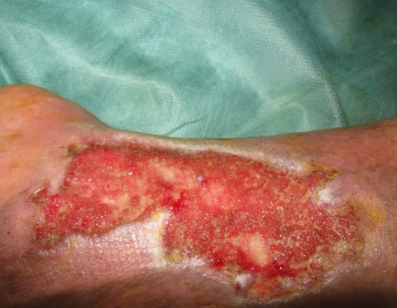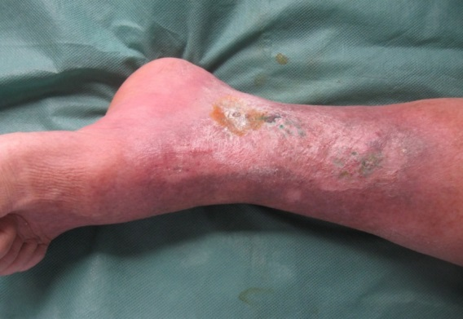
- On admission; 2) After VAC- therapy; 3) 3 months after surgery

Female patient B, 52 years old. Diagnosis: Chronic wound of the left shin

III. Reference:
- Borgqut O., Ingemansson R., Malmsjo M. The Influence of Low and High Pressure Levels during Negative-Pressure Wound Therapy on Wound Contraction and Fluid Evacuation. 2011. Plastic and Reconstructive Surgery, Vol.127,2 :551-559.
- Grothier L.,Pardoe A. Chronic wounds: management of healing and wellbeing. 2013. Br. J. Nurs.22:26-30.
- Louis C., Michael J. Morykwas, Malcolm W. Marks, Anthony J. DeFranzo, Joseph A. Molnar, Lisa R. David. Vacuum-Assisted Closure: State of Clinic Art. 2006.Plastic and Reconstructive Surgery.Vol. 117:7S:127S - 142S.

IV.Biography:
Nor Nadiia Nikolaevna. Assistant of the Department of General Surgery of the Dnepropetrovsk Medical Academy, Candidate of Medical Sciences. In 1987 she graduated from the Dnepropetrovsk Medical Institute, specializing in medical treatment. In 1991, entered clinical residency at the Department of General Surgery and began working as an assistant at the Department of General Surgery since 1993. In 2013 she defended her thesis on "Early surgical interventions and their effectiveness in the treatment of patients with thermal trauma to the hand." He regularly participates in presentations at Ukrainian and international scientific conferences and congresses devoted to the treatment of wounds, burns and their consequences. He is a member of the European Association of Combustiologists. Published more than 50 publications in magazines and collections.

V.Presenting author details

Full Name: Nor Nadiia Nikolaevna
Contact number: 0684182414
Twitter account:
Linked In account:
Session name/ number:
Category: Oral presentation
Passport Number:FN450964

