Fundamentals of Ultrasound Wound Care: Technologies, Devices, Science and Clinical Outcomes
Eliaz Babaev, D.Sc., Ph.D.

Abstract

Nowadays Ultrasound wound and skin treatment including infection control has been gaining interest in hospitals, clinics, wound care centers and doctors’ offices.

The purpose of this presentation is to share, review, and evaluate the safety, validity, and efficacy of ultrasound treatment of all types of acute and chronic wounds including diabetic foot ulcers and share the results with the existing and future users by enhancing their understanding of potential positive outcomes from using the different Ultrasound devices in wound management.

For wound treatment purposes the low and high frequency ultrasound devices have been used, which have been in clinical trials or marketed worldwide. The ultrasonic parameters and design of instruments are very influential and critical for different aspects of wound treatment, such as ultrasonic energy delivery to target, tissue fractionation/ fragmentation/ debridement, liquefaction/ histotripsy, erosion, homogenization, liquation and wound therapy. Ultrasound treatment applies effective ways to prevent damage to surrounding healthy tissue and to succeed in therapeutic wound treatment. Treatment was both contact and non-contact modes, depending on the manufacturers, high and low frequency devices and wound conditions such as acute, infected, chronic, trauma, diabetic, non-diabetic, burn, radiation related, animal bite, gun shut, hard-to-heal, etc.

The Qoustic Wound Therapy System® medical device is Arobella’s flagship wound care product sold in domestic and international markets. The system is cutting edge wound care offering previously unseen benefits to patients. This is evident from competitors’ unsuccessful efforts to catch up with Arobella’s technical advances by releasing similar devices. Devices advantages: less pain or no pain, selective debridement, preparation of wound bed for skin grafting, excisional debridement, contact and non-contact ultrasound therapy, increase of SPP, strong bactericidal effect, less scars, etc.
Image
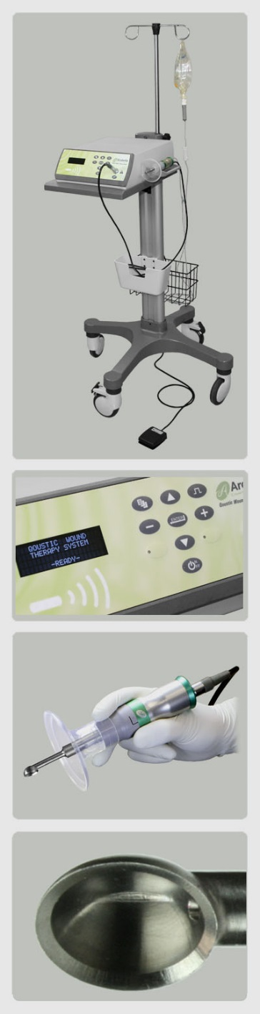
Recent Publications (minimum 5)
- Lifshyts Y.Z, Babaev E. et. al. First experience of application of technology of a two – stream low – frequency ultrasound technology in abdominal surgery. Pub Med PMID 26817081. Sept. 2016
- Babaev E. US Patent Ultrasonic atomization and/or separation system 9,101,949, August, 2015
- Babaev E. P. Ultrasound Wound Therapy. How low frequency ultrasound can used to promote wound healing. J. Wound Care Therapies. Fall 2014
- Babaev E. P. US Patent 8,235,919. Ultrasonic method and device for wound treatment. August, 2012
- Babaev E. P. US Patent 8, 062,289 Ablative ultrasonic – cryogenic apparatus, November, 2011

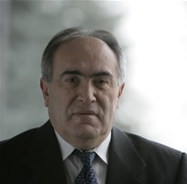
Biography
Eliaz P. Babaev (sometimes spelled Eilaz) is a co-founder, President and CEO of Arobella Medical, LLC. A recognized leader in his field, all Arobella technology and innovation is grounded in Eliaz' fifty years working in non-imaging advanced ultrasound technology. Eliaz has been a consistent and prodigious inventor, with over 50 Issued and over20 pending U.S. Patents in areas such as advanced ultrasound technology, biomedical materials and orthopedics. Before co-founding Arobella, Eliaz has held numerous positions in business and academia. He was the co-founder, CEO and later Chief Technical Officer of Celleration, Inc. Prior to that, Eliaz worked as an ultrasound system design engineer and research scientist for DiaSorin, Inc., SpectRx, and AeroPag-USA, Inc. Before immigrating to the United States in 1994, Eliaz was a Professor and Director of the Biomedical Engineering Center at Azerbaijan Technical University. Before that he was a Ph.D student and Assistant Professor in the Biomedical Engineering Department of Bauman Moscow State Technical University. Eliaz has also been a Research Fellow in Biomechanics and Bioengineering at the Warsaw University of Technology and Bulgarian Academy of Sciences, and a Visiting Professor at several universities in the People's Republic of China.
Email: babaev@arobella.com

Notes/Comments:

