Investigating organic-anorganic hybrid materials with natural compounds for wound dressings
Assist. Prof. Maja Somogyi Škoc, PhD, University of Zagreb Faculty of Textile Testing, Croatia

Abstract
Silica-cinnamon and silica-garlic hybrid materials were prepared and characterized as a potential new material for medical textiles, i.e. wound dressings. Wound dressings made using the most modern textile processes with the addition of antimicrobial agents and the like, depending on their purpose, are very efficient for their treatment. For the treatment of chronic wound a large number of wound dressings of various structural characteristics and mechanisms of action are used. Most of them are based on high performance fabrics in form of non-woven with different collagen products/alginate fibres/ foams or hydrogels with antimicrobial compounds such as silver, betaine, chitin, or polyhexamethylene biguanide etc. to try to both protect the healing wound from infection and also to help promote the wound healing process itself. Some of new research in wound healing have focused on novel molecules of interest such as nitric oxide but for some chronic wounds the answer could be in the nature with naturally compounds honey, curcuma, aloe vera, cinnamon, garlic, peppermint oil, etc.
Cinnamomum verum (cinnamon) and Allium sativum (garlic) contain compounds with a wide range of proven antibacterial, antiviral, antipyretic, anti-inflammatory and antifungal properties. Silica-cinnamon and silica-neem hybrid cotton fabrics were prepared by dip-coating from 3-glycidyloxypropyltrimethoxysilane (GLYMO) as a precursor with catalyst and with commercially available powder of cinnamon and granule of garlic. The aim was to achieve cinnamon / garlic evenly distributed and represented along the fibres, still present in sufficiently quantity after laundering. The coatings were characterized by infrared spectroscopy (FTIR-ATR), scanning electron microscopy (SEM) and crease recovery angle. Determination of antibacterial activity was performed by agar diffusion plate test to Staphylococcus and Escherichia coli.

Image
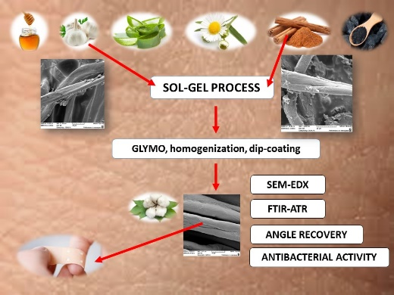
Recent Publications
- Mouthuy P-A; Somogyi Škoc M, Čipak Gašparović A, Milković L, Carr A J, Žarković N (2017) Investigating the use of curcumin-loaded electrospun filaments for soft tissue repair applications. International Journal of Nanomedicine. 12:3977-3991
- Somogyi Škoc M, Macan J, Petrak V (2016) Preparation and characterization of silica-curcuma hybrid material. 16th World Textile Conference Autex 2016. University of Ljubljana. Slovenia. 6-60-1-6-60-8
- Somogyi Škoc M, Macan J, Pezelj E (2014) Modification of polyurethane-coated fabrics by sol-gel thin films. Journal of applied polymer science. 131(4):39914-1-39914-13
- Somogyi Škoc M, Pezelj E (2012) Abrasion Resistance of High Performance Fabrics. Abrasion Resistance of Materials. In Tech d.o.o. 35-52.
- Somogyi Škoc M, Pezelj E (2011) Properties and Preparation of Resistant Polyurethane-coated Fabrics to Ageing by Sol-Gel Thin Films. New Frontiers in Fiber Materials Science. Clemson University, South Carolina, USA, 2011.

Biography
Assist. Prof. Maja Somogyi Škoc, PhD is the Head of the Department of Materials, Fibres and Textile Testing at the University Of Zagreb Faculty Of Textile Technology. Her scientific research and professional work includes field of testing and quality assurance of textiles with an emphasis on technical textiles and its 12 areas. A particular area of scientific research interest relates to the area of modification textiles by sol-gel process (medical purpose – antimicrobial properties for wound dressings, technical purpose – anti-aging protection etc., both by natural compounds and by nanoparticles). She performs two courses of undergraduate study and two on graduate study. As the mentor she was involved in the development of more than 24 final/diploma thesis.
Email: maja.somogyi@ttf.hr

Notes/Comments:

