Swelling studies of in-situ reduced Ag-NPs/ PVA nanocomposite films

Asmaa Selim* ^{1,3} , Andras Jozsef Toth ¹ , Daniel Fozer ¹, Eniko Haaz ¹, Peter Mizsey^{1,2}
¹Department of Chemical and Environmental Process Engineering, Budapest University of Technology and Economics, Budapest, Hungary
²Institute of Chemistry, University of Miskolc, Miskolc, Hungary
³Chemical Engineering Department, National Research Centre, Giza, Egypt

Abstract
In this investigation, metal-polymer hybrid nanocomposite films containing poly (vinyl alcohol) and silver nanoparticles (AgNPs/PVA) were prepared due to their potential application in various domains including separation and purification. The silver nanoparticles were generated in PVA matrix by the reduction of silver nitrate as silver ions with PVA as a reducing agent molecule over magnetic stirrer at 70-80 °C. The successful generation of silver nanoparticles in PVA matrix was confirmed by UV–Vis spectroscopy showing a single peak at around 420 nm due to the plasmonic effect of silver nanoparticles. Nanocomposite AgNPs/PVA films were characterized using scanning electron microscope (SEM), Fourier transform infrared (FT-IR) spectroscopy, and thermogravimetric analysis (TGA). The stability of the membranes in pure water, water uptake and the swelling behavior of these nanocomposites membranes in several organic solvents were reported. Comparison of the virgin and nanocomposites membranes showed that membranes based on silver nanoparticles and polyvinyl alcohol are promising for separation processes.

Image
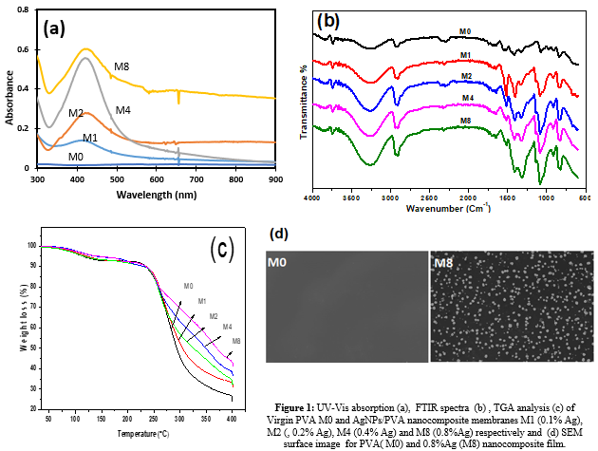
Recent Publications
- R.S. Patil, M.R. Kokate, C.L. Jambhale, S.M. Pawar, S.H. Han, S.S. Kolekar, One-pot synthesis of PVA-capped silver nanoparticles their characterization and biomedical application, Advances in Natural Sciences: Nanoscience and Nanotechnology, 3 (2012).
- Y. Badr, M.A. Mahmoud, Enhancement of the optical properties of poly vinyl alcohol by doping with silver nanoparticles, Journal of Applied Polymer Science, 99 (2006) 3608-3614.
- Z.H. Mbhele, M.G. Salemane, C.G.C.E.v. Sittert, J.M. Nedeljkovic´, V. Djokovic´, A.S. Luyt, Fabrication and Characterization of Silver-Polyvinyl Alcohol Nanocomposites, Chem. Mater., 15 (2003) 5019-5024.
- Gautam, S. Ram, Preparation and thermomechanical properties of Ag-PVA nanocomposite films, Materials Chemistry and Physics 119 (2010) 266-271.
- N.V. BHAT, N.S. KARMAKAR, D.C. KOTHARI, Synthesis of Nanocomposites of Polyvinyl Alcohol with Silver Nanoparticles and Their Use, International Journal of Nanoscience, 12 (2013) 8.
- J.M. Devi, M. Umadevi, Synthesis and Characterization of Silver–PVA Nanocomposite for Sensor and Antibacterial Applications, Journal of Cluster Science, 52 (2013) 12.


Bibliography
PhD scholar at Budapest University of Technology and Economics in Department of Chemical and Environmental Process Engineering. Previously, I accomplished my master’s degree under the prestigious program entitled Erasmus Mundus Masters in Membrane Engineering, majoring in Nanoscience & Nanotechnology of Membrane Engineering. My current research work is focused on development of PVA polymeric membranes for pervaporation (Water desalination and dehydration of alcoholic solutions)

Email: as_kh_f@hotmail.com
Notes/Comments:

