Zn_{0.8}Cd_{0.2}S@PCBM Hybrid as an Efficient Electron Transport Layer for Air-Processed p-i-n Planar Perovskite Solar Cells: Improvement of Interfacial Electron Transfer and Device Stability women
Yaru Li, Fudan University, P.R. China
Zhong-Sheng Wang*, Fudan University, P.R. China

Abstract (300 word limit)
Hybrid organometal halide perovskite solar cells (PSCs) have drawn significant attention owing to their excellent physical properties: large absorption coefficients, high carrier mobility, tunable bandgaps and specifically long charge carrier diffusion lengths. PCBM as the most commonly used ETL in p-i-n planar PSCs is not perfect. On the one hand, its intrinsic organic properties lead to poor lifetime. On the other hand, PCBM is undesirable for protecting the perovskite from the invasion of the ambient oxygen and moisture. We herein demonstrate an inorganic/organic hybrid, Zn_{0.8}Cd_{0.2}S nanoparticles (ZCS) embedded in PCBM, as an efficient electron transport layer (ETL) for air-processed p-i-n perovskite solar cells (PSCs), as shown in Figure 1, and the doping effect and doping mechanism are systematically studied. As compared to the PCBM, the ZCS@PCBM ETL exhibits improved electron extraction at the perovskite/ETL interface, increased electron transportation within the ETL, enhanced charge collection efficiency, and suppressed interfacial charge recombination, resulting in significantly improved power conversion efficiency (PCE) from 14.41% to 17.18% by 19.2%. Interestingly, the ZCS nanoparticles can protect the perovskite layer from the erosion by the ambient moisture, and 82% of the initial PCE for the non-encapsulated devices with ZCS@PCBM ETL is retained after 500 h storage in the atmosphere (humidity 30-60%) versus only 13% of the initial PCE remained for PCBM ETL without ZCS doping. recognition.

Image
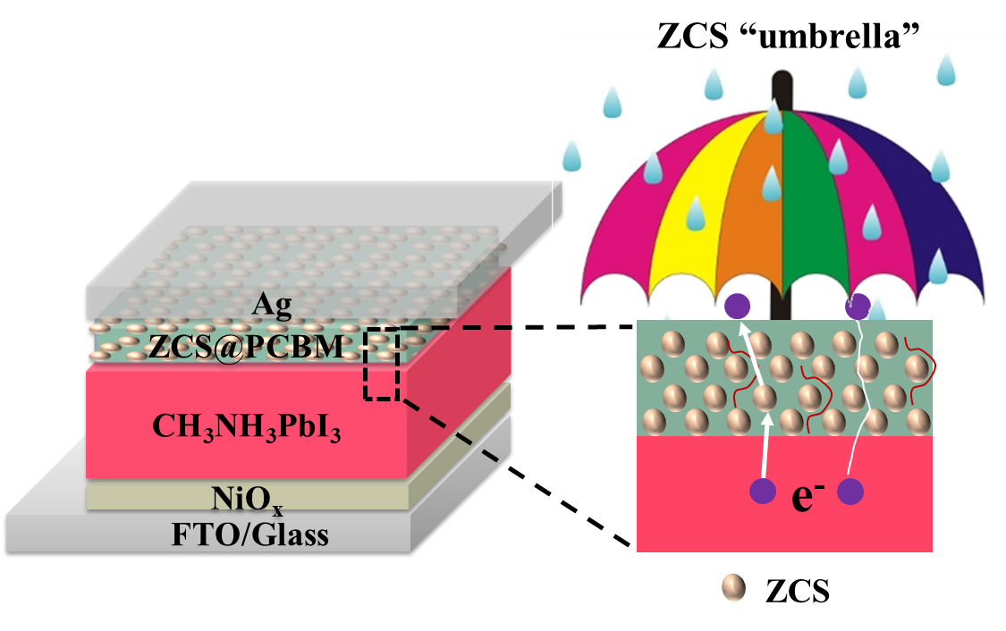
Figure 1. The PSC structure with the Zn_{0.8}Cd_{0.2}S@PCBM ETL.
Recent Publications (minimum 5)
- Kojima A, Teshima K, Shirai Y, Miyasaka T (2009) Organometal Halide Perovskite as Visible-Light Sensitizers for Photovoltaic Cells. J. Am. Chem. Soc. 131:6050-6051.
- Zhou H, Chen Q, Li, G, Luo, S, Song T, Duan H, Hong Z, You J, Liu Y, Yang Y (2014) Interface engineering of highly efficient perovskite solar cells. Science 345:542-546.
- Liu M, Johnston M, Snaith HJ (2013) Efficient Planar Heterojunction Perovskite Solar Cells by Vapour Deposition. Nature 501:395-402.
- Xing G, Mathews N, Sun S, Lim S, Lam Y, Gratzel M, Mhaisalkar S, Sum T (2013) Long-Range Balanced Electron- and Hole- Transport Lengths in Organic-Inorganic CH₃NH₃PbI₃. Science 342:344-347.
5. Zhang T, Yang M, Zhao Y, Zhu K (2015) Controllable Sequential Deposition of Planar CH₃NH₃PbI₃ Perovskite Films via Adjustable Volume Expansion. Nano Lett. 15:3959-3963.

Biography (150 word limit)
Zhong-Sheng Wang has his expertise in dye-sensitized solar cells (DSSCs) and perovskite solar cells in improving the efficiency and long-term stability. Their finding of single-component solid state electrolyte with functional imidazolium iodide ionic conductors creates new pathways for enhancing the efficiency of all-solid-state DSSCs. He and co-workers have developed metal selenides as efficient and low-cost electrocatalysts for massive production of DSSCs. He and co-workers have designed and synthesized a lot of metal-free organic dyes for use as efficient sensitizers of DSSCs.
Email: zs.wang@fudan.edu.cn

Notes/Comments:

