Novel BODIPY-Pt NRs Nanoconjugates In vitro Antimicrobial Photodynamic Inactivation of selected Bacterial and Fungal species
M. Thatyana, University of the Witwatersand, PhD, RSA
M. Patel, University of the Witwatersand, PhD, RSA
S. Moeno, University of the Witwatersand, PhD, RSA

Abstract

Antimicrobial drug resistance continues to be a global threat in recent years (1). The need for alternative scientific methods to curb the challenge is of significant importance. Photodynamic therapy combines the use of photosensitizers PSs (organic dyes) and a light of specific wavelength in the presence of molecular oxygen to produce reactive oxygen species (e.g. singlet oxygen species ¹O₂) which result in cell death (2,3). This study demonstrate the synthesis of BODIPY PSs and their antimicrobial inactivation of S. aureus, S. pyogenes, E. coli and P. earuginosa and antifungal inactivation of C. albicans, C. tropicalis, C. glabbrata and C. parapsilosis applications. Three times in vitro laboratory tests (using a two-fold serial dilution method) were carried out for statistical significance of data. BODIPY PSs with iodine moieties in their core structure demonstrated a significant activity towards the microorganisms under study. The results demonstrated a 5 fold reduction of viable cells after irradiation with light after 45 minutes. Significant photodynamic inactivation activity was observed with C. albicams, C. tropicalis, S. pyogenes and S. aureus respectively with MIC of <0.05 mg/mL respectively. While with E. coli, P.earuginosa, C. glabbrata and C. parapsilosis there was no much activity, which showed resistance towards these microorganisms. The stability test on C. albicans demonstrated an MIC of <2.5 nM concentration which suggested that the BODIPYs after inoculated for more than 24 hours they turn to agglomerate and form dimers and trimmers.

Biography
MaxwellThatyana is an aspiring researcher with expertise in antimicrobiology and anticancer research. His work involves the synthesis and modification of photosensitizers with the aid to their application as anticancer agents. The inspiration towards this study developed after he was introduced to national nanoscience postgraduate teaching and training program (NNPTTP) which exposed him to diverse applications of nanoscie spectrum. This work demonstrates a promising future towards defeating infectious disease and drug resistance.
Email: thatyanam4@gmail.com

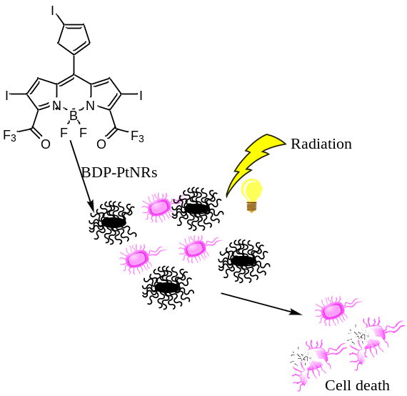
Fig.1 BODIPY Photodynamic inactivation effect on microorganism.
References
1: Hille J. and Johnson N.W., 2017; Translational Research in Oral Oncology, 2(): 1-13
2: M. Wainwright, 2008, Med. Chem. 8(): 280– 291.
3: J. F. Lovell, T. W. B. Liu, J. Chen, G. Zheng, 2010, Chem. Rev. 110(), 2839 –2857.

