Synthesis and Characterization of a Novel Ditopic Bridging Ligand Based on Terpyridyl/ Bipyridyl Systems
Ramin Zibaseresht*, Associate Professor, PhD, Biomaterials and Medicinal Chemistry Research Centre, AJA University of Medical Sciences and Maritime University of Imam Khomeini, Iran

Abstract

A major problem in the development of cytotoxic anti-cancer drugs is to achieve discrimination between cancer cells and normal tissue. Often, the more rapid proliferation of cancer cells compared with (most) normal cells is targeted. As a result, most drugs in use are anti-proliferative agents which target DNA, either directly (e.g. alkylating agents) or via its ancillary enzymes (e.g. topoisomerase inhibitors). However, poor discrimination between cancer cells and other rapidly dividing cells in the body can still lead to the well known debilitating side effects of chemotherapy.

This research project is aimed at developing inorganic molecules containing Ru(II) and Co(III) ions which will release and activate a cytotoxin when they are hit by light of a particular wavelength. This project is centred around the synthesis and study of molecules which are made up of four components, shown schematically in Figure 1.[1]

Our research programme is centered at the synthesis of heterodinuclear complexes. In these studies, we are focusing on the preparation and use of ditopic ligands where the two metal ion binding sites are differentiated by the number of donor atoms in each site, the configuration of the binding site, or the types of donor atom that are present in the sites. This binding site differentiation offers the prospect of using the different coordination properties of the binding sites to control the regiochemistry of complexation, ensuring that the correct metal ion is incorporated at the correct binding site in the ligand [2-8].

In this paper, the synthetic strategies involved in the synthesis and characterization of some functionalized terpyridines will be outlined. Synthetic strategy of a selected ligand is depicted in Figure 2. Transition metal complexes of such ligands have also been synthesized and characterized using conventional methods such as NMR spectroscopy, ES-MS spectrometry (Figure 3).

Image
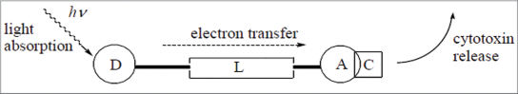
Figure 1: Photoactivated cytotoxin: Photoinduced electron transfer from donor (D) to acceptor (A) through linker (L) causes cytotoxin (C) release. 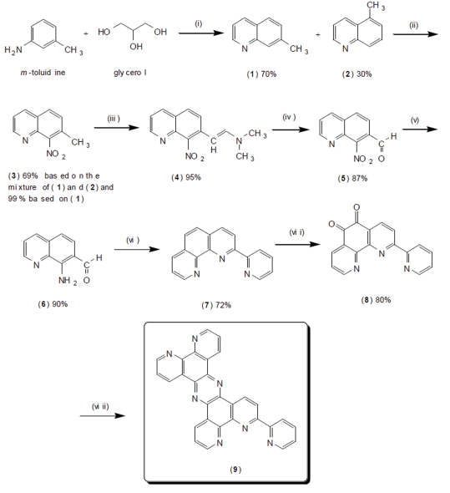

Figure 2: Synthesis of ditopic bridging ligand 6-pyrid-(tetrapyrido[2,3-a:2’,3’-c:3”,2”-h:2’”,3’”-j]phenazin.
Recent Publications

R. Zibaseresht , PhD Thesis, University of Canterbury (2006).

R. Zibaseresht and R. M. Hartshorn, Australian Journal of Chemistry 58 (2005) 345-353.

R. Zibaseresht and R. M. Hartshorn, Dalton Transaction (2005) 3898-3908.

R. Zibaseresht, A. M. Downward and R. M. Hartshorn, Australian Journal of Chemistry 63 (2010) 669-679.

P. A. Thornley, J. C. Starkey, R. Zibaseresht, M. I. J. Polson, J. L. Wiakira and R. M. Hartshorn, Journal Coordination Chemistry (2011) 145-158.

R. Zibaseresht, P. Karimi, M. R. Amirloo, and S. Mohit Azar, International Journal of Chemical Research 5(1) (2013) 153-158.

 Biography
Ramin Zibaseresht is an Associate Professor in Chemistry at Maritime University of Imam Khomeini in Noshahr and Adjunct Associate Professor at AJA University of Medical Sciences in Tehran. He received his B.Sc. in Chemistry from Shiraz University, his M.Sc. in Inorganic Chemistry from Pune University, and his PhD in Inorganic Chemistry from the University of Canterbury. He is currently the Head of Biomaterials and Medicinal Chemistry Research Centre in Tehran.
Email: rzi12@uclive.ac.nz

