Reversible aggregation of Patchy Colloidal particles: Chains, bundles and crystals.
Isha Malhotra, Research Scholar, Indian Institute of Technology-Delhi, India.
Sujin B. Babu, Assistant Professor, Indian Institute of Technology-Delhi, India.

Abstract

In the present study we are performing simulation of simple model of two patch colloidal particles undergoing reversible diffusion limited cluster aggregation using patchy Brownian cluster dynamics. In addition to the reversible aggregation of patches, the spheres are coupled with isotropic reversible aggregation through the Kern-Frenkel potential. We have investigated the effect of strength of bond (anisotropic and isotropic) interaction on self-assembly under different solvent qualities for various volume fractions. We define the strength of isotropic (anisotropic) temperature T_{i} (T_{a}). We will show that at low T_{i}, we end up with chain conformation or monomeric conformation depending upon T_{a.} Bundling and crystallization process is similar to nucleation and growth phenomenon observed in colloidal system with short-range interaction. Transition from chains to bundles and bundles to crystals will be discussed. We are also proposing a model for amyloid fibers and sickle cell crystallization.
Image
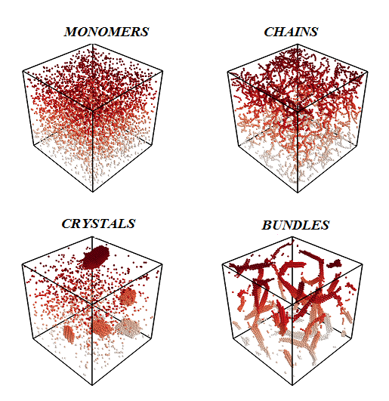

Recent Publications (minimum 5)
- Malhotra I, Babu S. B. (2018) Aggregation kinetics of irreversible patches coupled with reversible isotropic interaction leading to chains, bundles and globules. Pure and Applied Chemistry, 90(6), 1085-1098.

 Biography
I have expertise in simulation of Patchy colloidal particles undergoing irreversible and reversible diffusion limited cluster aggregation using Patchy Brownian cluster Dynamics. In our recent study based on irreversible aggregation of patchy colloidal particles under different solvent conditions, we observed fibers forming bundles depending on the attractive interaction strength between the fibers or in other words depending on the quality of solvent. This bundling transformation is very similar to nucleation and growth phenomena observed in the colloidal system with short-range attraction. We have proposed a model for Amyloid fibers and the formation of these fibers is responsible for many neurodegenerative diseases like Alzheimer’s and Parkinson’s disease. In the present study we are proposing a model for sickle cell crystallization and we hope to give insight in the biological aggregation of sickle cell hemoglobin.
Email: phz148106@iitd.ac.in

Notes/Comments:

