The in vitro antimicrobial effects of colloidal nanoparticles distributed in solutions and on a solid materials
Iva Rezić¹, Maja Somogyi Škoc¹, Iva Samaržija¹, Lela Pintarić¹, Vanja Ljoljić Bilić², Ivan Pokrovac², Ivan Kosalec²,
University of Zagreb:
¹Faculty of Textile Technology,
² Faculty of Pharmacy and Biochemistry

Abstract (300 word limit)
Statement of the Problem: Nanoparticles in colloidal dispersion are powerful antimicrobial agents and can be applied on cellulose in order to produce materials with significant antimicrobial effects. Such products are already widely spread and can be found on many everyday items including clothing, car materials, food packaging, geotextiles and among many others, medical textiles. This work is focused on testing nanoparticles in solution and after application on cellulose materials. Such products are foreseen as materials used in medicine or sports wardrobe.
Methodology & Theoretical Orientation: In order to assess the possible antimicrobial in vitro impact of nanoparticles in colloidal dispersion, and compare it to nanoparticles arising from medical textiles and sports materials, this work aimed to detect the antimicrobial effects of commercially available nanoparticles (Ag, ZnO and TiO₂) on different model microorganisms (Staphylococcus aureus, Escherichia coli and Candida albicans). We have used several methods (dilution, diffusion, time-kill), and compared the influence of nanoparticles regarding their size, concentration and chemical composition.
Findings: Results showed that colloidal nanoparticles differ in antimicrobial properties regarding size (40 nm Ag had 1.04 ppm MBK and 0.2 ppm MIK, and 10 nm Ag had 0.31 ppm MBK and 0.08 ppm MIK), concentration (higher related to higher activity) and chemical composition (100 nm ZnO had effects on Staphylococcus aureus and Escherichia coli while 100 nm TiO₂ did not). After detecting the most powerful combination of parameters influencing antimicrobial effectiveness, we modified cellulose with nanoparticles and characterized it by Nanoparticle tracking analyzer, FTIR spectroscopy and SEM-EDX methodology.
Conclusion & Significance: This work shows significant progress in development of new materials with powerful antimicrobial properties. In our future work we will aim to produce special materials showing antimicrobial effects against special microorganisms that are resistant to antibiotics, which can lead to prototypes and development of specially powerful antimicrobial products.
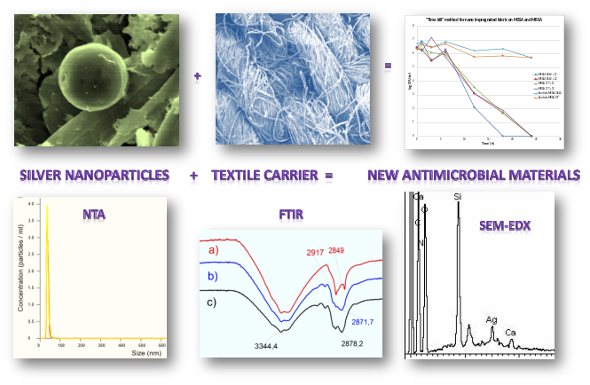
Figure 1: Graphical presentation of the methodology used in this research: nanoparticles used in modification of cellulose resulted with new materials with antimicrobial activities
Recent Publications (minimum 5)
- Rezić I (2012) Analysis and Risk of Nanomaterials in Environmental and Food Samples, Engineered Nanoparticles in Textiles and Textile Wastewaters. 59, COAC, Chennai: Elsevier, 235-264.
- Rezić I, Špehar M, Jakovljević S (2016) Characterization of Ag and Au nanolayers on Cu alloys by TLC, SEM-EDS and ICP-OES. Mat Corr, DOI: 10.1002/maco.201609176
- Rezić I (2011) Determination of engineered nanoparticles on textiles and in textile wastewaters, Trends Anal Chem 30:1159–1167.
- Rezić I, Zeiner M, Steffan I (2011) Determination of 28 selected elements in textiles by axially viewed inductively coupled plasma optical emission spectrometry. Talanta 83:865-871.
- Rezić I (2009) Optimization of ultrasonic extraction of 23 elements from cotton. Ultrason Sonochem 16:63–69.
- Rezić I, Steffan I (2007) ICP-OES determination of metals present in textile materials. Microchem J 85:46-51.

 Biography (150 word limit)
Assistant professor Iva Rezić, PhD PhD is the Head of Department of Applied Chemistry at the University of Zagreb where she leads the group for synthesis and characterization of metallic nanoparticles. She has two PhDs and expertise in material science and characterization, nanotechnology, chemical trace elements analysis and statistical modeling of complex mixtures. Her DOE model enables formulation of new polymers with antimicrobial layers. Iva Rezić applied this model during years of experience in research, evaluation and teaching. The results of scientific work she presented in the university handbook, 4 book chapters and 54 scientific papers. For the results of her work, Iva Rezić has received 9 awards and scholarships. Until now she lead 4 international projects and collaborated on 13 others. She is the Editor-in-chief of the TEDI journal, editor of 4 and the reviewer for 33 journals. Actively participates as a member of various associations, commissions and committees.
Email: iva_rezic@net.hr
Notes/Comments: Work is supported by Croatian Science Foundation through the “Synthesis and targeted application of metallic nanoparticles STARS”, UIP–2014–09–1534 and Financial support from the University of Zagreb, both under supervision of ass. prof. Iva Rezić, PhD PhD.

