+Accessing Breast Care Services in Limited - Resource Settings
Agnes M Musonda Program Manager Breast and Cervical Cancer Health Promotions, Center of Infectious Disease Research in Zambia (CIDRZ), Zambia

Abstract
Statement of the Problem: Women in limited resource settings (Zambia) experience severe difficulties in accessing breast care services. Zambia portrays a similar breast cancer burden picture as that documented within other limited resource settings; lack of public knowledge and information on the signs and symptoms of breast cancer; lack of access to affordable breast cancer screening services, diagnosis and treatment; traditional cultural beliefs that limit health seeking behaviour and limited skilled human resource in breast cancer care. Zambia National Cancer Registry Report 2008 – 2012, recorded 10.7% cancer cases (9.4% Women and 1.3% Men), but these low numbers can be attributed to a lack of standardised monitoring systems and poor documentation mechanisms in both the public and private health institutions. The main objective of this study is to identify the main key barriers to accessing breast care services in Zambia. Methodology: Analysis of the community health promotions data for the Breast Cancer Prevention Program was conducted to understand service utilization. Findings: The key barriers are: Policy: Lack of standardised health strengthening systems; lack of standardised monitoring and evaluation systems. Service Provision: Lack of public awareness activities on breast cancer; lack of standardised training on clinical breast examination, patient navigation, ultrasound guided examination and diagnosis; limited skilled human resource; limited health facilities providing breast cancer services; one national oncology centre and limited palliative care services population of 15,470,000. Late Presentation: Poor referral systems; limited functional diagnostic equipment; limited access to histopathology services resulting in high cases of women being diagnosed in the late stages of breast cancer causing unacceptably high mortality rates. Conclusion & Significance: Establish regional breast cancer diagnostic clinics, increase community based breast cancer awareness activities; increase community based clinical breast examinations campaigns with linked referrals to diagnostic centers, integrate routine clinical breast examinations into the cervical cancer screening program.

Image
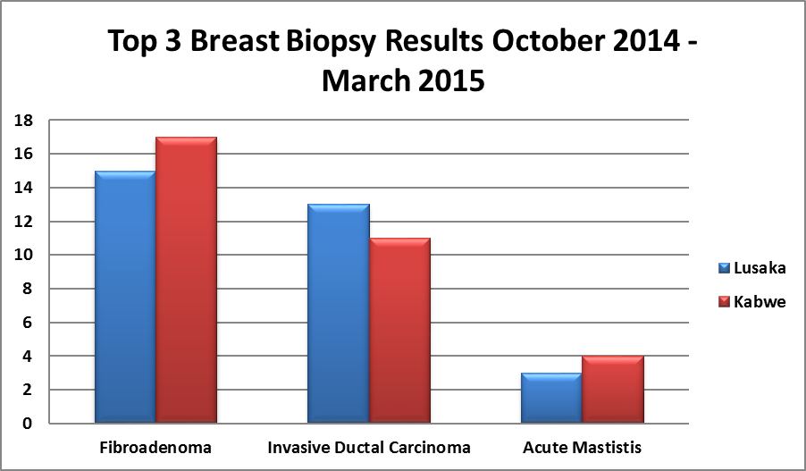
Recent Publications
- Brigitte Frett, Groesbeck P. Parham, Agnes Musonda et tel (2015) Availability of Palliative Care Services in Zambia: A Nationwide Facility Survey
- Globocan (2012) Breast Cancer Estimated Incidences, Mortality and Prevalence Worldwide.
- Groesbeck P. Parham, Kennedy Lishimpi, et tal (2015) A Comprehensive Assessment of Breast and Cervical Cancer Control in Zambia
- Ministry of Health (2013) Zambia National Cancer Registry Report 2008 – 2012
- Ministry of National Planning (2015) Central Statistics Office Zambia Report

Biography
Agnes Musonda is Program Manager Breast and Cervical Cancer Health Promotions at the Centre of Infectious Research in Zambia (CIDRZ). Agnes is very passionate about her work involving the fight against breast cancer and in 2014 she was extremely instrumental in the establishment of the Breast Cancer Prevention Program where she helped design effective community referral systems to reduce the long patient waiting time. With over 5000 women screened to date, Agnes continues to conduct free clinical breast examinations for women with limited access to breast care services. Before joining CIDRZ Agnes worked as Program Officer Quality Improvement at FHI360 where she immensely contributed to the development of National Quality Improvement Guidelines, she previously served as Quality Assurance Officer PSI where she developed health strengthening systems for HIV Counseling and Testing and Voluntary Medical Male Circumcision Programs and earlier served as clinician and researcher for Medesins Sans Frontiers HIV/AIDS project.

Email: agnesmwela@gmail.com

Notes/Comments:

