ABSTRACT

Tittle: Correlation Between Mothers Attitude on Immunization Myth and Basic Immunization Administration to Their Infants

Keywords: Mothers Attitude, Immunization, Myth, Basic Immunization

- Abstract Body

The completeness of basic immunization is very important for infants’ health. Yet, amid the community, the myth of immunization is very much believed so that it influences the mothers’ attitude on the myth of immunization. The objective of this research is to investigate the correlation between the mothers’ attitude on the immunization myth and the basic immunization administration to their infants.
This research used the observational analytical method with the cross sectional approach. The subject of research were all of the mothers whose infants were aged 1-9 months and who administered the basic immunization to their infants at Gajahan Community Health Clinic, Surakarta in 2018. The data of research were collected through questionnaire of attitude and data of basic immunization completeness.
The subject of research were 90 mothers. 41 of them ( 45,56% ) had a positive attitude and 49 of them ( 54,44% ) had a negative effect. 65 (72,22%) respondents already administered a complete basic immunization to their infants, and 25 respondents
already administered an incomplete basic immunization to their infants. The Chi square test shows that the p-value was =0.000 which less than the significance value of 0.05
There was a correlation between the mothers attitude on immunization myth and the basic immunization administration to their infants at Gajahan Community Health Clinic, Surakarta

- Image

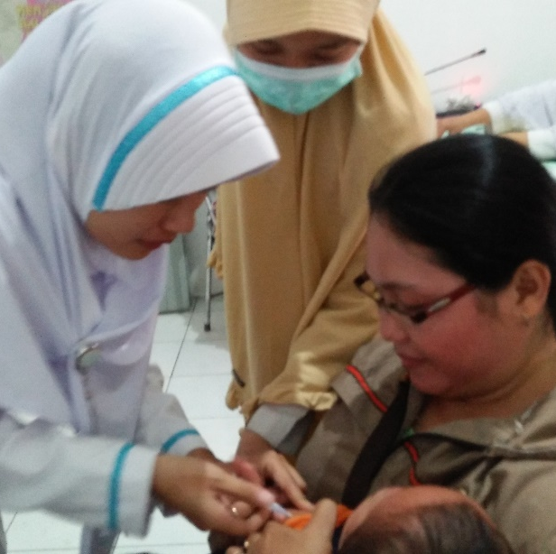

- Reference

- Abdullah, Suhazeli., 2014. Vaksin Untuk Bayi Anda; Mitos VS Realiti. Pertubuhan Amal Perubatan. Malaysia.
- J, Simon. and Jonathan C., 2014. Paediatrics Lecture Notes 9E. Hoboken.

- Saifudin, M., 2014. Imunisasi: Lumpuhkan Generasi?. Pustaka Muslim. Yogyakarta

- Biography

Affryta Nur Fauzia Analda, was born in Sukabumi, April 16, 1997. She is a student at Diploma III Midwifery of Medical Faculty of Sebelas Maret University. She has completed the Senior High School at the age of 18 years at 1 Senior High School Sukabumi. She has a hobby to make design posters and been through some of the race and get the winner.

- Presenting author details

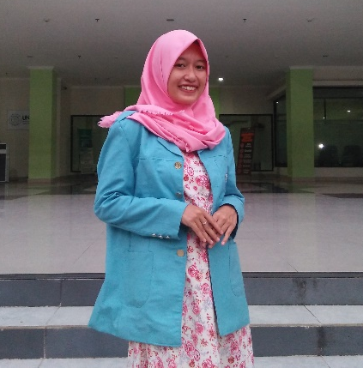

Full Name : Affryta Nur Fauzia Analda
Contact number : +628112641647
Twitter account : @anfaanalda
Session name/ number : Midwifery Pediatrics
Category : Poster presentation
Passport Number : On Process

