Conventional Vs Wholistic therapy, which is the better option in the management of Knee Osteoarthritis associated with obesity?
Dr John Ebnezar,Department of Orthopedics,Parimala Health Care Services,Bangalore,India
Key words: Osteoarthritis,Obesity,Wholistic,Yoga,AAOS

Osteoarthritis knee is the most common joint disorder affecting nearly 10% of the world population. There are several non-modifiable and modifiable risk factors for OA Knees with Obesity being the greatest modifiable risk factor. How excess weight influences OA is not clear. Obesity has both a mechanical and inflammatory component in the development and worsening of knee arthritis.

Traditionally osteoarthritis knees have been treated with non-pharmacological, pharmacological and surgical methods. When OA Knee is associated with obesity where the situation is far more complex, these treatment methods are not effective. There is a need for paradigm shift from conventional to comprehensive treatment. A patient with OA and obesity knees suffers as a whole and not in isolation and the traditional treatment methods alone may not be enough. Yoga with its multidimensional approach of body, mind and soul implications could be an answer.
Extensive research on the role of yoga as an add on in the treatment of OA knees associated with obesity has shown excellent to good results. My research studies were picked up by American Association of Orthopedic Surgeons (AAOS) in formulating the 2013 Non-Arthroplasty treatment guidelines for OA Knees. A broad based treatment called “Wholistic Treatment” keeping yoga as the central option in the treatment of OA Knees and Obesity seems to be the best option.
Biography (150 Words)
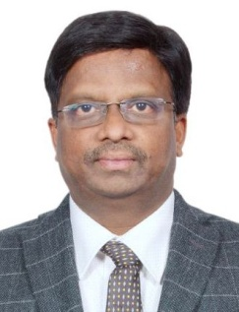
Dr. John Ebnezar is an internationally renowned orthopedic surgeon, passionate about creating, conceptualizing, implementing preventive new orthopedic health awareness modules with an aim to propagate low cost orthopedic health care. He is specialized in trauma, spine, geriatric orthopedics and sports medicine. He holds Guinness World Records both for academics (2010) and social service (2015), only orthopedic surgeon in the world to do so. He is a PhD in yoga, involved in 6 original-yoga researches, won Best Research Award from SVyasa Yoga University (2012) for his work on knee arthritis and role of yoga in fracture healing (2010). He has pioneered a new treatment method, WHolistic Orthopedics, by blending modern orthopedics with Indian Yoga, which is simple, cheap, effective alternative for patients for whom knee replacement is not an option and also for patients with modern life style orthopedic problems and has redefined the way orthopedic ailments are treated across the globe.

Recent Publications:
1-3:
