An Evidence Review on Current Models of Registered Nursing and Midwifery Practice in the Community

Names and Affiliation Patricia Leahy-Warren PhD, MSc (research), Hdip PHN, BSc, RPHN, RM, RGN, School of Nursing and Midwifery, Brookfield Health Sciences Complex, UCC.
Dr. Helen Mulcahy DN, MSc (Nursing), BSc (Nursing), HDipPHN, RGN, RM, RPHN. School of Nursing and Midwifery, Brookfield Health Sciences Complex, UCC.

Abstract
Statement of the problem:Primary and community health services are the typical points of access for most people and the location where most care is delivered. The scope of primary healthcare is complex and multifaceted and therefore requires a practice framework with sound conceptual and theoretical underpinnings. There is a paucity of literature describing effective models of nursing and midwifery in the community. Therefore, the aim of this evidence review was to identify an effective model that could be used to guide nursing and midwifery in the community.
Methodology and Theoretical orientation: A rigorous systematic search of databases was undertaken to retrieve both empirical and grey relevant and appropriate literature. This process was guided by systematic review methodologies and reported in line with the Preferred Reporting Items for Systematic Reviews and Meta-Analysis (PRISMA) statement. The breadth of evidence from the final papers selected on community nursing was initially categorised and subsequently synthesized into four themes.
Findings: The four themes were not mutually exclusive: (1) Integrated and Collaborative Care; (2) Organisation and Delivery of Nursing & Midwifery Care in the Community; (3) Adjuncts to Nursing Care and (4) an Overarching Model. The evidence overall is methodologically weak with few robust and well-designed RCTs determining the effectiveness of various interventions on community/ nursing or midwifery interventions.
Conclusion and significance: While the evidence overall points to a range of positive outcomes associated with different types of community nursing and midwifery interventions, there remains uncertainty about which components offer the ‘critical ingredients’ for positive outcomes. Although no single overarching model of nursing and midwifery practice in the community emerged from the literature, what does emerge are evidence-based dimensions that can inform an effective model for the future.

Image
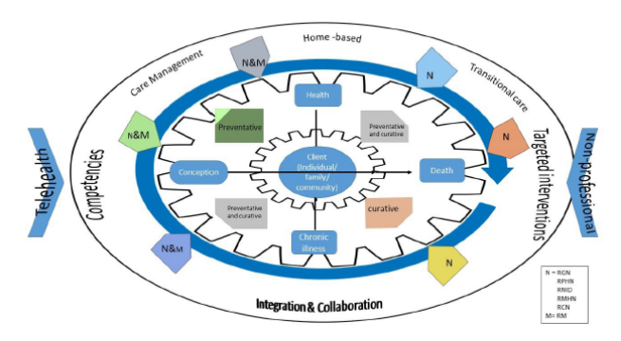
Figure 1: Conceptual Model Incorporating Findings (Leahy-Warren et al., 2017)
Recent Publications:
Centre for Systematic Reviews and Dissemination (CRD) (2008) Systematic Reviews CRD’s guidance for undertaking reviews in health care Centre for Reviews and Dissemination, University of York, Available at: https://www.york.ac.uk/media/crd/Systematic_Reviews.pdf
Clancy, A., Leahy-Warren, P., Day, M. R., & Mulcahy, H. (2013). Primary health care: comparing public health nursing models in Ireland and Norway. Nursing Research And Practice, 2013, 426107-426107. doi:10.1155/2013/426107
Higgins J, and Green S. (2011a) Cochrane Handbook for Systematic Reviews of Interventions Version 5.1.0 [updated March 2011]: The Cochrane Collaboration.
Leahy-Warren, P., Mulcahy, H., Benefield, L., Bradley, C., Coffey, A., Donohoe, A., . . . Savage, E. (2017). Conceptualising a model to guide nursing and midwifery in the community guided by an evidence review. BMC Nursing, 16(1), 35. doi:10.1186/s12912-017-0225-3
Moher D., Liberati A., Tetzlaff J., and Altman, D. G. (2009) Preferred reporting items for systematic reviews and meta-analyses: the PRISMA statement. Annals of Internal Medicine 151(4), 264-269.

 Biography (first author)

Patricia Leahy-Warren is Senior lecturer at the School of Nursing & Midwifery, University College Cork, Ireland. Her primary research interests relate to community nursing, public health and maternal and child health nursing across the lifespan. She has conducted a number of funded commissioned reports, systematic reviews and studies relating to maternal and child health and public health nursing. She has published widely in the international literature and is on the editorial board of Nursing Research. She leads a research cluster on Maternal and Child Health Nursing at University College Cork and has developed strong collaborative interdisciplinary research relationships both nationally and internationally.

