Propagation Channel Models for 5G millimetre wave wireless
mobile networks
Waqas Manan, MPhil, University of Bradford, UK

Abstract
At present, the current 4G systems provide a universal platform for broadband mobile services; however, mobile traffic is still growing at an unprecedented rate and the need for more sophisticated broadband services is pushing the limits on current standards to provide even tighter integration between wireless technologies and higher speeds. This has led to the need for a new generation of mobile communications: the so-called 5G. Although 5G systems are not expected to penetrate the market until 2020, the evolution towards 5G is widely accepted to be the logical convergence of internet services with existing mobile networking standards leading to the commonly used term “mobile internet” over heterogeneous networks, with several Gbits/s data rate and very high connectivity speeds. Therefore, to support highly increasing traffic capacity and high data rates, the next generation mobile network (5G) should extend the range of frequency spectrum for mobile communication that is yet to be identified by the ITU-R. The mm-wave spectrum is the key enabling feature of the next-generation cellular system, for which the propagation channel models need to be predicted to enhance the design guidance and the practicality of the whole design transceiver system.
The proposed work addressed the main concepts of the propagation channel behaviour using ray tracing software package for simulation and then results were tested and compared against practical analysis in a real-time environment including indoor and outdoor for mm Wave frequency bands. The characteristics of Indoor-Indoor (LOS and NLOS), propagations channels were intensively investigated at millimetre wave (mm Wave) frequencies by proving the data rate in gigahertz/sec. The computed data achieved from the 3-D Shooting and Bouncing Ray (SBR)


Wireless Insite based on the effect of frequency dependent electrical properties of building materials. Ray tracing technique has been utilized to predict multipath propagation characteristics in mm-wave bands at different propagation environments and results were compared to the theoretical models.

Indoor/Indoor Model

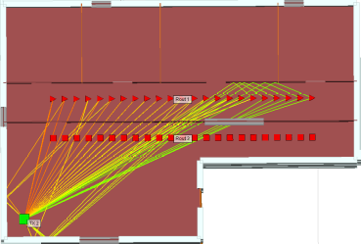
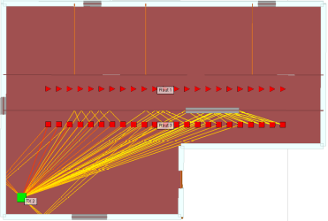

Recent Publications
- Manan, W.; Obeidat, H.; Al‐Abdullah, A.; Abd‐Alhameed, R.; Hu, F. Indoor to indoor and indoor to outdoor millimeter wave propagation channel simulations at 26 Ghz, 28 Ghz and 60 Ghz for 5G mobile networks. Int. J. Eng. Sci 2018, 7, 8–18.
- Obeidat, H.; Ullah, A.; AlAbdullah, A.; Manan, W.; Obeidat, O.; Shauieb, W.; Dama, Y.; Kara‐Za, C.; Abd‐Alhameed, R. Channel Impulse Response at 60 GHz and Impact of Electrical Parameters Properties on Ray Tracing Validations. Electronics 2021, 10, 393. https://doi.org/10.3390/electronics10040393
- Atta Ullah1, Naser Ojaroudi Parchin1, Waqas Mannan1, Yasir I. A. Al-Yasir1, Chan H See2, Raed A. Abd-Alhameed1,” F-Shape Dual-Band MIMO Antenna System for Next-Generation Smartphone Applications”.
- Abd-Alhameed, Raed A.; Manan, Waqas,” Propagation channel models for 5G mobile networks”. University of Bradford Faculty of Engineering and Informatics, 2018.

Biography
Waqas Manan has significant 5G research capabilities in wireless communication (research), software engineering and computer science. He has extensive expertise and knowledge in wireless communication (5G) and beyond which allows him to use his research potential in the emerging technology. His research focuses on propagation channel models for next generation mobile networks. The main concepts of the propagation channel behavior (Indoor and outdoor millimeter-wave channel simulations) are using ray tracing software package for simulation and then results are tested and compared against practical analysis in a real-time environment.
Email:waqas_manan2000@yahoo.com

Notes/Comments:

