Improving Solution Architecture of Internet of Things to Support a Successful Implementation of Digital Transformation in the Context of 2030 vision of Saudi Arabia
Alanoud Abdulmohsen Alsudairy,King Saud University, SA
Dr. Ahmed Abdullah Alsanad, King Saud University, SA
Dr. Ahmed Emam , King Saud University, SA

Abstract
The Internet of Things (IoT) is a system that exchanges information between computing devices and people over a network. As it is a new field within Saudi Arabia (SA), there is no dominant business model within the public sector that provides it. Thus, this results in difficulties adopting the IoT. IoT is emerging now and SA is taking the lead in the region with this mega event for enabling infrastructure, or increasing the infrastructure capacity for the Internet in line with Vision 2030.In addition to giving an overview of the main IoT challenges, studies have revealed that there is a lack of a unified consistency in design of solutions architecture for providing the coordination support required to integrate the IoT into the SA digital transformation plan and there is a lack of governmental standards, which is another factor that limits the adoption of the IoT in SA.The research aims to examine the improve the current framework with ultimate goal to create a positive impact on Saudi vision 2030. This investigation will result in a design of a solutions architecture that suits public and private sector. This requires a thorough investigation of literature review relevant on implementing IoT dynamic solution architecture within digital transformation environment. This should result in enabling researchers and developers to manage the activities of the IoT and speed time to market solution deployment in digital transformation within the SA 2030 vision. Discussing this digital transformation will result in a design of a framework for a solutions architecture that fits for most IT platforms. This includes the design, implementation, experimental validation, and evaluation of the effects on the quality of a system. This research starts by providing an overview of the IoT. Then, a summary of some technical details that pertain to the technologies that enable the IoT. Including that should help to achieve the SA 2030 vision for both public and private sectors.

Image
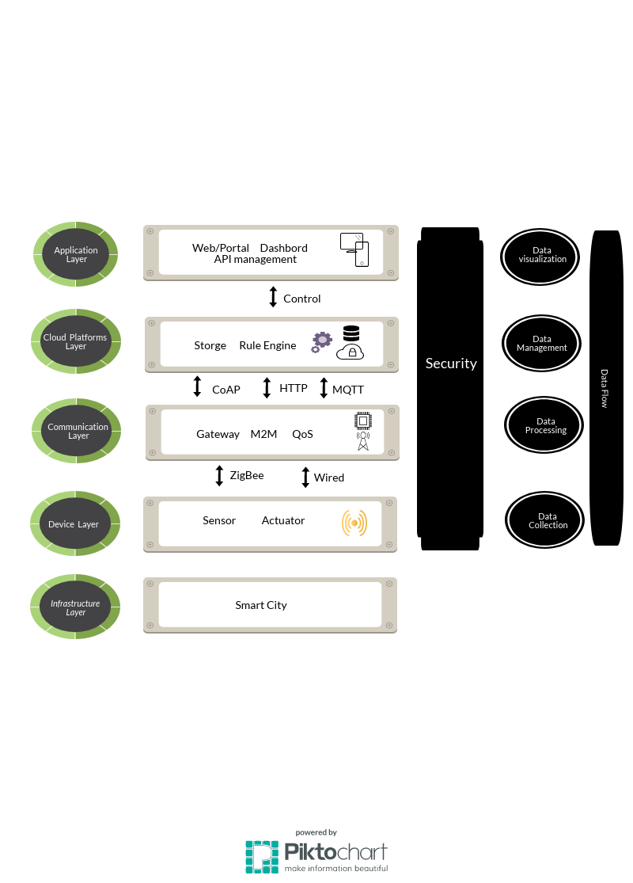Figure 1:Proposed model architecture

Biography
This research’s given the importance to help make an effective impact of the IoT on the digital transformation in the vision for 2030 of SA. The challenge we face is to design dynamic solutions architecture in SA, to develop a practical decision framework that addresses business, functional, technical, and implementation perspectives. We expect to provide more transparency and to raise awareness on how the changes that come with the IoT impact the digital transformation of SA.
Email: alanoodalsudairy@gmail.com

Notes/Comments:

