Continuous water content measurement in bulk solids and liquids
Benjamin Bixel, Sales Engineer, Liebherr-Mischtechnik GmbH, Germany

Abstract (300 word limit)
Continuous water content measurement is playing an increasingly important role in a wide variety of
industrial applications. Suitable sensors for measuring the water content in bulk materials and liquids
enable continuous monitoring of the water content and product moisture during all production,
processing and finishing processes. It also makes sense to include the measurement in a complete
control loop, especially with regard to quality assurance and quality improvement. Another
advantage of continuous monitoring is the energy savings achieved during the production process.
Such sensors are used, for example, in the area of ​​bulk goods. Building materials such as sand, clay or
iron ore can be measured here, as can biomass, food or chemical products. But the water content
also plays an important role in liquids such as oils, fuels and emulsions. The focus here is on
preventing corrosion damage and protecting engines, for example.

Image
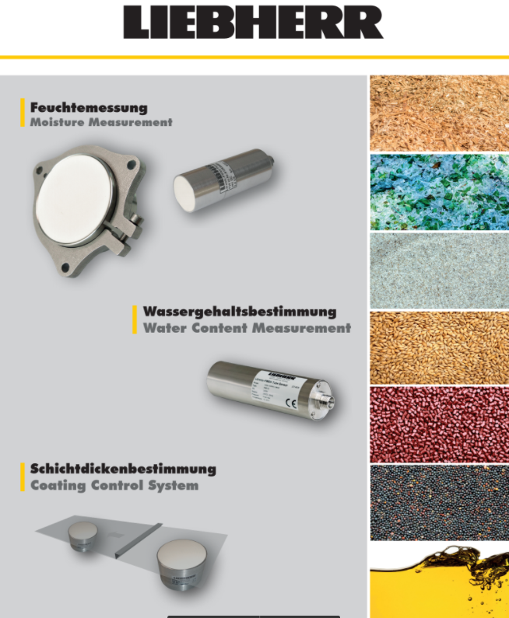

Biography (150 word limit)
Benjamin Bixel works as a sales manager for the international well known company Liebherr. At his facilities, Liebherr is working on sensor and measurement equipment with the focus on moisture and water content sensors.
DEmail: drXXXXXXX@xxxmail.com

Notes/Comments:

