Eating habits of Portuguese university students: comparison between normal season, academic evaluations, and COVID-19 lockdown period

Cíntia Ferreira-Pêgo, RN, MSc, PhD, CBIOS – Universidade Lusófona's Research Center for Biosciences and Health Technologies, Av. Campo Grande 376, 1749-024 Lisbon, Portugal.
Mónica Monteiro, RD, School of Sciences and Health Technologies, Universidade Lusófona de Humanidades e Tecnologias. Av. Campo Grande 376, 1749-024 Lisbon, Portugal.

Abstract

The entrance to the university is characterized as a period prone to stress, caused mainly by academic demand, which leads to changes in the students' eating habits. Due to the COVID-19 pandemic, university students' eating habits may also undergo drastic changes due to stress caused by lockdown, compulsory social isolation, and uncertainty about their academic future. An analysis of 332 Portuguese university students from different areas of study was carried out through an online questionnaire, to verify whether the stress caused by the assessments, as well as by COVID-19, had any kind of influence on the students' diet, as well as if it was different among students from the health sciences area and other unrelated areas. The adoption of less healthy eating habits was prevalent during the period of academic evaluations and, conversely, the period of lockdown by COVID-19 was characterized by better food choices. Students from other areas of study not related to the health sciences showed less healthy eating habits. However, despite the knowledge acquired throughout the course, students in the health sciences also tended to adopt less adequate food choices, mainly during the period of academic evaluations, which indicates that stress and anxiety end up prevailing over previously this acquired knowledge.

Image
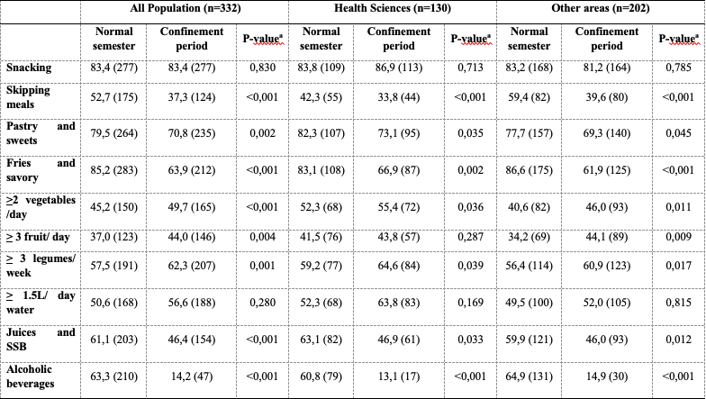
Recent Publications (minimum 5)
- Bárbara R, Ferreira-Pêgo C. Changes in Eating Habits among Displaced and Non-Displaced University Students. Int J Environ Res Public Health. 2020 Jul 25;17(15):5369. doi: 10.3390/ijerph17155369. PMID: 32722495; PMCID: PMC7432331.
- Ferreira-Pêgo C, Rodrigues J, Costa A, Sousa B. Eating behavior: The influence of age, nutrition knowledge, and Mediterranean diet. Nutr Health. 2020 Dec;26(4):303-309. doi: 10.1177/0260106020945076. Epub 2020 Aug 11. PMID: 32779518.
- Pereira P, Palma C, Ferreira-Pêgo C, Amaral O, Amaral A, Rijo P, Gregório J, Palma L, Nicolai M. Grape Pomace: A Potential Ingredient for the Human Diet. Foods. 2020 Nov 29;9(12):1772. doi: 10.3390/foods9121772. PMID: 33260373; PMCID: PMC7760011.
- Lívia Barroso, Cláudia Viegas, João Vieira, Cíntia Ferreira-Pêgo, Joyce Costa, Pedro Fonte. Lipid-based carriers for food ingredients delivery. Journal of Food Engineering. 2021. 295. DOI: 10.1016/j.jfoodeng.2020.110451.
- Ferreira-Pêgo C, Babio N, Bes-Rastrollo M, Corella D, Estruch R, Ros E, Fitó M, Serra-Majem L, Arós F, Fiol M, Santos-Lozano JM, Muñoz-Bravo C, Pintó X, Ruiz-Canela M, Salas-Salvadó J; PREDIMED Investigators. Frequent Consumption of Sugar- and Artificially Sweetened Beverages and Natural and Bottled Fruit Juices Is Associated with an Increased Risk of Metabolic Syndrome in a Mediterranean Population at High Cardiovascular Disease Risk. J Nutr. 2016 Aug;146(8):1528-36. doi: 10.3945/jn.116.230367. Epub 2016 Jun 29. PMID: 27358413.


Biography (150 word limit)
Graduated with a degree in Human Nutrition and Dietetics from the Universitat Rovira i Virgili, Spain (2010), and a master’s degree in Training and Sports Nutrition from the Universidad Europea de Madrid, Spain (2012). Ph.D. with International Mention in Nutrition and Metabolism from the Universitat Rovira i Virgili and the University of Arkansas (2016). The main epidemiological research interests are the Mediterranean Diet, the consumption of dairy products, hydration and/or the consumption of different types of beverages, and their relationship with health and disease. Currently, the main interest resides in the evaluation of dietary habits and behavior of university students.

Email: cintia.pego@ulusofona.pt

Notes/Comments:

