Challenges on Account of Invasive Alien Plants for India
R.K. Kohli

Abstract (300 word limit)

Biodiversity is a well-known parameter of ecosystem stability and sustainability. For obvious reasons, its conservation has become a major global challenge. India, credited with 10 bio-geographic regions and 4 of the 36 “Biodiversity Hotspots”, has become the favoured place for invasion by exotic plant species, impacting biodiversity loss. Though not a new phenomenon, invasion of Alien Invasive Species (IAS) has gained momentum during the last 3 decades because of several reasons. The magnitude of its major impact on biodiversity loss and consequential ecosystem integrity and ecology varies, depending upon the geographical features of the area, population density and type of landscape. Being a signatory to the Convention on Biological Diversity, India is seriously concerned about the control of IAS in this era of globalization and economic integration. However, like many other countries, we lack data on total area occupied by alien plants and even on total number of such species in any of the states/UTs, apart from the quantum of damage to biodiversity. Of course, no individual/a group of individuals or an institution alone can undo the damage or prevent it from further deterioration. It demands long-term strategies, global partnership and collaborative actions It is proposed to share about the Invasive Alien Plants (including neo-invasives), discuss the major issues, difficulties, possible solutions and the efforts of India so as to control their spread.

RK Kohli
Vice-chancellor
Amity University Punjab, Mohali
rkkohli@pb.amity.edu

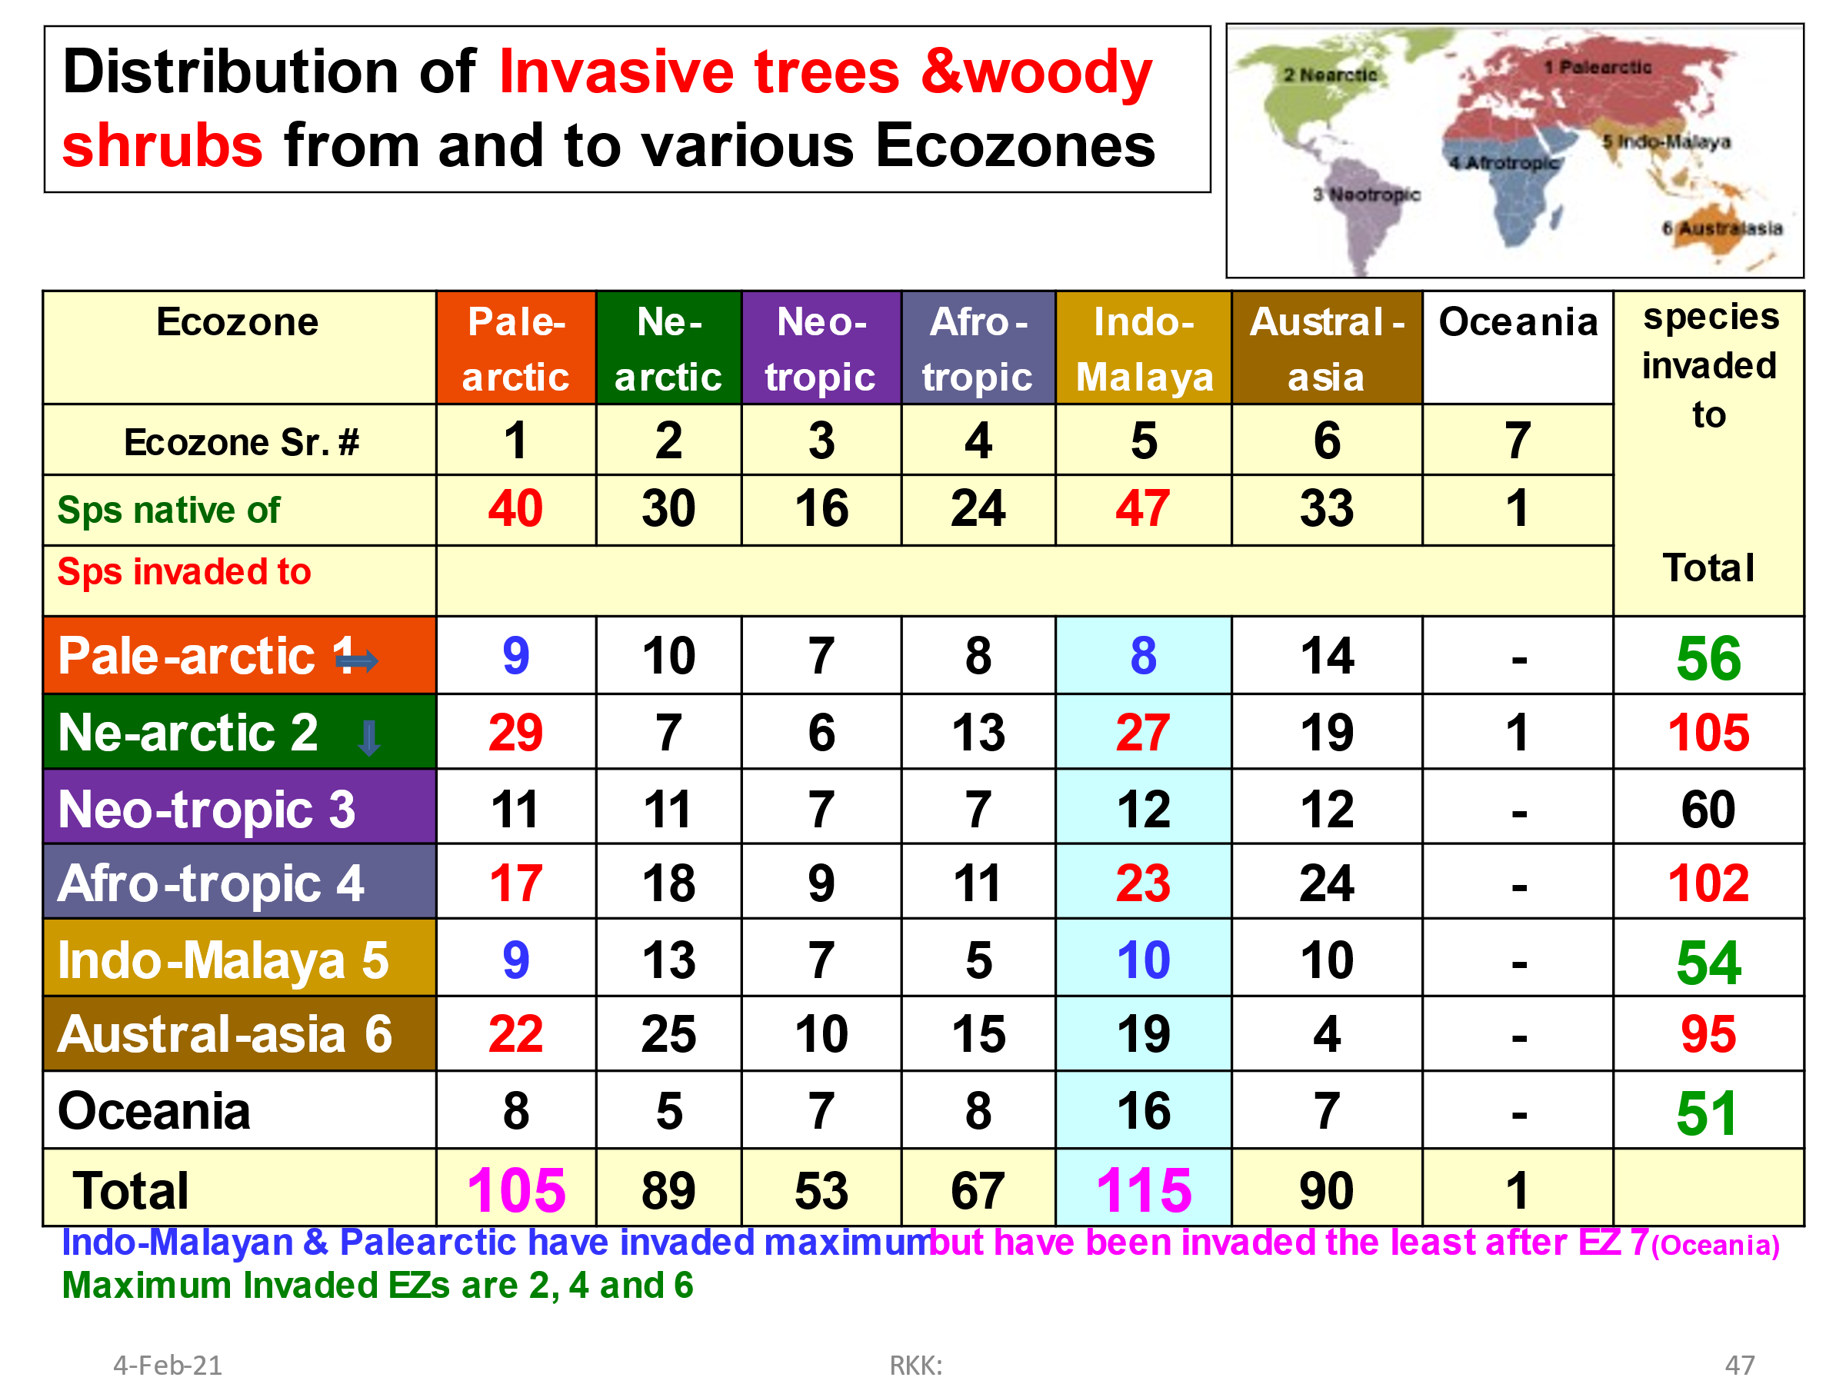

Recent Publications (minimum 5)
- Invasive Plant Ecology: (Eds. S. Jose, H.P.Singh, D.R.Batish and R.K.Kohli) CRC Press, Taylor and Francis Pub. USA Catalog no. 4398; 282 pp., ISBN: 978-1-4398-8126-2 (hardback) 2013.
- Invasive Alien Plants: An Ecological Appraisal for Indian sub-continent (Eds. Bhatt, J.R., Singh, J.S., Tripathi, R.S., Singh, S.P. and Kohli, R.K). CABI, UK. ; 2012; ISBN-13: 978 7 84593 907 6 (Price £ 80)
- Invasive plants and Forest Ecosystems (Eds. Ravinder Kumar Kohli, Shibu Jose, Harminder Pal Singh, Daizy Rani Batish) CRC Press, Taylor and Francis Pub. USA Catalog no. 43374, 456 pp., ISBN: 978-1-4200-4337-2, ISBN 10: 1420043374; 2009 (Price US $129.95).
- Ecological Basis of Agroforestry (Eds Daizy Rani Batish, Ravinder Kumar Kohli, Shibu Jose, Harminder Pal Singh) CRC Press, Taylor and Francis Pub. USA Catalog no. 43277, c. 400 pp., ISBN: 978-1-4200-4327-2008 (Price US $119.95 / £68.99).
5. Handbook of Sustainable Weed Management (Eds. H.P.Singh, D. R. Batish and R. K. Kohli). Haworth Press, Inc. New York, USA, Pp. 892 + xxiii (ISBN 13:978-1-56022-956-8 (HC alk. Paper) (ISBN 10:1-56022-956-X (HC alk. Paper) (ISBN 13:978-1-56022-957-5 (pbk alk. Paper) (ISBN 10:1-56022-957-8 (pbk alk. Paper) March, 2006 (Price US $ 139/=)
6. Allelopathy in Agroecosystems (Eds. R.K. Kohli, H.P.Singh and D.R.Batish Haworth Press, Inc. New York, USA p.447, 2001 (ISBN 1-56022-090-2 (alk. Paper) and (ISBN 1-56022-091-0 (pbk. Alk. Paper) It has been co-published simultaneously as Journal of Crop Production, volume 4, No 2(#8) 2001 (Price US $ 79/= )

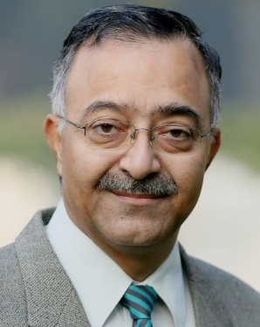
Dr Ravinder Kohli, a Certified Senior Ecologist of ESA USA is serving as Vice-chancellor of Amity University Mohali, Punjab India. Decorated with several state and national level awards, he is coordinating a commissioned R&D project on Invasive Alien Plants across Indian Himalayas. He is a Fellow of all the four official National Science Academies and is the JC Bose National Fellow of DST for the 2nd term of 5 years. He has successfully guided 53 PhD and 29 MPhil candidates. He served for 10 years as coordinator of International Working Group on Ecology of Invasives of the IUFRO (Austria) and had been a member IUFRO Task Force on Biological Invasion. He had held SAARC Chair in Bangladesh and had been an Adjunct Professor of the Chinese Academy of Sciences for 2 years. His research interest focuses on understanding the reasons of successful invasion.
Biography (150 word limit)

