How to create a culture of empowerment around your zero-waste program
Bruce Buchan, CEO & Founder, CleanRiver Recycling Solutions

Abstract (300 word limit)
This presentation is a critical must-see for anyone seeking tangible strategies to drive engagement in their zero waste program. The presentation will include key strategies that have been proven to work in numerous fortune 500 companies who are leading the way in sustainability.

Key learning objectives (attendees will leave with the following actionable knowledge):
- How to effectively plan a zero waste program and identify and overcome any potential challenges
- Practical advice on how to engage custodial teams, staff and students to ensure the success of your zero waste program
- A thorough understanding of how the “3C Process” drives cultural change within their organization to assist them in reaching their zero waste goals
Are you set up for success or failure?
- An overview of key areas that are critical for program success from waste hauler contracts, financial restrictions, equipment, custodial challenges and high contamination issues.
- How to identify where your organization is now regarding culture.
- An overview of the 3C Process best practices for zero waste success (Culture, Communication, Collection)
How to effectively drive change in the culture to bring about sustainability success
- The impact of senior leadership
- Practical tips on how to engage employees and custodial team in the zero-waste program
- Extended Producer Policies
- Overview of Langley Events Centre case study – used the “3C Process” to reduce landfill waste by 63%
- Overview of Xcel Energy Center case study – how they increased their diversion rate to 66% using the “3C Process”

Image
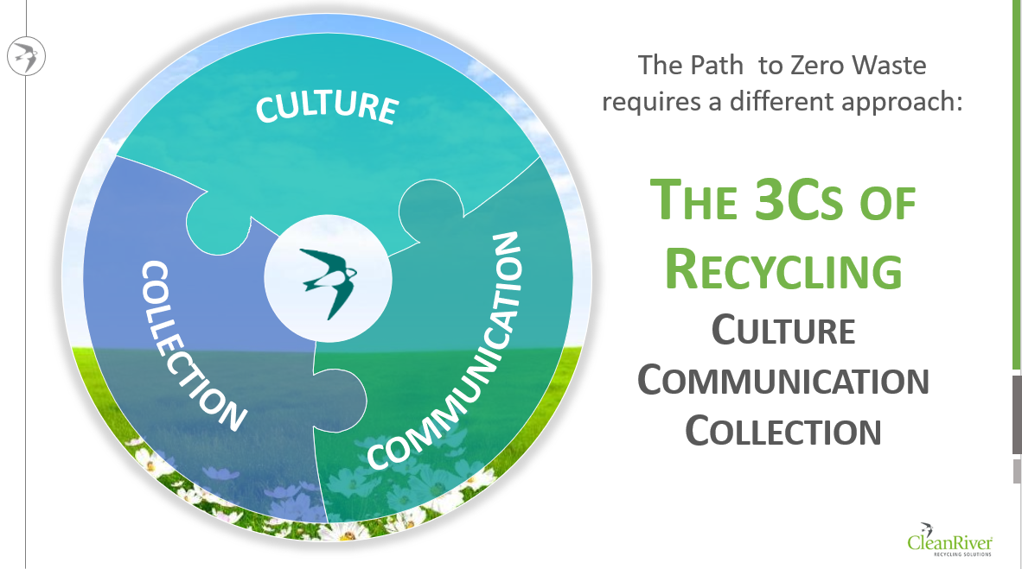


Bruce is a driver and promoter for sustainability change and believes that Culture, Communication and Collection are the 3 driving factors for achieving zero waste. This redefined concept – “CleanRiver 3C Process” has been adopted and widely followed by organizations such as Google, Tesla, Facebook and Tim Hortons. A highly sought-after speaker at industry events, Bruce shares his 25 years’ experience through best practices on effective waste management, achieving social ROI, developing a sustainable culture in organizations and the financial ROI from effective recycling.

Contact Details:
Email: bruce.buchan@cleanriver.com
Contact Number: 1 888 646 4246
Linked In/twitter Account Id:
Facebook profile: N/A
Session:
Presentation Category: Oral

Notes/Comments:

The content provided in this presentation arms the audience with key tangible actions and strategies on how to increase engagement with their zero waste programs through a cultural shift

