Shifting Paradigms: Building a Sustainable and Resilient Recycling Program
Stephen W. Brooks, JD

Abstract (300 word limit)
Statement of the Problem: As the recycling is a fluid industry affected by global markets, certain commodities will lose market value. This ebb and flow affecting positive revenue stream of a recycling program can be mitigated as the FLETC model has proven. The FLETC saw significant reduction in the revenue generated or tonnage diverted. Another factor that will impact the overall program is the amount of training being conducted across the enterprise. The more training that is conducted, the more solid waste will be generated and subsequently recycled. During soft market periods increasing the volume recycled will keep revenue positive. But even then, you have to shift your paradigm, or how you traditionally view your operation. With the soft markets, the FLETC, following it model, generated more positive revenue than ever before. The only challenge to exponentially increasing revenue is the lack of a dedicated facility based on the projected volume. The FLETC model is one of how to run a business within a governmental operation. Its success is manifest in the during 2018, the recycling program generated over $1million dollars (USD) in today’s softened global marketplace. Overall, FLETC generated $1,077,567.11 in gross revenue from the sales of marketable recyclables during FY 2018. This amount represents approximately 84.5% more revenue than the amount generated in FY 2017.
FLETC Gross Revenue FY 2018 Total $1,077,567.11 FY 2017 Total $583,864.76 Percentage Increase/Decrease 84.5% Increase. Start small, and with “low hanging fruit”. Those recyclable commodities that you have an abundance of and are easily collected and processed. Once the processes and procedures are refined, then move to another commodity. But first and foremost, have markets identified from the very beginning.

Image
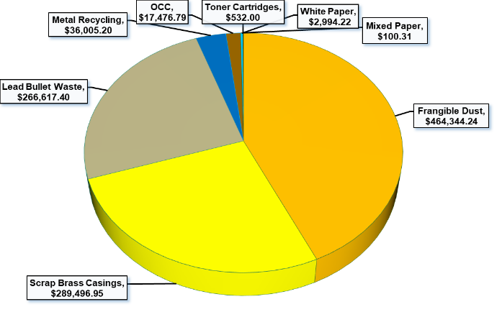

Recent Publications (minimum 5)
- Federal Times (2015) Shifting paradigms and the recycling program at FLETC.
- Waste Today (2017) Paradigm shift: The Department of Homeland Security’s Federal Law Enforcement Training Centers is changing the way it handles waste, and it's paying off.
- Recycling Annual Report (2018).

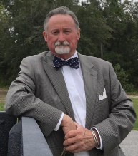Biography (150 word limit)
Stephen Brooks is the Recycling Program manager for the Federal Law Enforcement Training Centers enterprise wide. Over the past 5 years he has led a team of diverse individuals in accomplishing what had been said as impossible. Establishing and developing a robust, and profitable recycling program within a governmental agency. Stephen was named the 2015 “Sustainability Hero” for the Department of Homeland Security (DHS) in addition to other governmental awards to include a Presidential Award in the area of sustainability. Stephen is a sought-after speaker in the areas of recycling, sustainability, and resiliency and a note author,
Email: stephenbrooks207@yahoo.com

Notes/Comments:

