Isolation, Identification of Newcastle disease Virus in Embryonated Chicken eggs and Chicken Embryo Fibroblast (CEF) Cells
Omazia Nasir, Bs. Applied Microbiology, Pakistan

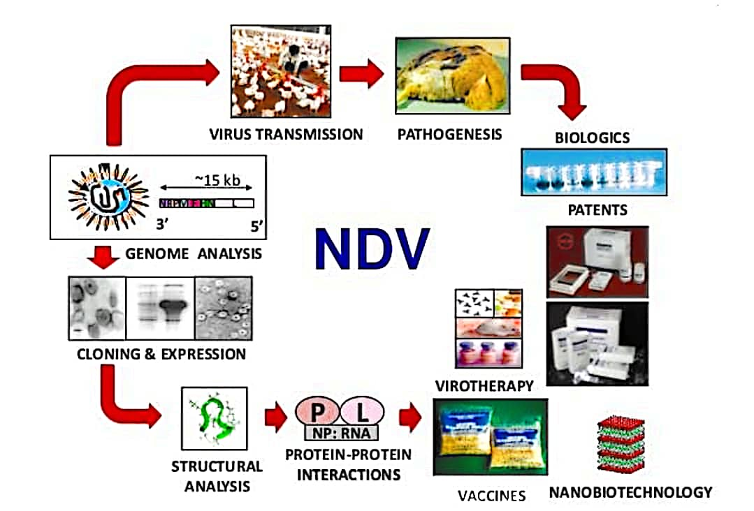
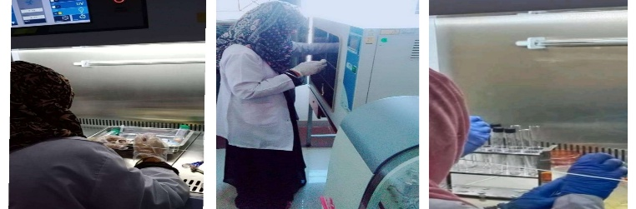
Abstract

The infectious agent of Newcastle disease is called Newcastle disease Virus which is a major viral disease of poultry all over the world. The main objective of this research is the isolation, identification and adaptation of Newcastle Disease Virus in Embryonated Chicken Eggs, and Chicken Embryo Fibroblast (CEF) Cells. To investigate and diagnose the NDV, and growth of NDV was confirmed by embryo mortality, Cytopathic effects (CPE) in cell culture, hemagglutination (HA) and Hemagglutination inhibition (HI) test. For the presence of Newcastle disease Virus, reverse transcription polymerase chain reaction (PCR) was performed. Two types of samples were collected: one was tracheal sample and another was cloacal swabs. Three passages were performed to adapt NDV on the embryonated chicken eggs. The virus inoculation was performed by allantoic route and the allantoic fluid was then tested to confirm the presence of Newcastle disease Virus in the sample with hemagglutination (HA) and hemagglutination-inhibition (HI) tests. In order to check Newcastle disease Virus presence on Chicken embryo fibroblast cells three consecutive passages were performed. After performing first and second passages, no clear evidence of cyotpathic effect (CPE) was found. But at the end of third passage, clear, pure and consistent CPEs were found. RT-PCR (Real Time polymerase chain reaction successfully amplified a 750bp fragment covering parts of Matrix and Fusion protein genes of Newcastle disease Virus, which was isolated from the samples that were positive either in chicken embryos or in embryo cell culture. After Observing, it is suggested that RT-PCR could be a rapid and sensitive system for the detection of NDV. Experimental results show that the Newcastle disease virus is able to grow in the CEF cells.

Image

Recent Publications
- K. Ganar, M. Das, S. Sinha, and S. Kumar, “Newcastle disease virus: current status and our understanding,” Virus Research, vol. 184, pp. 71–81, 2014.
- L. Susta, M. E. B. Jones, G. Cattoli et al., “Pathologic characterization of genotypes XIV and XVII Newcastle disease viruses and efficacy of classical vaccination on specific pathogen-free birds,” Veterinary Pathology, vol. 52, no. 1, pp. 120–131, 2015.
- Martin, P.A.J. The epidemiology of Newcastle disease in village chickens. In Proceedings of the Newcastle Disease in Village chickens, Control with Thermostable Oral Vaccines; Spradbrow, P.B., Ed.; Australian Centre for International Agricultural research: Kuala Lumpur, Malaysia, 1991; pp. 40–45.
- Surveillance and Genetic Characterization of Virulent Newcastle Disease Virus Subgenotype V.3 in Indigenous chickens from Backyard Poultry Farms and Live Bird Markets in Kenya, 2021
- Wang, JY., Liu, WH., Ren, JJ. Et al. Characterization of emerging Newcastle disease virus isolates in China. Virol J 12, 119 (2015)

Biography
Omazia Nasir Student of Bs. Applied Microbiology, 6th semester in Cholistan University of Veterinary and Animal Sciences Bahawalpur, Pakistan. I’m working in Clinical Laboratory, Bahawalpur and I’ve expertise in Culture. Recently, I’m doing research on the recent strain of Covid (Delta Variant) Combination of Lactoferrin, Amoxicillin and mRNA against SARS-CoV-2 Delta Variant, I completed my project on water waste management system by use microorganisms, CUVAS awarded me certificate and got 2nd position in oral competition on the topic of One Health related to antimicrobial resistance. I'm working at this stage, I've many ideas regarding New emerging diseases (Antimicrobial Resistance, COVID, Cancer therapy and many more) but due to lack of funds, opportunities, and laboratories i can't work.
Email: omazia106@gmail.com

