Nigerian Animal Health Experience: International Practice and National Profession
¹Oluwadare O. Paul, ²Salihu Abubakar, ³Babas I. Samuel, ⁴Friday Osuagwu.
Nigerian Association of Animal Health and Husbandry Technologists, MHWUN House, Abuja Nigeria.

Abstracts

Statement of problem: global Animal Health is one of the major interfaces between people, animals and environment. The Practitioners play the main role in animal production and processing, training and research while the Practice provides interface for safe foods and local healthcare delivery templates. The inundated missing links between Veterinary and Animal Health professionals indicated that regular country PVS Evaluation Missions are useful to assess/ monitor progress made for necessary changes in legislation, structural modifications, health investments impact and improved compliance with international standards. Healthy animal is needed contribute to the elimination of global threats around hunger and lack of nutrition through optimum animal welfare sustainable food production. Methodology and Theoretical Orientation: using an inter professional subjective survey as baseline for Veterinary and Animal Health Semantics of competent animal welfare and safe public healthcare delivery, import risks analysis and boarder inspection, manpower development and quarantine through the fundamental components of OIE PVS Evaluation of human, physical and financial resources; technical authority/ compatibility; interactions with stakeholders; access to market. Findings: the missing link in interplay of Veterinary Professionals and Animal Health Practitioners need close up in the today's global society. This has been ignored at the detriments of the animal, farmer, consumer, environment, domestic society and global productivity since the production of food of animal origin historically remains one of the fundamental pillars on which food security and poverty alleviation of the SDGs is based. Conclusion and Significance: noteworthy Animal Health Professional recognition and interplay is important for farm, animal, consumer and ecosystem to stay healthy and productivity portrays a healthy society with solid practitioners and rich practice. Recommendations are made in the OIE Nigeria 2019 Visit to provide for the creation of Animal Health Technologists to recognize middle manpower cadre in international reference.

Image
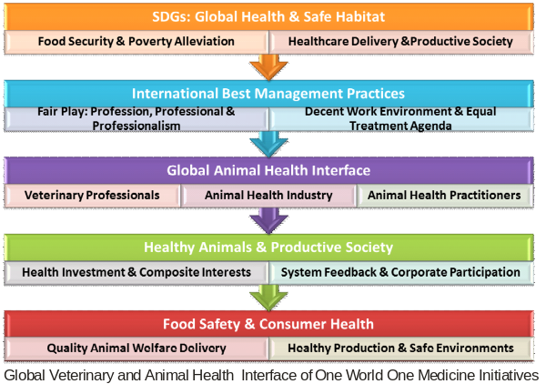

Recent Publications:
- Oluwadare et-al (2016) Practical Guides to the Management of Common Livestock Diseases in the Tropics (2016). ISBN: 978-978-085-137-8 (897 pages)
- Oluwadare O. Paul (2017) Common Fungi Complications and Mycotoxicosis in Public Healthcare Delivery and Animal Production. ISBN: 978-978-961-103-4
- Oluwadare O. Paul (2018) Common Poisons and Intoxicosis in Tropical Animal Husbandry and Livestock Production – ISBN: 978-978-966-726-0 (366 pages)
- Oluwadare O. Paul and Sansi J. A. Aderonke (2017) Basics and Principles of Tropical Organic Livestock and Aquaculture. ISBN: 978-978-949-476-7 (600 pages)
- Oluwadare O. Paul, Adeleye A. Olusegun (2018) Nigerian Journal of Animal Health and Husbandry Technologists. Professional Conflicts in Veterinary Workplace: Causes, Forms and Recommendations. ISSN: 2504-9917. 131-13.

