- Abstract body
NOVEL PROCYANIDIN ANTIOXIDANT: A POTENTIAL ANTI-FATIGUE AGENT IN DONKEYS SUBJECTED TO PACKING DURING THE COLD-DRY SEASON IN NORTHERN NIGERIA

Olaifa Folashade Helen^{1*}, Ayo Joseph Olusegun², Aluwong Tangang² and Rekwot Peter Ibrahim³
¹Department of Veterinary Physiology and Biochemistry, University of Ilorin, Ilorin, Nigeria
²Department of Veterinary Physiology, Ahmadu Bello University, Zaria, Nigeria
³National Animal Production and Research Institute, Ahmadu Bello University, Shika, Nigeria
Corresponding Author, Email Address: folashadeakanmu@yahoo.com, Phone number: +2347035936989

The experiment aimed at determining the effect of a novel procyanidin on some biomarkers of fatigue in donkeys subjected to packing during the cold-dry season in northern Nigeria. Matured male donkeys (n=10) were used for the study. Five of them were given PYC in feed for seven days prior to packing (test donkeys), while another five were given feed only (control donkeys). Blood sample was collected for plasma analyses from each donkey before, during, after packing and at day three and seven after packing. The plasma samples were analysed for creatine kinase (CK), tumor necrosis factor-alpha (TNF-α), superoxide dismutase (SOD) and total antioxidant capacity (TAC). The TNF-∞ concentration was significantly (P < 0.05) higher in the control group (35.6 ± 3.3 ng/ml), when compared with the test group (29.6 ± 2.4 ng/ml). The CK activity was significantly (P < 0.05) higher in the control group during (95.9 ± 12.4µ/L), after (186.5 ±12.9 µ/L), 3 (60.3 ± 8.8 µ/L) and 7 days after (205.8 ± 8.0 µ/L) packing when compared with test group, with values of 71.7 ± 5.3 µ/L, 140.2 ± 19.8 µ/L, 49.2 ± 20.3 µ/L and 71.9 ± 15.7 µ/L, respectively. The SOD activity increased in the test group especially after packing (755.7 ± 74.1 µ/L) and was significantly (P < 0.05) higher than the value obtained in control group (443.2 ± 59.9 µ/L). The TAC values obtained during the packing period were significantly (P < 0.05) higher in test group when compared to the control group. In conclusion, packing caused muscle inflammation and damage indicating fatigue, however PYC improved the antioxidant status.
- Keywords: Fatigue; donkey; harmattan; pycnogenol
- Picture:

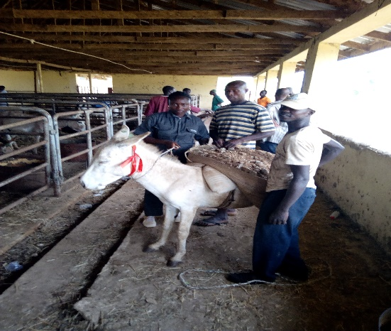
- Biography:
Olaifa Folashade Helen is a PhD student at the Department of Veterinary Physiology, Ahmadu Bello University, Zaria, Nigeria. She has been researching on work donkeys within her environment since 2008 and has published her findings in reputable journals. She is presently a physiology lecturer at the Department of Veterinary Physiology, University of Ilorin, Ilorin, Nigeria.
- Presenting author details
Full name: Olaifa Folashade Helen
Contact number: +2347035936989
Session name/number: nil
Category: Oral presentation
Passport number: A09629075

