New strategy against Brucellosis in Azerbaijan
M.Khatibi, D.Aghalarov, M.Shikhiyev, T.Seyidov, A.Azimov, Agricultural Competitiveness Improvement Project, Azerbaijan ; C. Ponsart, French Agency for Food, Environmental and Occupational Health & Safety, France; R.Jackson,international expert, epidemiologist, PHD

Abstract (300 word limit)
Within the Agricultural Competitive Improvement Project, a large seromonitoring survey was conducted between October 2015 and February 2016 in order to determine the prevalence of brucellosis in Azerbaijan. Blood samples were collected from randomly selected cattle and small ruminants according to a representative geographic distribution (225 villages and 197 winter pasture flocks in 51 different villages). A total of 92389 blood samples (33383 cattle and 59006 small ruminants) were collected and tested by Rose-Bengal test. A subset of 1697 positive samples were then confirmed by competitive ELISA test. All data (identification of animals, codes of villages, species, age, gender of animals) were recorded into a custom designed Microsoft Access database. Serum samples were were stored in a serum bank at minus 20 - 30 °C for a 5 years period. Biosafety measures were implemented during the project according to OIE and WHO standards (OIE, 2016; WHO, 2006). Seromonitoring revealed about 1 % (from 0 % to 3,7 %) prevalence rate in cattle and 2 % (from 0,1 % to 5,8 %) in small ruminants (figure 1). Prevalence rate among small ruminants in winter pastures averaged 2.5 % (from 0 % to 14.3 %). These results leaded to define an appropriate control strategy based on vaccination (El Idrissi, 2014). At first, a “full-flock” vaccination campaign was implemented in 2016 using Rev.1 vaccine of small ruminants (Blasco et al., 2011). Then, annual vaccination campaigns were applied during 3 successive years in young animals (3 to 8 months old). Since 2017, conjunctival vaccination of young cattle (3 to 8 months old) started using S19 vaccine (van Straten et al., 2016). As next step, this control strategy will be evaluated and adjusted in 2020 through a new serological epidemiological survey.

(a)

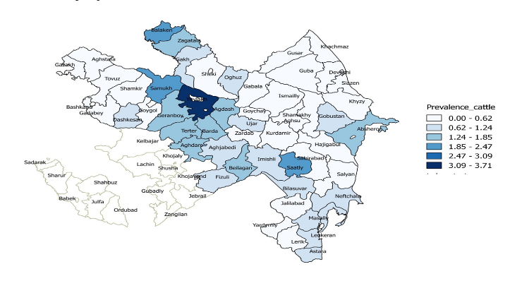

(b)

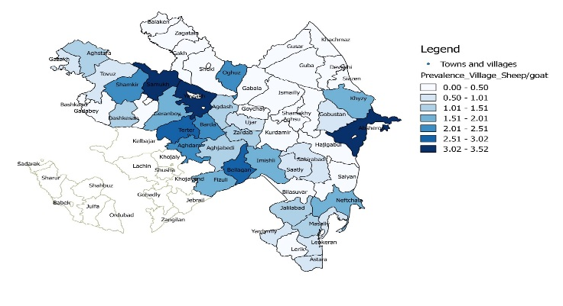Figure 1 Seroprevalence rates of brucellosis in cattle (a) and small ruminants (b) in Azerbaijan

Recent Publications (minimum 5)
- Blasco JM, Molina-Flores B (2011). Control and eradication of Brucella melitensis infection in sheep and goats. Vet Clin North Am Food Anim Pract. 27(1): 95-104. Review.
- El Idrissi A (2014) FAO works to curb the burden of brucellosis. Focus on, N°8. http://www.fao.org/3/a-i3916e.pdf
- OIE (2016). Infection with Brucella abortus, B. melitensis and B. suis. In Manual of Diagnostic Tests and Vaccines for Terrestrial Animals 2018.
- van Straten M, Bardenstein S, Keningswald G, Banai M (2016). Brucella abortus S19 vaccine protects dairy cattle against natural infection with Brucella melitensis. Vaccine. 34(48):5837-5839.
- WHO (2006). Brucellosis in humans and animals. https://www.who.int/csr/resources/publications/Brucellosis.pdf

Biography (150 word limit)
Masud Khatibi is a veterinarian with a strong expertise in project management. Since 2014, He is coordinating the ACIP Brucellosis project implemented in Azerbaijan and participated to field vaccination of ruminants against brucellosis, implementing and coordinating training of vets and students. Email: masudkhatibi@mail.ru

Notes/Comments: This project has been funded by World Bank (P122812). http://projects.worldbank.org/P122812/third-agricultural-development-credit-project?lang=en&tab=overview

