Mixed infection of two subspecies of Mycobacterium avium in a dog with disseminated mycobacteriosis

Cinzia Marianelli, PhD, Istituto Superiore di Sanità, Italy
Daniela Ape, DVM, Belli Lisi Studio Veterinario, Italy
Federica Rosi Mori, DVM, Belli Lisi Studio Veterinario, Italy

Abstract
Opportunistic mycobacteriosis caused by Mycobacterium avium-intracellulare complex (MAC) is considered rare in dogs, presumably due to an innate resistance to these organisms, and causes severe disease only in immunocompromised individuals. Clinical sings are generally non-specific, making ante mortem diagnosis difficult and granulomatous inflammations are consistently revealed at necropsy. In the rare cases of in vivo diagnosis, disseminated MAC infections with a worse outcome are found. We report the results of the investigation of a rare case of disseminated mycobacteriosis caused by multiple Mycobacterium avium subspecies coinfection in a crossbred dog.
A fine-needle aspirate sample from the popliteal lymph node was cultured. Twenty-two colonies were isolated and typed using DNA sequencing of the partial rpsA gene. In order to ensure the most appropriate antimicrobial therapy for the dog, isolates were also tested in vitro against clarithromycin, ciprofloxacin, rifampicin, streptomycin, amikacin, doxycycline, ethambutol and linezolid, using a resazurin microdilution assay. Two M. avium subspecies were identified, namely M. avium subsp. avium and M. avium subsp. hominissuis. Both pathogens were found to be sensitive to all of the drugs tested except for ethambutol. Although the therapy administered was adequate, the dog's overall clinical status worsened progressively and the animal died eight months later.
MAC infections are a serious public health issue due to their potential zoonotic risk in humans and their intrinsic resistance to many anti-tuberculosis drugs. Information from this study may be useful in rapidly identifying the bacillus and assessing its drug susceptibility profile.

Image
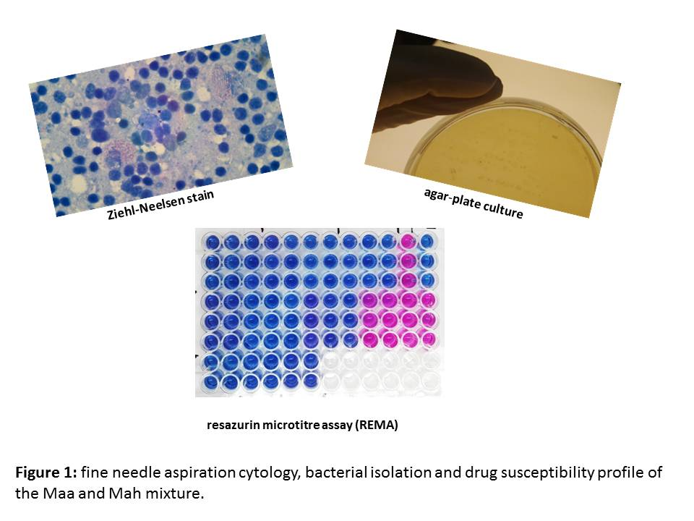
Recent Publications
- Armas F, Furlanello T, Camperio C, Trotta M, Novari G, Marianelli C (2016) Molecular characterization and drug susceptibility profile of a Mycobacterium avium subspecies avium isolate from a dog with disseminated infection. J Med Microbiol 65:278-285.
- Campora L, Corazza M, Zullino C, Ebani VV, Abramo F (2011) Mycobacterium avium subspecies hominissuis disseminated infection in a Basset Hound dog. J Vet Diagn Invest 23:1083-1087.
- Huang CC, Wu MF, Chen HC, Huang WC (2018) In vitro activity of aminoglycosides, clofazimine, d-cycloserine and dapsone against 83 Mycobacterium avium complex clinical isolates. J Microbiol Immunol Infect 51:636-643.
- Kim MC, Kim J, Kang W, Jang Y, Kim Y (2016) Systemic infection of Mycobacterium avium subspecies hominissuis and fungus in a pet dog. J Vet Med Sci 78:157-160.
- O'Toole D, Tharp S, Thomsen BV, Tan E, Payeur JB (2005) Fatal mycobacteriosis with hepatosplenomegaly in a young dog due to Mycobacterium avium. J Vet Diagn Invest 17:200-204.

 Biography
Cinzia Marianelli is a Research Scientist at the Department of Food Safety, Nutrition and Veterinary Public Health of the Italian National Institute of Health (Istituto Superiore di Sanita) in Rome, Italy. Her research activities mainly focus on the diagnosis and epidemiology of bacterial zoonosis, development of molecular diagnostic techniques for the rapid identification of bacterial pathogens, surveillance for antibiotic resistant pathogens, and development of new non-antibiotic therapies to control animal infections.
Email: cinzia.marianelli@iss.it

